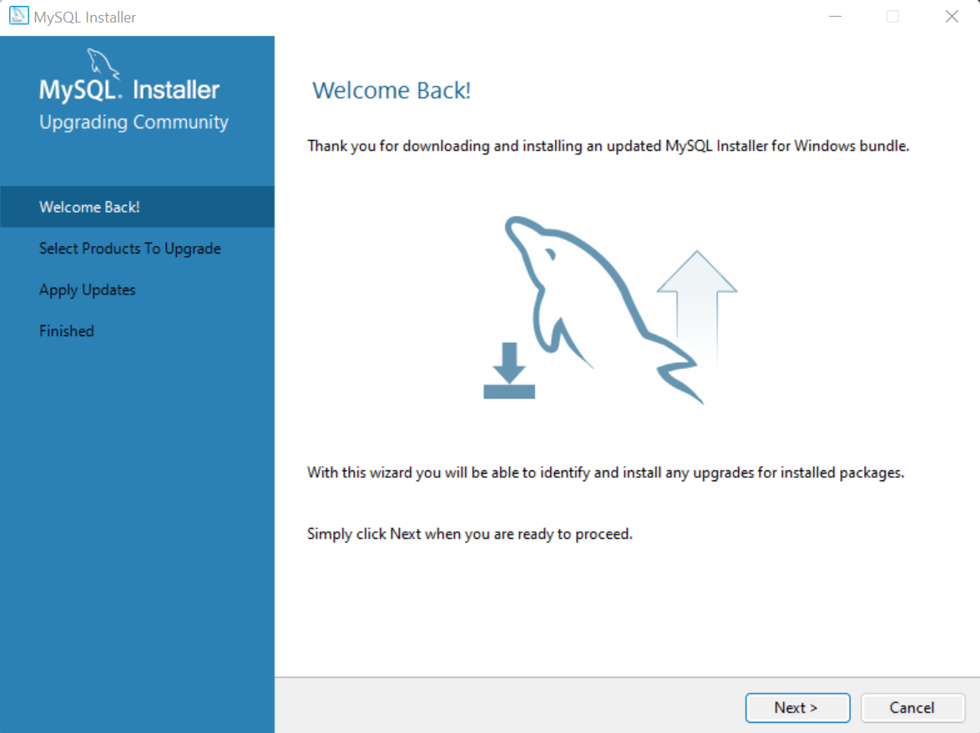

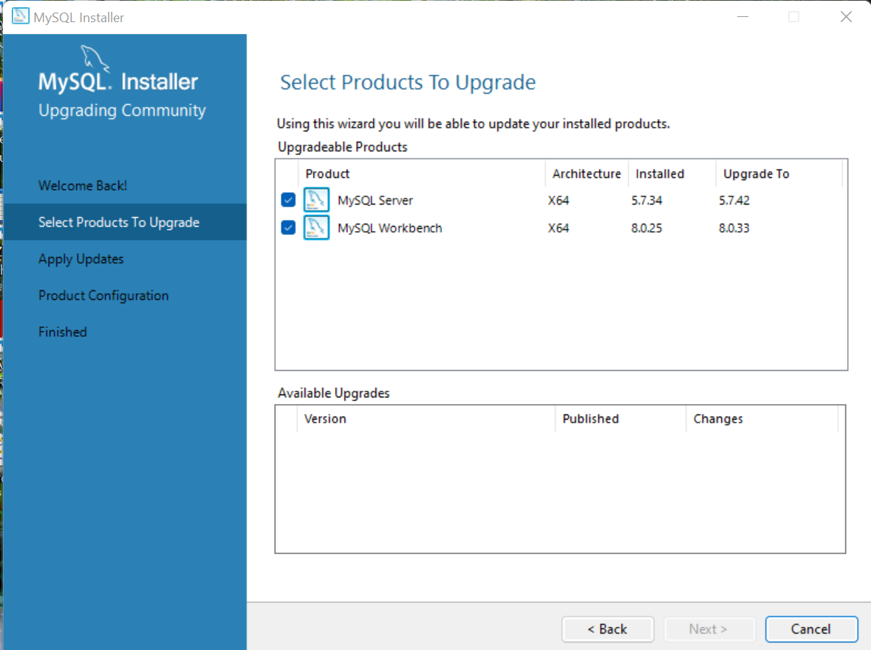

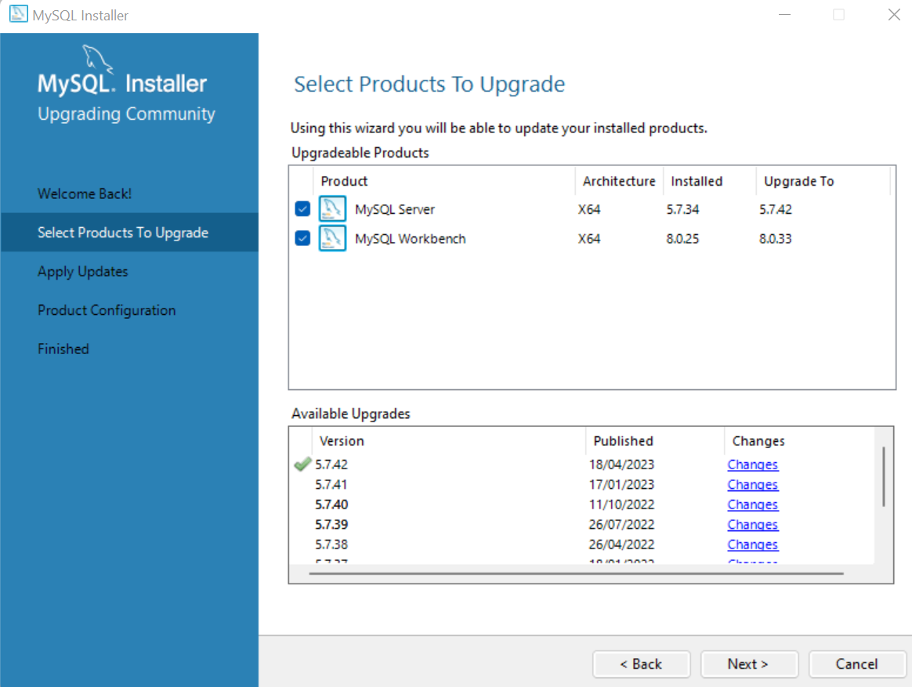

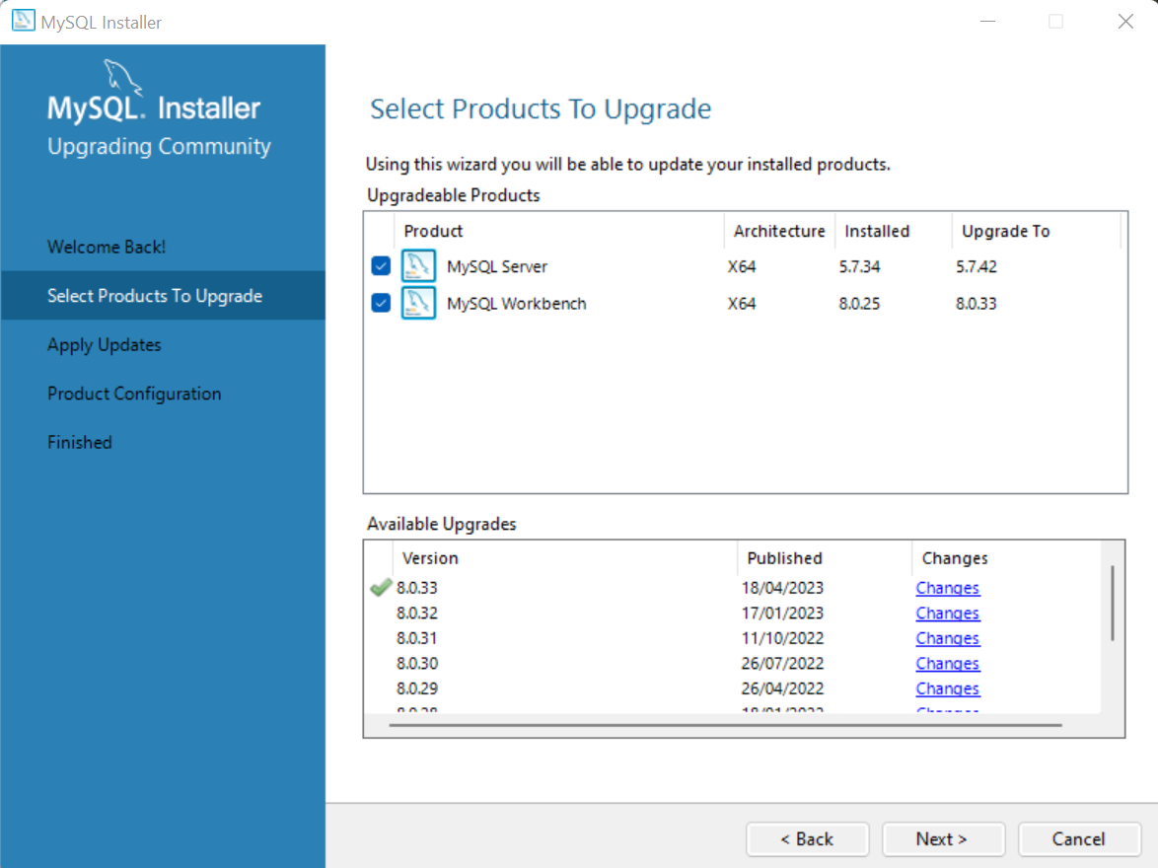

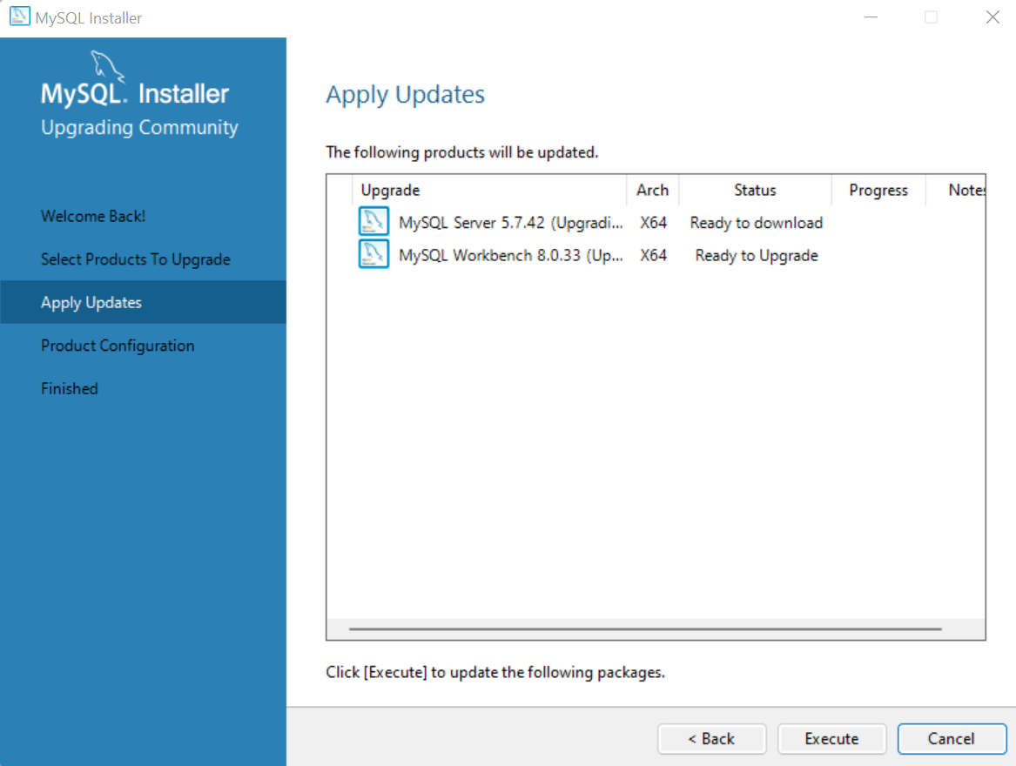

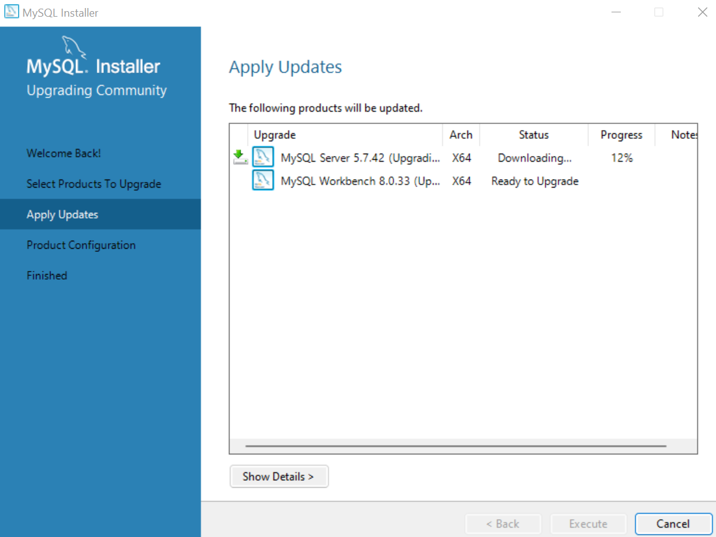

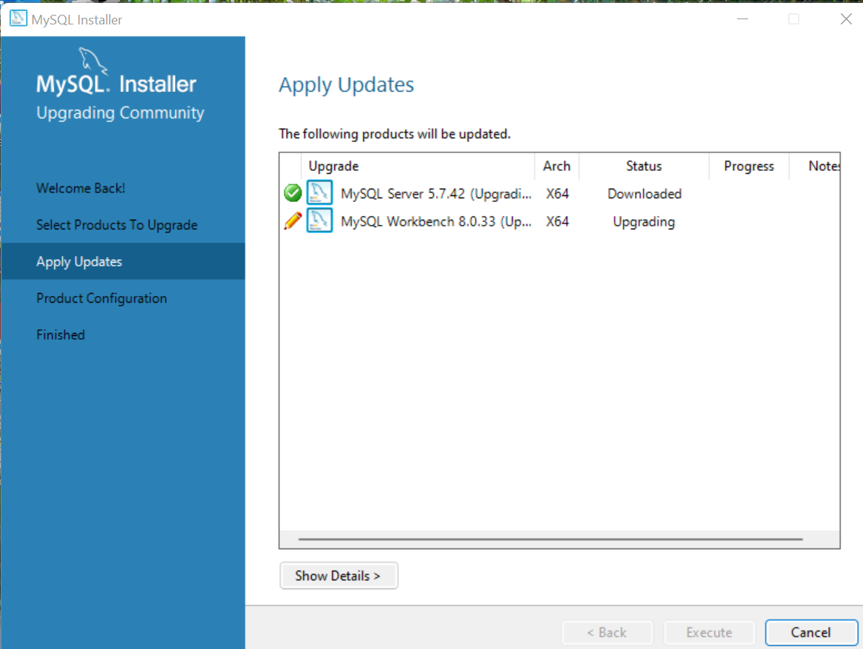

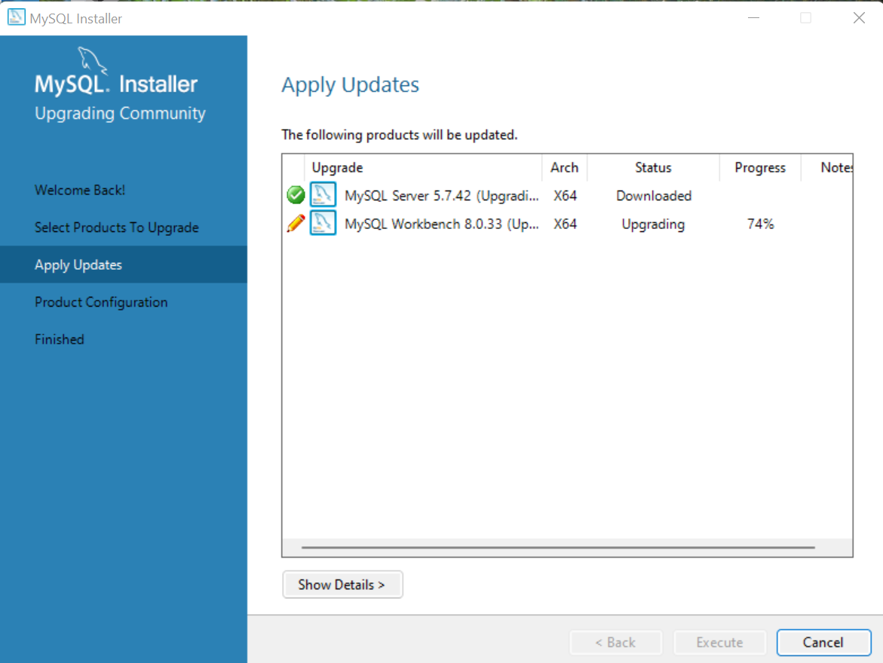

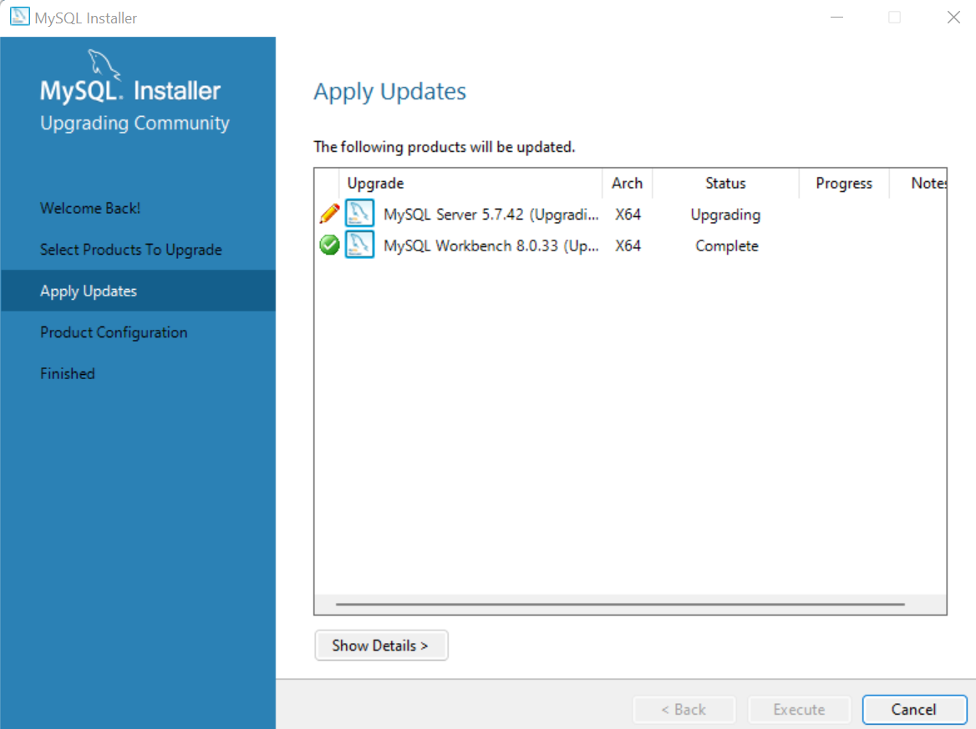

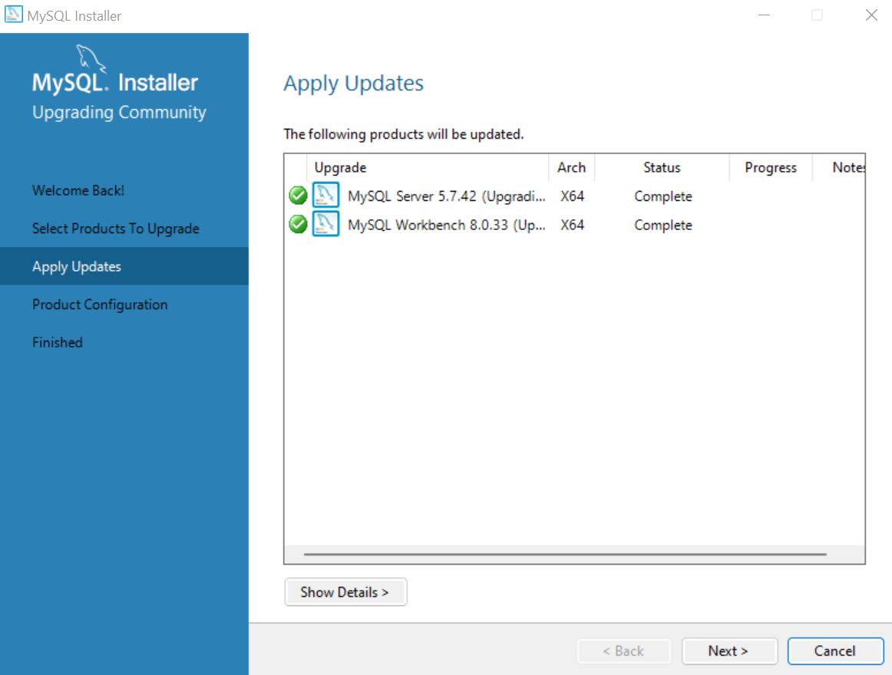

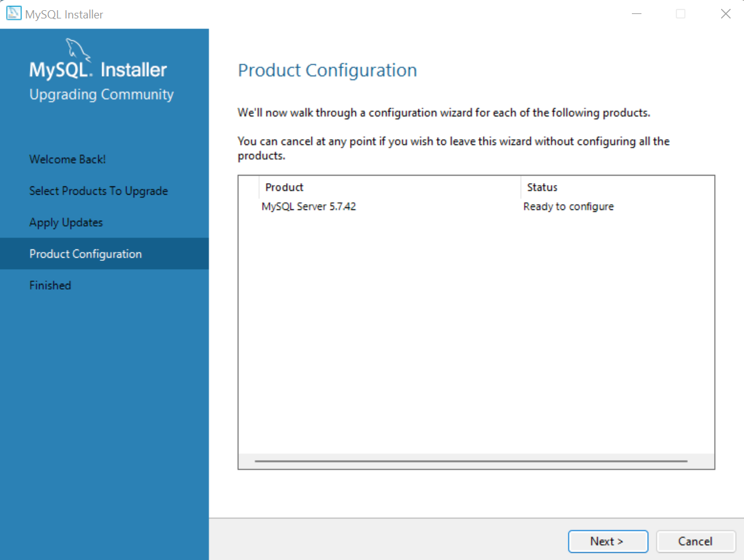

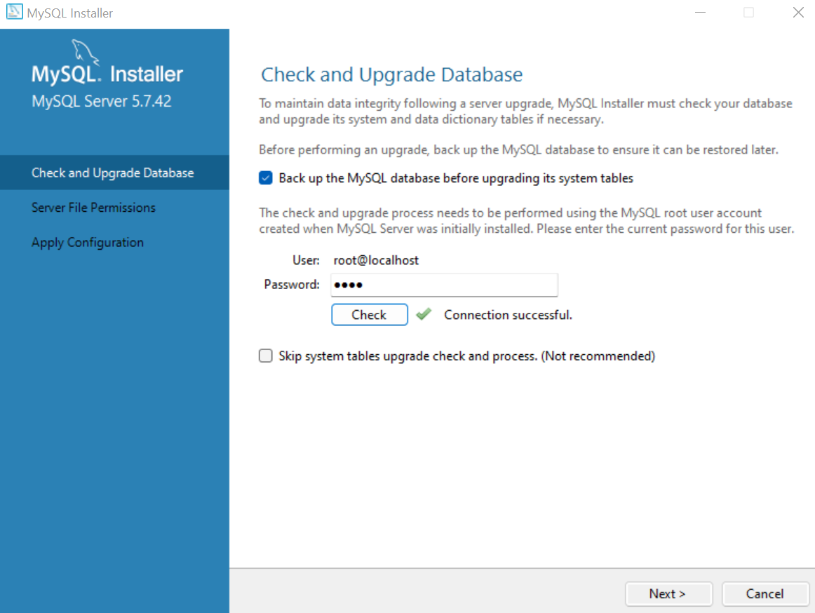

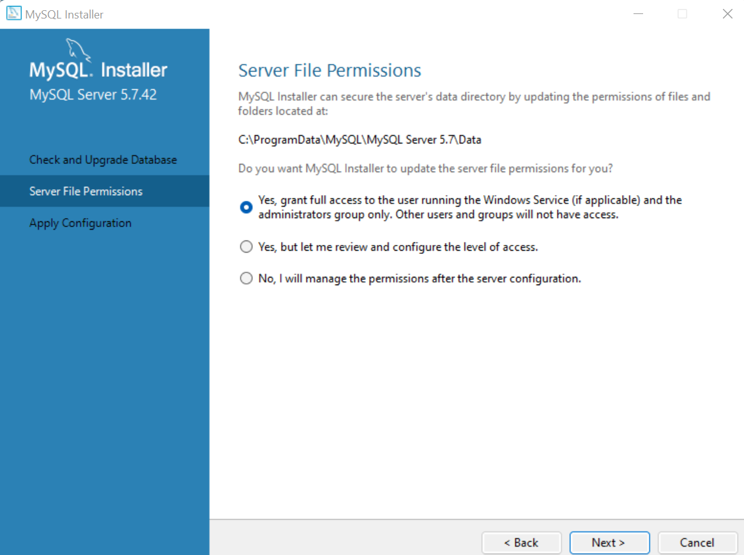

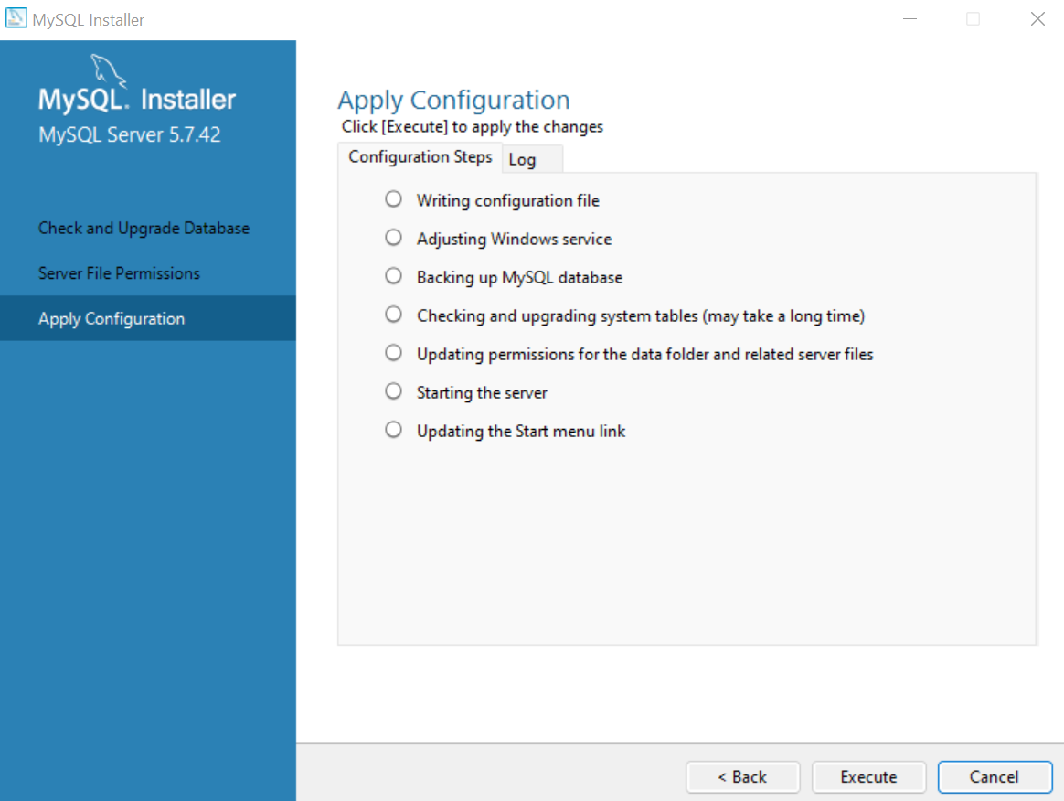

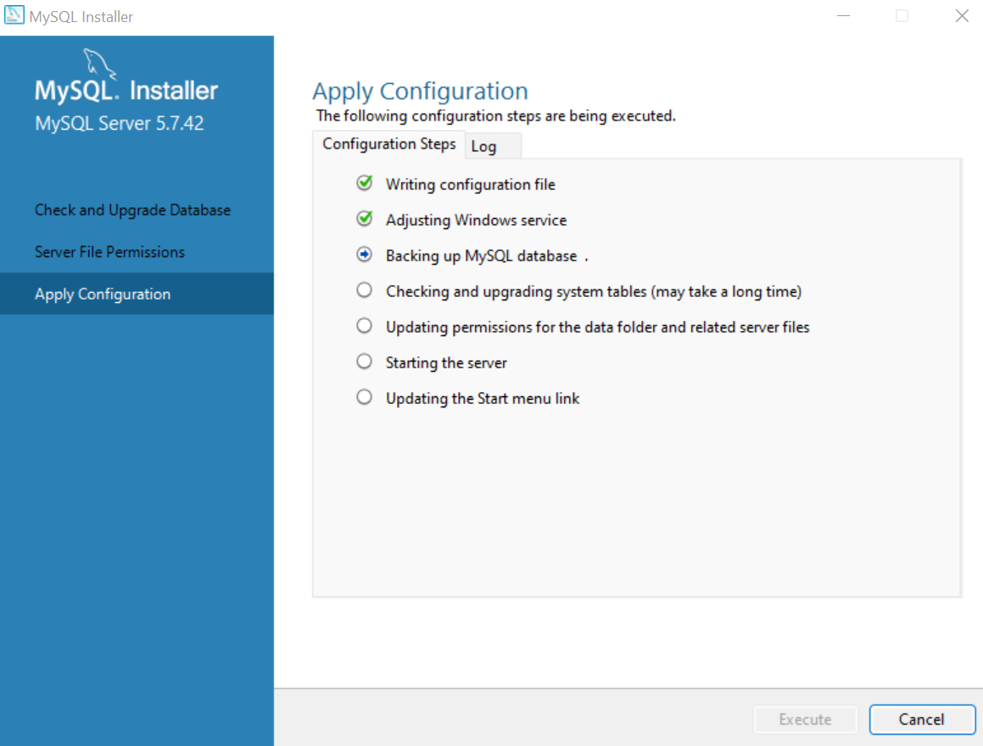

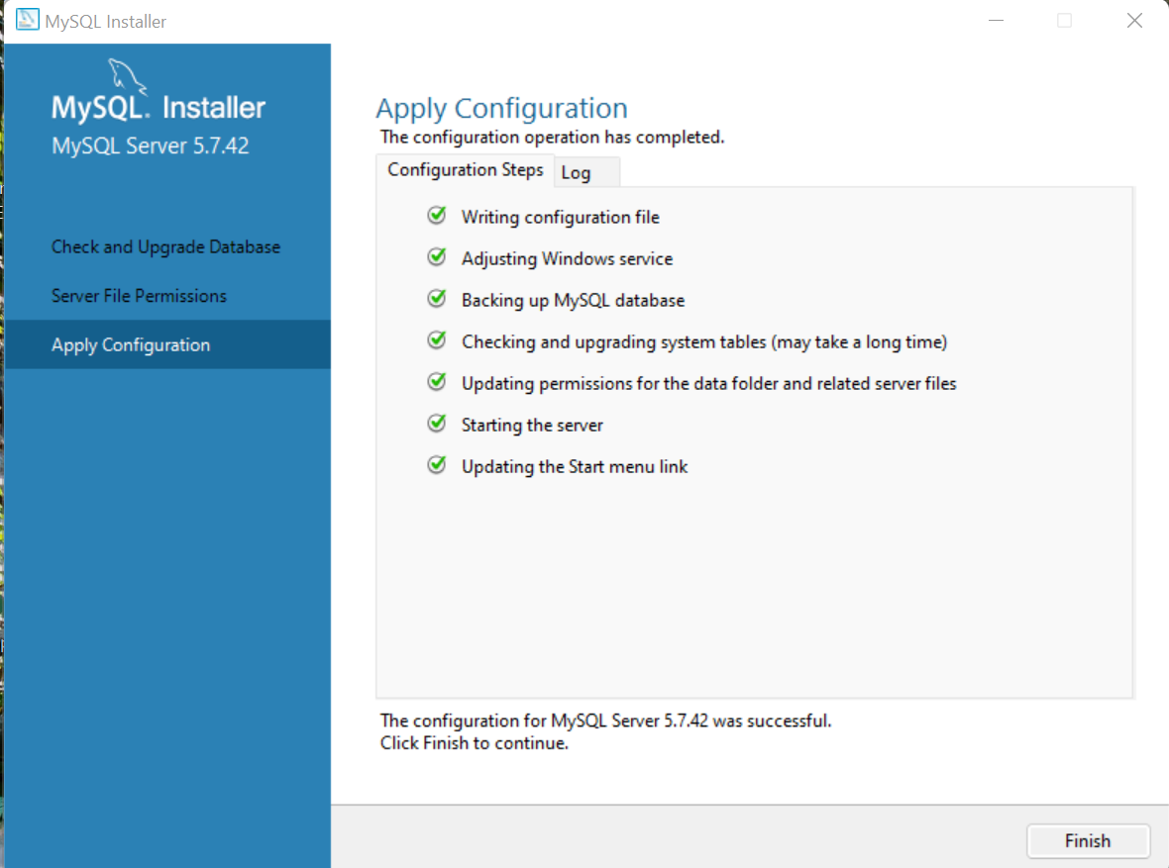

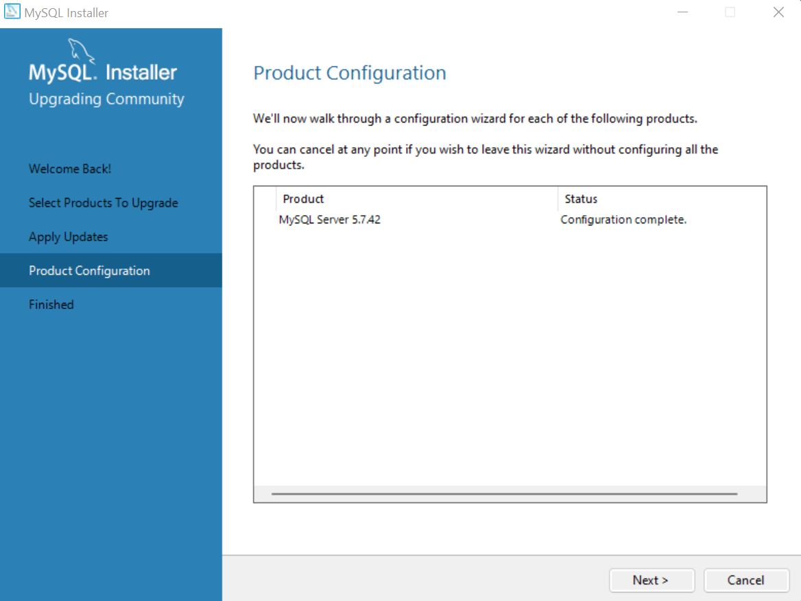

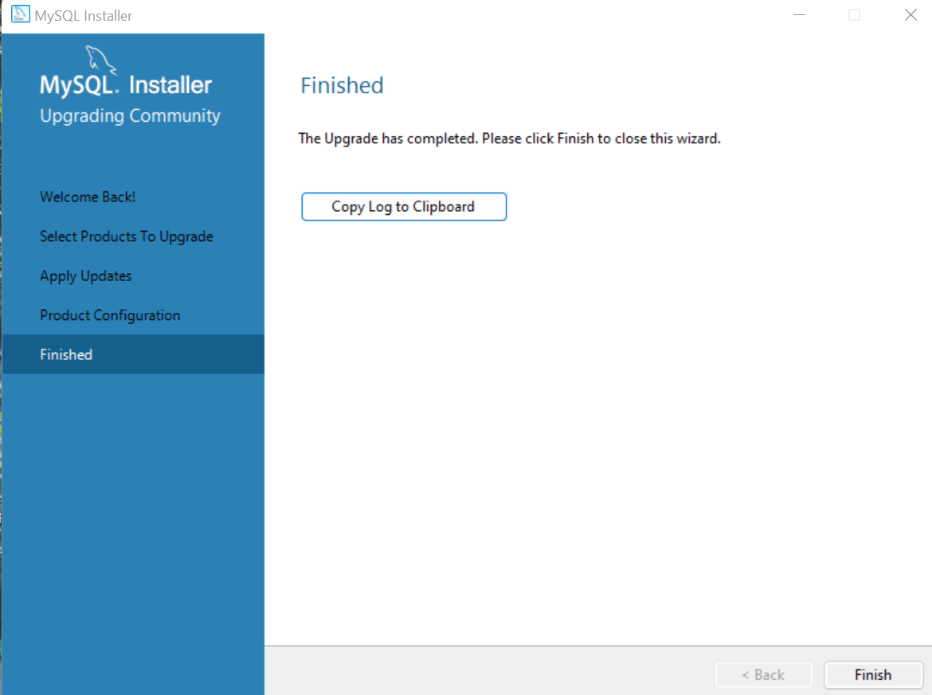

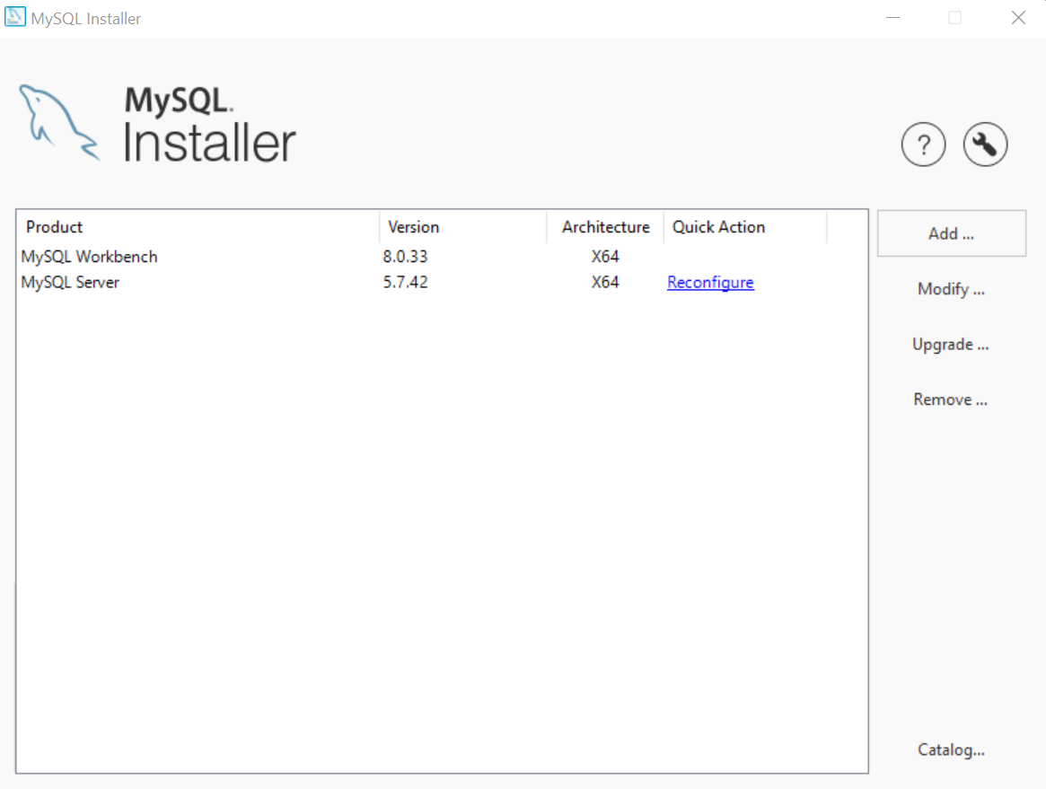

1: Download of product 'mysql-server' started from https://cdn.mysql.com/Downloads/MySQL-5.7/mysql-5.7.42-winx64.msi

1: Download of package 'MySQL Server 5.7.42' succeeded

2: Action 19:43:35: INSTALL.

2: 1: MySQL Workbench 8.0 CE 2: {4F41C0F4-388C-4160-9F2E-C8D945DDB54C}

2: Action 19:43:35: FindRelatedProducts. Searching for related applications

2: Action 19:43:35: AppSearch. Searching for installed applications

2: Action 19:43:35: SetWIX_IS_NETFRAMEWORK_45_OR_LATER_INSTALLED.

2: Action 19:43:35: LaunchConditions. Evaluating launch conditions

2: Action 19:43:35: ValidateProductID.

2: Action 19:43:35: CostInitialize. Computing space requirements

2: Action 19:43:35: FileCost. Computing space requirements

2: Action 19:43:35: CostFinalize. Computing space requirements

2: Action 19:43:35: MigrateFeatureStates. Migrating feature states from related applications

2: Action 19:43:35: InstallValidate. Validating install

2: Action 19:43:35: RemoveExistingProducts. Removing applications

2: Action 19:43:35: SetAdditionalCleanupDir1.

2: Action 19:43:35: SetAdditionalCleanupDir2.

2: Action 19:43:35: SetAdditionalCleanupDir3.

2: Action 19:43:35: InstallInitialize.

2: Action 19:43:35: ProcessComponents. Updating component registration

2: Action 19:43:36: GenerateScript. Generating script operations for action:

2: Updating component registration

2: Action 19:43:36: UnpublishFeatures. Unpublishing product features

2: Action 19:43:36: RemoveRegistryValues. Removing system registry values

2: Action 19:43:36: RemoveShortcuts. Removing shortcuts

2: Action 19:43:36: RemoveFiles. Removing files

2: Action 19:43:36: RemoveFolders. Removing folders

2: Action 19:43:36: CreateFolders. Creating folders

2: Folder: Creating folders

2: Action 19:43:36: InstallFiles. Copying new files

2: File: Copying new files, Directory: , Size:

2: Action 19:43:37: PrecompilePythonFiles.SetProperty.

2: Action 19:43:37: PrecompilePythonFiles.

2: Action 19:43:37: CreateShortcuts. Creating shortcuts

2: Shortcut: Creating shortcuts

2: Action 19:43:37: WriteRegistryValues. Writing system registry values

2: Key: Writing system registry values, Name: , Value:

2: Action 19:43:37: RegisterUser. Registering user

2: Action 19:43:37: RegisterProduct. Registering product

2: Registering product

2: Action 19:43:37: PublishFeatures. Publishing product features

2: Feature: Publishing product features

2: Action 19:43:37: PublishProduct. Publishing product information

2: Action 19:43:37: DeletePythonFolderOldInstall.SetProperty.

2: Action 19:43:37: DeletePythonFolderOldInstall.

2: Action 19:43:37: DeleteUtilitiesFolderOldInstall.SetProperty.

2: Action 19:43:37: DeleteUtilitiesFolderOldInstall.

2: Action 19:43:37: InstallFinalize.

2: Action 19:43:37: ProcessComponents. Updating component registration

2: Action 19:43:37: CreateFolders. Creating folders

2: Folder: C:\Program Files\MySQL\MySQL Workbench 8.0\data\

2: Action 19:43:37: InstallFiles. Copying new files

2: File: _asyncio.pyd, Directory: C:\Program Files\MySQL\MySQL Workbench 8.0\python\DLLs\, Size: 59904

2: File: _decimal.pyd, Directory: C:\Program Files\MySQL\MySQL Workbench 8.0\python\DLLs\, Size: 336384

2: File: _msi.pyd, Directory: C:\Program Files\MySQL\MySQL Workbench 8.0\python\DLLs\, Size: 32768

2: File: _overlapped.pyd, Directory: C:\Program Files\MySQL\MySQL Workbench 8.0\python\DLLs\, Size: 37376

2: File: _queue.pyd, Directory: C:\Program Files\MySQL\MySQL Workbench 8.0\python\DLLs\, Size: 21504

2: File: abc.py, Directory: C:\Program Files\MySQL\MySQL Workbench 8.0\python\lib\collections\, Size: 68

2: File: ac_charset.png, Directory: C:\Program Files\MySQL\MySQL Workbench 8.0\images\sql\, Size: 1769

2: File: ac_collation.png, Directory: C:\Program Files\MySQL\MySQL Workbench 8.0\images\sql\, Size: 1666

2: File: ac_column.png, Directory: C:\Program Files\MySQL\MySQL Workbench 8.0\images\sql\, Size: 1714

2: File: ac_engine.png, Directory: C:\Program Files\MySQL\MySQL Workbench 8.0\images\sql\, Size: 1694

2: File: ac_event.png, Directory: C:\Program Files\MySQL\MySQL Workbench 8.0\images\sql\, Size: 1673

2: File: ac_function.png, Directory: C:\Program Files\MySQL\MySQL Workbench 8.0\images\sql\, Size: 1582

2: File: ac_index.png, Directory: C:\Program Files\MySQL\MySQL Workbench 8.0\images\sql\, Size: 1666

2: File: ac_keyword.png, Directory: C:\Program Files\MySQL\MySQL Workbench 8.0\images\sql\, Size: 1756

2: File: ac_logfilegroup.png, Directory: C:\Program Files\MySQL\MySQL Workbench 8.0\images\sql\, Size: 1654

2: File: ac_operator.png, Directory: C:\Program Files\MySQL\MySQL Workbench 8.0\images\sql\, Size: 1678

2: File: ac_routine.png, Directory: C:\Program Files\MySQL\MySQL Workbench 8.0\images\sql\, Size: 1702

2: File: ac_schema.png, Directory: C:\Program Files\MySQL\MySQL Workbench 8.0\images\sql\, Size: 1802

2: File: ac_sysvar.png, Directory: C:\Program Files\MySQL\MySQL Workbench 8.0\images\sql\, Size: 1761

2: File: ac_table.png, Directory: C:\Program Files\MySQL\MySQL Workbench 8.0\images\sql\, Size: 1647

2: File: ac_tablespace.png, Directory: C:\Program Files\MySQL\MySQL Workbench 8.0\images\sql\, Size: 1639

2: File: ac_trigger.png, Directory: C:\Program Files\MySQL\MySQL Workbench 8.0\images\sql\, Size: 1600

2: File: ac_user.png, Directory: C:\Program Files\MySQL\MySQL Workbench 8.0\images\sql\, Size: 1741

2: File: ac_uservar.png, Directory: C:\Program Files\MySQL\MySQL Workbench 8.0\images\sql\, Size: 1723

2: File: ac_view.png, Directory: C:\Program Files\MySQL\MySQL Workbench 8.0\images\sql\, Size: 1713

2: File: authentication_kerberos_client.dll, Directory: C:\Program Files\MySQL\MySQL Workbench 8.0\, Size: 6269080

2: File: authentication_ldap_sasl_client.dll, Directory: C:\Program Files\MySQL\MySQL Workbench 8.0\, Size: 54424

2: File: ccapiserver.exe, Directory: C:\Program Files\MySQL\MySQL Workbench 8.0\, Size: 167024

2: File: comerr64.dll, Directory: C:\Program Files\MySQL\MySQL Workbench 8.0\, Size: 26216

2: File: dashboard_header_innodb_dark.png, Directory: C:\Program Files\MySQL\MySQL Workbench 8.0\images\icons\, Size: 4007

2: File: dashboard_header_innodb_light.png, Directory: C:\Program Files\MySQL\MySQL Workbench 8.0\images\icons\, Size: 3079

2: File: dashboard_header_mysql_dark.png, Directory: C:\Program Files\MySQL\MySQL Workbench 8.0\images\icons\, Size: 3454

2: File: dashboard_header_mysql_light.png, Directory: C:\Program Files\MySQL\MySQL Workbench 8.0\images\icons\, Size: 3241

2: File: dashboard_header_network_dark.png, Directory: C:\Program Files\MySQL\MySQL Workbench 8.0\images\icons\, Size: 3764

2: File: dashboard_header_network_light.png, Directory: C:\Program Files\MySQL\MySQL Workbench 8.0\images\icons\, Size: 2858

2: File: fido2.dll, Directory: C:\Program Files\MySQL\MySQL Workbench 8.0\, Size: 243816

2: File: wb_catalog_utils.py, Directory: C:\Program Files\MySQL\MySQL Workbench 8.0\modules\, Size: 8224

2: File: table_utils_grt.py, Directory: C:\Program Files\MySQL\MySQL Workbench 8.0\modules\, Size: 6675

2: File: wb_utils_grt.py, Directory: C:\Program Files\MySQL\MySQL Workbench 8.0\modules\, Size: 57110

2: File: wb_admin_grt.py, Directory: C:\Program Files\MySQL\MySQL Workbench 8.0\modules\, Size: 37385

2: File: wb_model_utils.py, Directory: C:\Program Files\MySQL\MySQL Workbench 8.0\modules\, Size: 11031

2: File: utilities.grt.dll, Directory: C:\Program Files\MySQL\MySQL Workbench 8.0\, Size: 34816

2: File: db.mysql.editors.wbp.be.dll, Directory: C:\Program Files\MySQL\MySQL Workbench 8.0\, Size: 428032

2: File: grt.dll, Directory: C:\Program Files\MySQL\MySQL Workbench 8.0\, Size: 856576

2: File: iconv.dll, Directory: C:\Program Files\MySQL\MySQL Workbench 8.0\, Size: 939520

2: File: libcairo.dll, Directory: C:\Program Files\MySQL\MySQL Workbench 8.0\, Size: 942080

2: File: cdbc.dll, Directory: C:\Program Files\MySQL\MySQL Workbench 8.0\, Size: 103936

2: File: db.mysql.editors.wbp.fe.dll, Directory: C:\Program Files\MySQL\MySQL Workbench 8.0\, Size: 280064

2: File: glib-2.0-0.dll, Directory: C:\Program Files\MySQL\MySQL Workbench 8.0\, Size: 1503232

2: File: gmodule-2.0-0.dll, Directory: C:\Program Files\MySQL\MySQL Workbench 8.0\, Size: 18432

2: File: gobject-2.0-0.dll, Directory: C:\Program Files\MySQL\MySQL Workbench 8.0\, Size: 395264

2: File: gthread-2.0-0.dll, Directory: C:\Program Files\MySQL\MySQL Workbench 8.0\, Size: 10752

2: File: libpng16.dll, Directory: C:\Program Files\MySQL\MySQL Workbench 8.0\, Size: 195072

2: File: libxml2.dll, Directory: C:\Program Files\MySQL\MySQL Workbench 8.0\, Size: 1412096

2: File: db.mysql.editors.wbp.wr.dll, Directory: C:\Program Files\MySQL\MySQL Workbench 8.0\, Size: 3024384

2: File: db.mysql.grt.dll, Directory: C:\Program Files\MySQL\MySQL Workbench 8.0\, Size: 519168

2: File: Aga.Controls.dll, Directory: C:\Program Files\MySQL\MySQL Workbench 8.0\, Size: 144896

2: File: MySQLCsUtilities.dll, Directory: C:\Program Files\MySQL\MySQL Workbench 8.0\, Size: 116736

2: File: WBControls.dll, Directory: C:\Program Files\MySQL\MySQL Workbench 8.0\, Size: 271872

2: File: WBControls.dll.config, Directory: C:\Program Files\MySQL\MySQL Workbench 8.0\, Size: 184

2: File: MySQLWorkbench.exe, Directory: C:\Program Files\MySQL\MySQL Workbench 8.0\, Size: 511488

2: File: db.search.wbp.dll, Directory: C:\Program Files\MySQL\MySQL Workbench 8.0\, Size: 223232

2: File: zip.dll, Directory: C:\Program Files\MySQL\MySQL Workbench 8.0\, Size: 103424

2: File: wb.model.editors.wbp.be.dll, Directory: C:\Program Files\MySQL\MySQL Workbench 8.0\, Size: 128000

2: File: wb.model.editors.wbp.fe.dll, Directory: C:\Program Files\MySQL\MySQL Workbench 8.0\, Size: 102400

2: File: wb.model.editors.wbp.wr.dll, Directory: C:\Program Files\MySQL\MySQL Workbench 8.0\, Size: 3017216

2: File: wb.model.grt.dll, Directory: C:\Program Files\MySQL\MySQL Workbench 8.0\, Size: 263168

2: File: base.dll, Directory: C:\Program Files\MySQL\MySQL Workbench 8.0\, Size: 558080

2: File: base.wr.dll, Directory: C:\Program Files\MySQL\MySQL Workbench 8.0\, Size: 388608

2: File: wb.printing.wbp.be.dll, Directory: C:\Program Files\MySQL\MySQL Workbench 8.0\, Size: 79872

2: File: wb.printing.wbp.fe.dll, Directory: C:\Program Files\MySQL\MySQL Workbench 8.0\, Size: 77824

2: File: wb.printing.wbp.wr.dll, Directory: C:\Program Files\MySQL\MySQL Workbench 8.0\, Size: 893440

2: File: zlib.dll, Directory: C:\Program Files\MySQL\MySQL Workbench 8.0\, Size: 83968

2: File: wb.py, Directory: C:\Program Files\MySQL\MySQL Workbench 8.0\, Size: 11963

2: File: mforms.py, Directory: C:\Program Files\MySQL\MySQL Workbench 8.0\, Size: 126368

2: File: cairo.py, Directory: C:\Program Files\MySQL\MySQL Workbench 8.0\, Size: 47673

2: File: db.mysql.query.grt.dll, Directory: C:\Program Files\MySQL\MySQL Workbench 8.0\, Size: 103424

2: File: _cairo.pyd, Directory: C:\Program Files\MySQL\MySQL Workbench 8.0\, Size: 271872

2: File: sshtunnel.py, Directory: C:\Program Files\MySQL\MySQL Workbench 8.0\, Size: 25889

2: File: _mforms.pyd, Directory: C:\Program Files\MySQL\MySQL Workbench 8.0\, Size: 1249792

2: File: python37.dll, Directory: C:\Program Files\MySQL\MySQL Workbench 8.0\, Size: 4610048

2: File: mysqldump.exe, Directory: C:\Program Files\MySQL\MySQL Workbench 8.0\, Size: 7290480

2: File: mysql.exe, Directory: C:\Program Files\MySQL\MySQL Workbench 8.0\, Size: 7331432

2: File: mysql_system_status.vbs, Directory: C:\Program Files\MySQL\MySQL Workbench 8.0\, Size: 2725

2: File: mysql_system_status_rmt.vbs, Directory: C:\Program Files\MySQL\MySQL Workbench 8.0\, Size: 2545

2: File: shell_snippets.py.txt, Directory: C:\Program Files\MySQL\MySQL Workbench 8.0\, Size: 1024

2: File: Scintilla.dll, Directory: C:\Program Files\MySQL\MySQL Workbench 8.0\, Size: 1574912

2: File: base.windows.dll, Directory: C:\Program Files\MySQL\MySQL Workbench 8.0\, Size: 115200

2: File: db_utils.py, Directory: C:\Program Files\MySQL\MySQL Workbench 8.0\, Size: 1503

2: File: grt_python_debugger.py, Directory: C:\Program Files\MySQL\MySQL Workbench 8.0\, Size: 16085

2: File: db.mysql.diff.reporting.wbp.dll, Directory: C:\Program Files\MySQL\MySQL Workbench 8.0\, Size: 224256

2: File: wbadminhelper.py, Directory: C:\Program Files\MySQL\MySQL Workbench 8.0\, Size: 9130

2: File: mforms.wr.dll, Directory: C:\Program Files\MySQL\MySQL Workbench 8.0\, Size: 4170240

2: File: wb.model.snippets.wbp.dll, Directory: C:\Program Files\MySQL\MySQL Workbench 8.0\, Size: 105472

2: File: HTMLRenderer.dll, Directory: C:\Program Files\MySQL\MySQL Workbench 8.0\, Size: 242176

2: File: parsers.dll, Directory: C:\Program Files\MySQL\MySQL Workbench 8.0\, Size: 3580928

2: File: wbadminhelper.exe, Directory: C:\Program Files\MySQL\MySQL Workbench 8.0\, Size: 18944

2: File: mysqlwbmeb.py, Directory: C:\Program Files\MySQL\MySQL Workbench 8.0\, Size: 38396

2: File: mysqlwbmeb.vbs, Directory: C:\Program Files\MySQL\MySQL Workbench 8.0\, Size: 45941

2: File: db.mysql.sqlparser.grt.dll, Directory: C:\Program Files\MySQL\MySQL Workbench 8.0\, Size: 2312704

2: File: vsqlite++.dll, Directory: C:\Program Files\MySQL\MySQL Workbench 8.0\, Size: 161280

2: File: antlr4-runtime.dll, Directory: C:\Program Files\MySQL\MySQL Workbench 8.0\, Size: 792064

2: File: db.mysql.parser.grt.dll, Directory: C:\Program Files\MySQL\MySQL Workbench 8.0\, Size: 1317376

2: File: db.mysql.wbp.dll, Directory: C:\Program Files\MySQL\MySQL Workbench 8.0\, Size: 861696

2: File: grt.db.fe.dll, Directory: C:\Program Files\MySQL\MySQL Workbench 8.0\, Size: 90624

2: File: mysql.forms.dll, Directory: C:\Program Files\MySQL\MySQL Workbench 8.0\, Size: 1013760

2: File: mysqlcppconn-9-vs14.dll, Directory: C:\Program Files\MySQL\MySQL Workbench 8.0\, Size: 9407488

2: File: sqlide.fe.dll, Directory: C:\Program Files\MySQL\MySQL Workbench 8.0\, Size: 84480

2: File: mysql.canvas.dll, Directory: C:\Program Files\MySQL\MySQL Workbench 8.0\, Size: 452608

2: File: Fedora_Linux_(MySQL_Package).xml, Directory: C:\Program Files\MySQL\MySQL Workbench 8.0\mysql.profiles\, Size: 545

2: File: CentOS_7_(MySQL_Package).xml, Directory: C:\Program Files\MySQL\MySQL Workbench 8.0\mysql.profiles\, Size: 599

2: File: Fedora_Linux_(Vendor_Package).xml, Directory: C:\Program Files\MySQL\MySQL Workbench 8.0\mysql.profiles\, Size: 545

2: File: Fedora_Linux_24_(Vendor_Package).xml, Directory: C:\Program Files\MySQL\MySQL Workbench 8.0\mysql.profiles\, Size: 539

2: File: Fedora_Linux_25_(Vendor_Package).xml, Directory: C:\Program Files\MySQL\MySQL Workbench 8.0\mysql.profiles\, Size: 543

2: File: FreeBSD_(MySQL_Package).xml, Directory: C:\Program Files\MySQL\MySQL Workbench 8.0\mysql.profiles\, Size: 579

2: File: Generic_Linux_(MySQL_tar_package).xml, Directory: C:\Program Files\MySQL\MySQL Workbench 8.0\mysql.profiles\, Size: 537

2: File: macOS_(MySQL_Package).xml, Directory: C:\Program Files\MySQL\MySQL Workbench 8.0\mysql.profiles\, Size: 642

2: File: OpenSolaris_(MySQL_Package).xml, Directory: C:\Program Files\MySQL\MySQL Workbench 8.0\mysql.profiles\, Size: 543

2: File: RHEL_(MySQL_Package).xml, Directory: C:\Program Files\MySQL\MySQL Workbench 8.0\mysql.profiles\, Size: 587

2: File: SLES_(MySQL_Package).xml, Directory: C:\Program Files\MySQL\MySQL Workbench 8.0\mysql.profiles\, Size: 537

2: File: Ubuntu_Linux_(MySQL_Package).xml, Directory: C:\Program Files\MySQL\MySQL Workbench 8.0\mysql.profiles\, Size: 512

2: File: Ubuntu_Linux_(sysvinit,_MySQL_Package).xml, Directory: C:\Program Files\MySQL\MySQL Workbench 8.0\mysql.profiles\, Size: 543

2: File: Ubuntu_Linux_(Vendor_Package).xml, Directory: C:\Program Files\MySQL\MySQL Workbench 8.0\mysql.profiles\, Size: 519

2: File: Ubuntu_Linux_(sysvinit,_Vendor_Package).xml, Directory: C:\Program Files\MySQL\MySQL Workbench 8.0\mysql.profiles\, Size: 543

2: File: Linux_(Custom).xml, Directory: C:\Program Files\MySQL\MySQL Workbench 8.0\mysql.profiles\, Size: 537

2: File: Windows_x64_(MySQL_x86_zip_Package).xml, Directory: C:\Program Files\MySQL\MySQL Workbench 8.0\mysql.profiles\, Size: 629

2: File: Windows_(MySQL_5.5_Installer_Package).xml, Directory: C:\Program Files\MySQL\MySQL Workbench 8.0\mysql.profiles\, Size: 623

2: File: Windows_(MySQL_5.6_Installer_Package).xml, Directory: C:\Program Files\MySQL\MySQL Workbench 8.0\mysql.profiles\, Size: 623

2: File: Windows_(MySQL_5.7_Installer_Package).xml, Directory: C:\Program Files\MySQL\MySQL Workbench 8.0\mysql.profiles\, Size: 625

2: File: Windows_(MySQL_8.0_Installer_Package).xml, Directory: C:\Program Files\MySQL\MySQL Workbench 8.0\mysql.profiles\, Size: 625

2: File: Oracle_Linux_6_(MySQL_Package).xml, Directory: C:\Program Files\MySQL\MySQL Workbench 8.0\mysql.profiles\, Size: 587

2: File: Oracle_Linux_7_(MySQL_Package).xml, Directory: C:\Program Files\MySQL\MySQL Workbench 8.0\mysql.profiles\, Size: 581

2: File: RHEL_7_(MySQL_Package).xml, Directory: C:\Program Files\MySQL\MySQL Workbench 8.0\mysql.profiles\, Size: 581

2: File: MySQL_Sandbox_Linux(MySQL_tar_package).xml, Directory: C:\Program Files\MySQL\MySQL Workbench 8.0\mysql.profiles\, Size: 611

2: File: MySQL_Sandbox_MacOS(MySQL_tar_package).xml, Directory: C:\Program Files\MySQL\MySQL Workbench 8.0\mysql.profiles\, Size: 612

2: File: WbPlugins.dll, Directory: C:\Program Files\MySQL\MySQL Workbench 8.0\, Size: 196096

2: File: wbprivate.be.dll, Directory: C:\Program Files\MySQL\MySQL Workbench 8.0\, Size: 4970496

2: File: wbprivate.wr.dll, Directory: C:\Program Files\MySQL\MySQL Workbench 8.0\, Size: 4890624

2: File: wbpublic.be.dll, Directory: C:\Program Files\MySQL\MySQL Workbench 8.0\, Size: 3352576

2: File: wbpublic.wr.dll, Directory: C:\Program Files\MySQL\MySQL Workbench 8.0\, Size: 5105152

2: File: structs.app.xml, Directory: C:\Program Files\MySQL\MySQL Workbench 8.0\structs\, Size: 14304

2: File: structs.db.mgmt.xml, Directory: C:\Program Files\MySQL\MySQL Workbench 8.0\structs\, Size: 15628

2: File: structs.db.migration.xml, Directory: C:\Program Files\MySQL\MySQL Workbench 8.0\structs\, Size: 7764

2: File: structs.db.mssql.xml, Directory: C:\Program Files\MySQL\MySQL Workbench 8.0\structs\, Size: 4384

2: File: structs.db.mysql.xml, Directory: C:\Program Files\MySQL\MySQL Workbench 8.0\structs\, Size: 12179

2: File: structs.db.oracle.xml, Directory: C:\Program Files\MySQL\MySQL Workbench 8.0\structs\, Size: 8498

2: File: structs.db.query.xml, Directory: C:\Program Files\MySQL\MySQL Workbench 8.0\structs\, Size: 20608

2: File: structs.db.sybase.xml, Directory: C:\Program Files\MySQL\MySQL Workbench 8.0\structs\, Size: 4636

2: File: structs.db.xml, Directory: C:\Program Files\MySQL\MySQL Workbench 8.0\structs\, Size: 32348

2: File: structs.eer.xml, Directory: C:\Program Files\MySQL\MySQL Workbench 8.0\structs\, Size: 3313

2: File: structs.model.xml, Directory: C:\Program Files\MySQL\MySQL Workbench 8.0\structs\, Size: 10340

2: File: structs.workbench.logical.xml, Directory: C:\Program Files\MySQL\MySQL Workbench 8.0\structs\, Size: 3653

2: File: structs.workbench.model.reporting.xml, Directory: C:\Program Files\MySQL\MySQL Workbench 8.0\structs\, Size: 1778

2: File: structs.workbench.model.xml, Directory: C:\Program Files\MySQL\MySQL Workbench 8.0\structs\, Size: 1339

2: File: structs.workbench.physical.xml, Directory: C:\Program Files\MySQL\MySQL Workbench 8.0\structs\, Size: 9087

2: File: structs.workbench.xml, Directory: C:\Program Files\MySQL\MySQL Workbench 8.0\structs\, Size: 4220

2: File: structs.xml, Directory: C:\Program Files\MySQL\MySQL Workbench 8.0\structs\, Size: 4484

2: File: structs.meta.xml, Directory: C:\Program Files\MySQL\MySQL Workbench 8.0\structs\, Size: 853

2: File: structs.ui.xml, Directory: C:\Program Files\MySQL\MySQL Workbench 8.0\structs\, Size: 2319

2: File: structs.wrapper.xml, Directory: C:\Program Files\MySQL\MySQL Workbench 8.0\structs\, Size: 1908

2: File: SQL DDL Statements.txt, Directory: C:\Program Files\MySQL\MySQL Workbench 8.0\snippets\, Size: 9700

2: File: SQL DML Statements.txt, Directory: C:\Program Files\MySQL\MySQL Workbench 8.0\snippets\, Size: 3814

2: File: DB Management.txt, Directory: C:\Program Files\MySQL\MySQL Workbench 8.0\snippets\, Size: 2564

2: File: eer_model_object_grt.py.txt, Directory: C:\Program Files\MySQL\MySQL Workbench 8.0\script_templates\, Size: 642

2: File: eer_model_utility_grt.py.txt, Directory: C:\Program Files\MySQL\MySQL Workbench 8.0\script_templates\, Size: 39

2: File: generic_grt.py.txt, Directory: C:\Program Files\MySQL\MySQL Workbench 8.0\script_templates\, Size: 531

2: File: sql_editor_catalog_grt.py.txt, Directory: C:\Program Files\MySQL\MySQL Workbench 8.0\script_templates\, Size: 726

2: File: sql_editor_filter_grt.py.txt, Directory: C:\Program Files\MySQL\MySQL Workbench 8.0\script_templates\, Size: 520

2: File: sql_editor_resultset_grt.py.txt, Directory: C:\Program Files\MySQL\MySQL Workbench 8.0\script_templates\, Size: 604

2: File: sql_editor_utility_grt.py.txt, Directory: C:\Program Files\MySQL\MySQL Workbench 8.0\script_templates\, Size: 39

2: File: __init__.py, Directory: C:\Program Files\MySQL\MySQL Workbench 8.0\workbench\, Size: 1151

2: File: db_driver.py, Directory: C:\Program Files\MySQL\MySQL Workbench 8.0\workbench\, Size: 4592

2: File: ui.py, Directory: C:\Program Files\MySQL\MySQL Workbench 8.0\workbench\, Size: 1543

2: File: database_object_selector_widget.py, Directory: C:\Program Files\MySQL\MySQL Workbench 8.0\workbench\, Size: 17050

2: File: wizard_page_widget.py, Directory: C:\Program Files\MySQL\MySQL Workbench 8.0\workbench\, Size: 4817

2: File: wizard_progress_page_widget.py, Directory: C:\Program Files\MySQL\MySQL Workbench 8.0\workbench\, Size: 22918

2: File: exceptions.py, Directory: C:\Program Files\MySQL\MySQL Workbench 8.0\workbench\, Size: 1197

2: File: database_schema_selector_widget.py, Directory: C:\Program Files\MySQL\MySQL Workbench 8.0\workbench\, Size: 11368

2: File: utils.py, Directory: C:\Program Files\MySQL\MySQL Workbench 8.0\workbench\, Size: 13601

2: File: db_utils.py, Directory: C:\Program Files\MySQL\MySQL Workbench 8.0\workbench\, Size: 13784

2: File: template.py, Directory: C:\Program Files\MySQL\MySQL Workbench 8.0\workbench\, Size: 9720

2: File: notifications.py, Directory: C:\Program Files\MySQL\MySQL Workbench 8.0\workbench\, Size: 2426

2: File: tcp_utils.py, Directory: C:\Program Files\MySQL\MySQL Workbench 8.0\workbench\, Size: 13752

2: File: plugins.py, Directory: C:\Program Files\MySQL\MySQL Workbench 8.0\workbench\, Size: 1680

2: File: os_utils.py, Directory: C:\Program Files\MySQL\MySQL Workbench 8.0\workbench\, Size: 13299

2: File: change_tracker.py, Directory: C:\Program Files\MySQL\MySQL Workbench 8.0\workbench\, Size: 11795

2: File: client_utils.py, Directory: C:\Program Files\MySQL\MySQL Workbench 8.0\workbench\, Size: 16014

2: File: log.py, Directory: C:\Program Files\MySQL\MySQL Workbench 8.0\workbench\, Size: 2087

2: File: wizard_form.py, Directory: C:\Program Files\MySQL\MySQL Workbench 8.0\workbench\, Size: 3486

2: File: __init__.py, Directory: C:\Program Files\MySQL\MySQL Workbench 8.0\workbench\graphics\, Size: 1151

2: File: canvas.py, Directory: C:\Program Files\MySQL\MySQL Workbench 8.0\workbench\graphics\, Size: 18071

2: File: cairo_utils.py, Directory: C:\Program Files\MySQL\MySQL Workbench 8.0\workbench\graphics\, Size: 19843

2: File: charting.py, Directory: C:\Program Files\MySQL\MySQL Workbench 8.0\workbench\graphics\, Size: 16818

2: File: db_datatype_groups.xml, Directory: C:\Program Files\MySQL\MySQL Workbench 8.0\data\, Size: 3067

2: File: main_menu.xml, Directory: C:\Program Files\MySQL\MySQL Workbench 8.0\data\, Size: 208985

2: File: model_toolbar.xml, Directory: C:\Program Files\MySQL\MySQL Workbench 8.0\data\, Size: 10770

2: File: model_option_toolbar_layer.xml, Directory: C:\Program Files\MySQL\MySQL Workbench 8.0\data\, Size: 816

2: File: model_option_toolbar_note.xml, Directory: C:\Program Files\MySQL\MySQL Workbench 8.0\data\, Size: 1414

2: File: model_option_toolbar_physical_relationship.xml, Directory: C:\Program Files\MySQL\MySQL Workbench 8.0\data\, Size: 1600

2: File: model_option_toolbar_physical_routinegroup.xml, Directory: C:\Program Files\MySQL\MySQL Workbench 8.0\data\, Size: 2319

2: File: model_option_toolbar_physical_table.xml, Directory: C:\Program Files\MySQL\MySQL Workbench 8.0\data\, Size: 6195

2: File: model_option_toolbar_physical_view.xml, Directory: C:\Program Files\MySQL\MySQL Workbench 8.0\data\, Size: 2198

2: File: model_option_toolbar_selection.xml, Directory: C:\Program Files\MySQL\MySQL Workbench 8.0\data\, Size: 911

2: File: paper_types.xml, Directory: C:\Program Files\MySQL\MySQL Workbench 8.0\data\, Size: 6869

2: File: shortcuts.xml, Directory: C:\Program Files\MySQL\MySQL Workbench 8.0\data\, Size: 147

2: File: shortcuts_basic.xml, Directory: C:\Program Files\MySQL\MySQL Workbench 8.0\data\, Size: 3683

2: File: shortcuts_physical.xml, Directory: C:\Program Files\MySQL\MySQL Workbench 8.0\data\, Size: 3689

2: File: tools_toolbar.xml, Directory: C:\Program Files\MySQL\MySQL Workbench 8.0\data\, Size: 959

2: File: tools_toolbar_basic.xml, Directory: C:\Program Files\MySQL\MySQL Workbench 8.0\data\, Size: 4458

2: File: tools_toolbar_physical.xml, Directory: C:\Program Files\MySQL\MySQL Workbench 8.0\data\, Size: 7812

2: File: data.db, Directory: C:\Program Files\MySQL\MySQL Workbench 8.0\data\, Size: 3072

2: File: default_toolbar.xml, Directory: C:\Program Files\MySQL\MySQL Workbench 8.0\data\, Size: 2296

2: File: dbquery_toolbar.xml, Directory: C:\Program Files\MySQL\MySQL Workbench 8.0\data\, Size: 13013

2: File: model_diagram_toolbar.xml, Directory: C:\Program Files\MySQL\MySQL Workbench 8.0\data\, Size: 9810

2: File: code_editor.xml, Directory: C:\Program Files\MySQL\MySQL Workbench 8.0\data\, Size: 24738

2: File: table_templates.xml, Directory: C:\Program Files\MySQL\MySQL Workbench 8.0\data\, Size: 21438

2: File: grt_list.png, Directory: C:\Program Files\MySQL\MySQL Workbench 8.0\images\grt\, Size: 862

2: File: grt_dict.png, Directory: C:\Program Files\MySQL\MySQL Workbench 8.0\images\grt\, Size: 875

2: File: grt_object.png, Directory: C:\Program Files\MySQL\MySQL Workbench 8.0\images\grt\, Size: 936

2: File: grt_simple_type.png, Directory: C:\Program Files\MySQL\MySQL Workbench 8.0\images\grt\, Size: 491

2: File: grt_struct.png, Directory: C:\Program Files\MySQL\MySQL Workbench 8.0\images\grt\, Size: 946

2: File: grt_module.png, Directory: C:\Program Files\MySQL\MySQL Workbench 8.0\images\grt\, Size: 735

2: File: grt_function.png, Directory: C:\Program Files\MySQL\MySQL Workbench 8.0\images\grt\, Size: 306

2: File: db.Column.11x11.png, Directory: C:\Program Files\MySQL\MySQL Workbench 8.0\images\grt\structs\, Size: 373

2: File: db.Column.16x16.png, Directory: C:\Program Files\MySQL\MySQL Workbench 8.0\images\grt\structs\, Size: 427

2: File: db.Column.fk.11x11.png, Directory: C:\Program Files\MySQL\MySQL Workbench 8.0\images\grt\structs\, Size: 412

2: File: db.Column.fk.16x16.png, Directory: C:\Program Files\MySQL\MySQL Workbench 8.0\images\grt\structs\, Size: 442

2: File: db.Column.pk.11x11.png, Directory: C:\Program Files\MySQL\MySQL Workbench 8.0\images\grt\structs\, Size: 377

2: File: db.Column.pk.16x16.png, Directory: C:\Program Files\MySQL\MySQL Workbench 8.0\images\grt\structs\, Size: 560

2: File: db.Role.16x16.png, Directory: C:\Program Files\MySQL\MySQL Workbench 8.0\images\grt\structs\, Size: 571

2: File: db.Role.48x48.png, Directory: C:\Program Files\MySQL\MySQL Workbench 8.0\images\grt\structs\, Size: 3189

2: File: db.Role.add.16x16.png, Directory: C:\Program Files\MySQL\MySQL Workbench 8.0\images\grt\structs\, Size: 627

2: File: db.Role.add.48x48.png, Directory: C:\Program Files\MySQL\MySQL Workbench 8.0\images\grt\structs\, Size: 3238

2: File: db.Role.editor.48x48.png, Directory: C:\Program Files\MySQL\MySQL Workbench 8.0\images\grt\structs\, Size: 3848

2: File: db.Routine.16x16.png, Directory: C:\Program Files\MySQL\MySQL Workbench 8.0\images\grt\structs\, Size: 656

2: File: db.Routine.24x24.png, Directory: C:\Program Files\MySQL\MySQL Workbench 8.0\images\grt\structs\, Size: 778

2: File: db.Routine.64x64.png, Directory: C:\Program Files\MySQL\MySQL Workbench 8.0\images\grt\structs\, Size: 2542

2: File: db.Routine.add.16x16.png, Directory: C:\Program Files\MySQL\MySQL Workbench 8.0\images\grt\structs\, Size: 608

2: File: db.Routine.editor.48x48.png, Directory: C:\Program Files\MySQL\MySQL Workbench 8.0\images\grt\structs\, Size: 3524

2: File: db.Routine.many.32x32.png, Directory: C:\Program Files\MySQL\MySQL Workbench 8.0\images\grt\structs\, Size: 1217

2: File: db.RoutineGroup.16x16.png, Directory: C:\Program Files\MySQL\MySQL Workbench 8.0\images\grt\structs\, Size: 808

2: File: db.RoutineGroup.add.16x16.png, Directory: C:\Program Files\MySQL\MySQL Workbench 8.0\images\grt\structs\, Size: 699

2: File: db.Schema.16x16.png, Directory: C:\Program Files\MySQL\MySQL Workbench 8.0\images\grt\structs\, Size: 759

2: File: db.Schema.24x24.png, Directory: C:\Program Files\MySQL\MySQL Workbench 8.0\images\grt\structs\, Size: 1107

2: File: db.Schema.32x32.png, Directory: C:\Program Files\MySQL\MySQL Workbench 8.0\images\grt\structs\, Size: 1583

2: File: db.Schema.add.32x32.png, Directory: C:\Program Files\MySQL\MySQL Workbench 8.0\images\grt\structs\, Size: 1303

2: File: db.Schema.editor.48x48.png, Directory: C:\Program Files\MySQL\MySQL Workbench 8.0\images\grt\structs\, Size: 3572

2: File: db.Schema.many.16x16.png, Directory: C:\Program Files\MySQL\MySQL Workbench 8.0\images\grt\structs\, Size: 974

2: File: db.Schema.many.32x32.png, Directory: C:\Program Files\MySQL\MySQL Workbench 8.0\images\grt\structs\, Size: 1836

2: File: db.Script.48x48.png, Directory: C:\Program Files\MySQL\MySQL Workbench 8.0\images\grt\structs\, Size: 1882

2: File: db.Script.add.48x48.png, Directory: C:\Program Files\MySQL\MySQL Workbench 8.0\images\grt\structs\, Size: 1653

2: File: db.Table.16x16.png, Directory: C:\Program Files\MySQL\MySQL Workbench 8.0\images\grt\structs\, Size: 543

2: File: db.Table.24x24.png, Directory: C:\Program Files\MySQL\MySQL Workbench 8.0\images\grt\structs\, Size: 853

2: File: db.Table.add.16x16.png, Directory: C:\Program Files\MySQL\MySQL Workbench 8.0\images\grt\structs\, Size: 498

2: File: db.Table.editor.48x48.png, Directory: C:\Program Files\MySQL\MySQL Workbench 8.0\images\grt\structs\, Size: 3965

2: File: db.Table.many.32x32.png, Directory: C:\Program Files\MySQL\MySQL Workbench 8.0\images\grt\structs\, Size: 1255

2: File: db.User.16x16.png, Directory: C:\Program Files\MySQL\MySQL Workbench 8.0\images\grt\structs\, Size: 411

2: File: db.User.48x48.png, Directory: C:\Program Files\MySQL\MySQL Workbench 8.0\images\grt\structs\, Size: 854

2: File: db.User.add.16x16.png, Directory: C:\Program Files\MySQL\MySQL Workbench 8.0\images\grt\structs\, Size: 444

2: File: db.User.add.48x48.png, Directory: C:\Program Files\MySQL\MySQL Workbench 8.0\images\grt\structs\, Size: 829

2: File: db.User.editor.48x48.png, Directory: C:\Program Files\MySQL\MySQL Workbench 8.0\images\grt\structs\, Size: 2566

2: File: db.View.16x16.png, Directory: C:\Program Files\MySQL\MySQL Workbench 8.0\images\grt\structs\, Size: 539

2: File: db.View.24x24.png, Directory: C:\Program Files\MySQL\MySQL Workbench 8.0\images\grt\structs\, Size: 673

2: File: db.View.64x64.png, Directory: C:\Program Files\MySQL\MySQL Workbench 8.0\images\grt\structs\, Size: 2245

2: File: db.View.add.16x16.png, Directory: C:\Program Files\MySQL\MySQL Workbench 8.0\images\grt\structs\, Size: 489

2: File: db.View.editor.48x48.png, Directory: C:\Program Files\MySQL\MySQL Workbench 8.0\images\grt\structs\, Size: 3340

2: File: db.View.many.32x32.png, Directory: C:\Program Files\MySQL\MySQL Workbench 8.0\images\grt\structs\, Size: 1281

2: File: GrtObject.16x16.png, Directory: C:\Program Files\MySQL\MySQL Workbench 8.0\images\grt\structs\, Size: 921

2: File: GrtObject.24x24.png, Directory: C:\Program Files\MySQL\MySQL Workbench 8.0\images\grt\structs\, Size: 1517

2: File: GrtObject.32x32.png, Directory: C:\Program Files\MySQL\MySQL Workbench 8.0\images\grt\structs\, Size: 2459

2: File: GrtObject.48x48.png, Directory: C:\Program Files\MySQL\MySQL Workbench 8.0\images\grt\structs\, Size: 4074

2: File: GrtObject.add.16x16.png, Directory: C:\Program Files\MySQL\MySQL Workbench 8.0\images\grt\structs\, Size: 784

2: File: GrtObject.add.24x24.png, Directory: C:\Program Files\MySQL\MySQL Workbench 8.0\images\grt\structs\, Size: 1227

2: File: GrtObject.add.32x32.png, Directory: C:\Program Files\MySQL\MySQL Workbench 8.0\images\grt\structs\, Size: 1869

2: File: GrtObject.add.48x48.png, Directory: C:\Program Files\MySQL\MySQL Workbench 8.0\images\grt\structs\, Size: 2973

2: File: GrtObject.many_32x32.png, Directory: C:\Program Files\MySQL\MySQL Workbench 8.0\images\grt\structs\, Size: 2381

2: File: GrtStoredNote.48x48.png, Directory: C:\Program Files\MySQL\MySQL Workbench 8.0\images\grt\structs\, Size: 2318

2: File: GrtStoredNote.add.48x48.png, Directory: C:\Program Files\MySQL\MySQL Workbench 8.0\images\grt\structs\, Size: 2051

2: File: workbench.logical.Model.16x16.png, Directory: C:\Program Files\MySQL\MySQL Workbench 8.0\images\grt\structs\, Size: 840

2: File: workbench.logical.Model.48x48.png, Directory: C:\Program Files\MySQL\MySQL Workbench 8.0\images\grt\structs\, Size: 2852

2: File: workbench.logical.Diagram.16x16.png, Directory: C:\Program Files\MySQL\MySQL Workbench 8.0\images\grt\structs\, Size: 661

2: File: workbench.logical.Diagram.48x48.png, Directory: C:\Program Files\MySQL\MySQL Workbench 8.0\images\grt\structs\, Size: 1591

2: File: workbench.logical.Diagram.add.48x48.png, Directory: C:\Program Files\MySQL\MySQL Workbench 8.0\images\grt\structs\, Size: 1367

2: File: workbench.model.ImageFigure.16x16.png, Directory: C:\Program Files\MySQL\MySQL Workbench 8.0\images\grt\structs\, Size: 652

2: File: workbench.physical.Layer.16x16.png, Directory: C:\Program Files\MySQL\MySQL Workbench 8.0\images\grt\structs\, Size: 358

2: File: workbench.physical.Layer.24x24.png, Directory: C:\Program Files\MySQL\MySQL Workbench 8.0\images\grt\structs\, Size: 647

2: File: workbench.physical.Layer.many.16x16.png, Directory: C:\Program Files\MySQL\MySQL Workbench 8.0\images\grt\structs\, Size: 628

2: File: workbench.model.NoteFigure.16x16.png, Directory: C:\Program Files\MySQL\MySQL Workbench 8.0\images\grt\structs\, Size: 500

2: File: workbench.physical.db2.Model.48x48.png, Directory: C:\Program Files\MySQL\MySQL Workbench 8.0\images\grt\structs\, Size: 2791

2: File: workbench.physical.Model.16x16.png, Directory: C:\Program Files\MySQL\MySQL Workbench 8.0\images\grt\structs\, Size: 835

2: File: workbench.physical.Model.48x48.png, Directory: C:\Program Files\MySQL\MySQL Workbench 8.0\images\grt\structs\, Size: 2882

2: File: workbench.physical.mssql.Model.48x48.png, Directory: C:\Program Files\MySQL\MySQL Workbench 8.0\images\grt\structs\, Size: 2948

2: File: workbench.physical.mysql.Model.16x16.png, Directory: C:\Program Files\MySQL\MySQL Workbench 8.0\images\grt\structs\, Size: 874

2: File: workbench.physical.mysql.Model.48x48.png, Directory: C:\Program Files\MySQL\MySQL Workbench 8.0\images\grt\structs\, Size: 3383

2: File: workbench.physical.oracle.Model.48x48.png, Directory: C:\Program Files\MySQL\MySQL Workbench 8.0\images\grt\structs\, Size: 3114

2: File: workbench.physical.RoutineGroupFigure.16x16.png, Directory: C:\Program Files\MySQL\MySQL Workbench 8.0\images\grt\structs\, Size: 761

2: File: workbench.physical.sqlite.Model.48x48.png, Directory: C:\Program Files\MySQL\MySQL Workbench 8.0\images\grt\structs\, Size: 2888

2: File: workbench.physical.sybase.Model.48x48.png, Directory: C:\Program Files\MySQL\MySQL Workbench 8.0\images\grt\structs\, Size: 2934

2: File: workbench.physical.TableFigure.16x16.png, Directory: C:\Program Files\MySQL\MySQL Workbench 8.0\images\grt\structs\, Size: 576

2: File: workbench.physical.Diagram.16x16.png, Directory: C:\Program Files\MySQL\MySQL Workbench 8.0\images\grt\structs\, Size: 676

2: File: workbench.physical.Diagram.48x48.png, Directory: C:\Program Files\MySQL\MySQL Workbench 8.0\images\grt\structs\, Size: 1648

2: File: workbench.physical.Diagram.add.48x48.png, Directory: C:\Program Files\MySQL\MySQL Workbench 8.0\images\grt\structs\, Size: 1410

2: File: workbench.physical.ViewFigure.16x16.png, Directory: C:\Program Files\MySQL\MySQL Workbench 8.0\images\grt\structs\, Size: 611

2: File: db.View.48x48.png, Directory: C:\Program Files\MySQL\MySQL Workbench 8.0\images\grt\structs\, Size: 1838

2: File: db.View.add.48x48.png, Directory: C:\Program Files\MySQL\MySQL Workbench 8.0\images\grt\structs\, Size: 1294

2: File: db.Routine.48x48.png, Directory: C:\Program Files\MySQL\MySQL Workbench 8.0\images\grt\structs\, Size: 2121

2: File: db.Routine.add.48x48.png, Directory: C:\Program Files\MySQL\MySQL Workbench 8.0\images\grt\structs\, Size: 1612

2: File: db.RoutineGroup.48x48.png, Directory: C:\Program Files\MySQL\MySQL Workbench 8.0\images\grt\structs\, Size: 2328

2: File: db.RoutineGroup.add.48x48.png, Directory: C:\Program Files\MySQL\MySQL Workbench 8.0\images\grt\structs\, Size: 1791

2: File: db.Table.48x48.png, Directory: C:\Program Files\MySQL\MySQL Workbench 8.0\images\grt\structs\, Size: 2864

2: File: db.Table.add.48x48.png, Directory: C:\Program Files\MySQL\MySQL Workbench 8.0\images\grt\structs\, Size: 1807

2: File: workbench.physical.Diagram.add.16x16.png, Directory: C:\Program Files\MySQL\MySQL Workbench 8.0\images\grt\structs\, Size: 689

2: File: db.Column.fknn.11x11.png, Directory: C:\Program Files\MySQL\MySQL Workbench 8.0\images\grt\structs\, Size: 438

2: File: db.Column.fknn.16x16.png, Directory: C:\Program Files\MySQL\MySQL Workbench 8.0\images\grt\structs\, Size: 473

2: File: db.Column.nn.11x11.png, Directory: C:\Program Files\MySQL\MySQL Workbench 8.0\images\grt\structs\, Size: 420

2: File: db.Column.nn.16x16.png, Directory: C:\Program Files\MySQL\MySQL Workbench 8.0\images\grt\structs\, Size: 449

2: File: db.DatatypeGroup.datetime.16x16.png, Directory: C:\Program Files\MySQL\MySQL Workbench 8.0\images\grt\structs\, Size: 1003

2: File: db.DatatypeGroup.geo.16x16.png, Directory: C:\Program Files\MySQL\MySQL Workbench 8.0\images\grt\structs\, Size: 926

2: File: db.DatatypeGroup.numeric.16x16.png, Directory: C:\Program Files\MySQL\MySQL Workbench 8.0\images\grt\structs\, Size: 878

2: File: db.DatatypeGroup.text.16x16.png, Directory: C:\Program Files\MySQL\MySQL Workbench 8.0\images\grt\structs\, Size: 820

2: File: db.DatatypeGroup.userdefined.16x16.png, Directory: C:\Program Files\MySQL\MySQL Workbench 8.0\images\grt\structs\, Size: 900

2: File: db.DatatypeGroup.blob.16x16.png, Directory: C:\Program Files\MySQL\MySQL Workbench 8.0\images\grt\structs\, Size: 659

2: File: db.mgmt.Connection.add.48x48.png, Directory: C:\Program Files\MySQL\MySQL Workbench 8.0\images\grt\structs\, Size: 1935

2: File: db.mgmt.Connection.16x16.png, Directory: C:\Program Files\MySQL\MySQL Workbench 8.0\images\grt\structs\, Size: 754

2: File: db.mgmt.Connection.32x32.png, Directory: C:\Program Files\MySQL\MySQL Workbench 8.0\images\grt\structs\, Size: 1542

2: File: workbench.Document.16x16.png, Directory: C:\Program Files\MySQL\MySQL Workbench 8.0\images\grt\structs\, Size: 4088

2: File: db.mgmt.Connection.add.16x16.png, Directory: C:\Program Files\MySQL\MySQL Workbench 8.0\images\grt\structs\, Size: 678

2: File: db.mgmt.Connection.48x48.png, Directory: C:\Program Files\MySQL\MySQL Workbench 8.0\images\grt\structs\, Size: 4081

2: File: workbench.Document.48x48.png, Directory: C:\Program Files\MySQL\MySQL Workbench 8.0\images\grt\structs\, Size: 6029

2: File: workbench.Document.32x32.png, Directory: C:\Program Files\MySQL\MySQL Workbench 8.0\images\grt\structs\, Size: 5076

2: File: db.View.many.16x16.png, Directory: C:\Program Files\MySQL\MySQL Workbench 8.0\images\grt\structs\, Size: 912

2: File: db.Table.many.16x16.png, Directory: C:\Program Files\MySQL\MySQL Workbench 8.0\images\grt\structs\, Size: 841

2: File: db.Routine.many.16x16.png, Directory: C:\Program Files\MySQL\MySQL Workbench 8.0\images\grt\structs\, Size: 935

2: File: db.mgmt.Connection.manage.48x48.png, Directory: C:\Program Files\MySQL\MySQL Workbench 8.0\images\grt\structs\, Size: 2106

2: File: db.Column.pkai.11x11.png, Directory: C:\Program Files\MySQL\MySQL Workbench 8.0\images\grt\structs\, Size: 402

2: File: db.Column.pkai.16x16.png, Directory: C:\Program Files\MySQL\MySQL Workbench 8.0\images\grt\structs\, Size: 569

2: File: db.mgmt.ServerInstance.48x48.png, Directory: C:\Program Files\MySQL\MySQL Workbench 8.0\images\grt\structs\, Size: 3759

2: File: db.mgmt.ServerInstance.manage.48x48.png, Directory: C:\Program Files\MySQL\MySQL Workbench 8.0\images\grt\structs\, Size: 2230

2: File: db.Schema.selected.32x32.png, Directory: C:\Program Files\MySQL\MySQL Workbench 8.0\images\grt\structs\, Size: 1935

2: File: db.Column.fk.side.16x16.png, Directory: C:\Program Files\MySQL\MySQL Workbench 8.0\images\grt\structs\, Size: 1254

2: File: db.Column.pk.side.16x16.png, Directory: C:\Program Files\MySQL\MySQL Workbench 8.0\images\grt\structs\, Size: 1322

2: File: db.Column.side.16x16.png, Directory: C:\Program Files\MySQL\MySQL Workbench 8.0\images\grt\structs\, Size: 1244

2: File: db.Routine.many.side.16x16.png, Directory: C:\Program Files\MySQL\MySQL Workbench 8.0\images\grt\structs\, Size: 1404

2: File: db.Routine.side.16x16.png, Directory: C:\Program Files\MySQL\MySQL Workbench 8.0\images\grt\structs\, Size: 1291

2: File: db.Schema.side.16x16.png, Directory: C:\Program Files\MySQL\MySQL Workbench 8.0\images\grt\structs\, Size: 1578

2: File: db.Table.many.side.16x16.png, Directory: C:\Program Files\MySQL\MySQL Workbench 8.0\images\grt\structs\, Size: 1336

2: File: db.Table.side.16x16.png, Directory: C:\Program Files\MySQL\MySQL Workbench 8.0\images\grt\structs\, Size: 1221

2: File: db.View.many.side.16x16.png, Directory: C:\Program Files\MySQL\MySQL Workbench 8.0\images\grt\structs\, Size: 1365

2: File: db.View.side.16x16.png, Directory: C:\Program Files\MySQL\MySQL Workbench 8.0\images\grt\structs\, Size: 1260

2: File: db.Column.many.side.16x16.png, Directory: C:\Program Files\MySQL\MySQL Workbench 8.0\images\grt\structs\, Size: 1418

2: File: db.ForeignKey.many.side.16x16.png, Directory: C:\Program Files\MySQL\MySQL Workbench 8.0\images\grt\structs\, Size: 1341

2: File: db.ForeignKey.side.16x16.png, Directory: C:\Program Files\MySQL\MySQL Workbench 8.0\images\grt\structs\, Size: 1305

2: File: db.Index.many.side.16x16.png, Directory: C:\Program Files\MySQL\MySQL Workbench 8.0\images\grt\structs\, Size: 1415

2: File: db.Index.side.16x16.png, Directory: C:\Program Files\MySQL\MySQL Workbench 8.0\images\grt\structs\, Size: 1390

2: File: db.Trigger.many.side.16x16.png, Directory: C:\Program Files\MySQL\MySQL Workbench 8.0\images\grt\structs\, Size: 1495

2: File: db.Trigger.side.16x16.png, Directory: C:\Program Files\MySQL\MySQL Workbench 8.0\images\grt\structs\, Size: 1540

2: File: db.Table.editor.24x24.png, Directory: C:\Program Files\MySQL\MySQL Workbench 8.0\images\grt\structs\, Size: 3540

2: File: db.View.broken.side.16x16.png, Directory: C:\Program Files\MySQL\MySQL Workbench 8.0\images\grt\structs\, Size: 1345

2: File: db.Index.16x16.png, Directory: C:\Program Files\MySQL\MySQL Workbench 8.0\images\grt\structs\, Size: 1694

2: File: db.ForeignKey.16x16.png, Directory: C:\Program Files\MySQL\MySQL Workbench 8.0\images\grt\structs\, Size: 1488

2: File: db.Trigger.16x16.png, Directory: C:\Program Files\MySQL\MySQL Workbench 8.0\images\grt\structs\, Size: 1802

2: File: db.schema.loading.side.16x16.png, Directory: C:\Program Files\MySQL\MySQL Workbench 8.0\images\grt\structs\, Size: 1724

2: File: db.Table.32x32.png, Directory: C:\Program Files\MySQL\MySQL Workbench 8.0\images\grt\structs\, Size: 1883

2: File: db.schema.unloaded.side.16x16.png, Directory: C:\Program Files\MySQL\MySQL Workbench 8.0\images\grt\structs\, Size: 1569

2: File: db.Column.pkfk.11x11.png, Directory: C:\Program Files\MySQL\MySQL Workbench 8.0\images\grt\structs\, Size: 4102

2: File: db.Column.pkfk.16x16.png, Directory: C:\Program Files\MySQL\MySQL Workbench 8.0\images\grt\structs\, Size: 4282

2: File: admin_info_stopped.png, Directory: C:\Program Files\MySQL\MySQL Workbench 8.0\images\icons\, Size: 2558

2: File: admin_info_running.png, Directory: C:\Program Files\MySQL\MySQL Workbench 8.0\images\icons\, Size: 2977

2: File: admin_info_offline.png, Directory: C:\Program Files\MySQL\MySQL Workbench 8.0\images\icons\, Size: 3060

2: File: admin_meb_backup.png, Directory: C:\Program Files\MySQL\MySQL Workbench 8.0\images\icons\, Size: 1424

2: File: admin_meb_restore.png, Directory: C:\Program Files\MySQL\MySQL Workbench 8.0\images\icons\, Size: 1413

2: File: admin_info_unknown.png, Directory: C:\Program Files\MySQL\MySQL Workbench 8.0\images\icons\, Size: 2912

2: File: MySQLWorkbench.ico, Directory: C:\Program Files\MySQL\MySQL Workbench 8.0\images\icons\, Size: 44189

2: File: MySQLWorkbench-256.png, Directory: C:\Program Files\MySQL\MySQL Workbench 8.0\images\icons\, Size: 16365

2: File: MySQLWorkbench-512.png, Directory: C:\Program Files\MySQL\MySQL Workbench 8.0\images\icons\, Size: 30664

2: File: tiny_new.png, Directory: C:\Program Files\MySQL\MySQL Workbench 8.0\images\icons\, Size: 748

2: File: tiny_new_diagram.png, Directory: C:\Program Files\MySQL\MySQL Workbench 8.0\images\icons\, Size: 707

2: File: tiny_new_doc.png, Directory: C:\Program Files\MySQL\MySQL Workbench 8.0\images\icons\, Size: 523

2: File: tiny_new_routine.png, Directory: C:\Program Files\MySQL\MySQL Workbench 8.0\images\icons\, Size: 833

2: File: tiny_new_schema.png, Directory: C:\Program Files\MySQL\MySQL Workbench 8.0\images\icons\, Size: 889

2: File: tiny_new_script.png, Directory: C:\Program Files\MySQL\MySQL Workbench 8.0\images\icons\, Size: 785

2: File: tiny_new_table.png, Directory: C:\Program Files\MySQL\MySQL Workbench 8.0\images\icons\, Size: 757

2: File: tiny_new_view.png, Directory: C:\Program Files\MySQL\MySQL Workbench 8.0\images\icons\, Size: 759

2: File: tiny_refresh.png, Directory: C:\Program Files\MySQL\MySQL Workbench 8.0\images\icons\, Size: 1640

2: File: tiny_refresh_plugins.png, Directory: C:\Program Files\MySQL\MySQL Workbench 8.0\images\icons\, Size: 1002

2: File: tiny_search.png, Directory: C:\Program Files\MySQL\MySQL Workbench 8.0\images\icons\, Size: 970

2: File: record_add.png, Directory: C:\Program Files\MySQL\MySQL Workbench 8.0\images\icons\, Size: 1382

2: File: record_back.png, Directory: C:\Program Files\MySQL\MySQL Workbench 8.0\images\icons\, Size: 1188

2: File: record_del.png, Directory: C:\Program Files\MySQL\MySQL Workbench 8.0\images\icons\, Size: 1300

2: File: record_discard.png, Directory: C:\Program Files\MySQL\MySQL Workbench 8.0\images\icons\, Size: 795

2: File: record_edit.png, Directory: C:\Program Files\MySQL\MySQL Workbench 8.0\images\icons\, Size: 1578

2: File: record_export.png, Directory: C:\Program Files\MySQL\MySQL Workbench 8.0\images\icons\, Size: 1497

2: File: record_import.png, Directory: C:\Program Files\MySQL\MySQL Workbench 8.0\images\icons\, Size: 1549

2: File: record_fetch_all.png, Directory: C:\Program Files\MySQL\MySQL Workbench 8.0\images\icons\, Size: 1350

2: File: record_first.png, Directory: C:\Program Files\MySQL\MySQL Workbench 8.0\images\icons\, Size: 1275

2: File: record_last.png, Directory: C:\Program Files\MySQL\MySQL Workbench 8.0\images\icons\, Size: 1279

2: File: record_next.png, Directory: C:\Program Files\MySQL\MySQL Workbench 8.0\images\icons\, Size: 1196

2: File: record_save.png, Directory: C:\Program Files\MySQL\MySQL Workbench 8.0\images\icons\, Size: 789

2: File: record_sort_asc.png, Directory: C:\Program Files\MySQL\MySQL Workbench 8.0\images\icons\, Size: 698

2: File: record_sort_desc.png, Directory: C:\Program Files\MySQL\MySQL Workbench 8.0\images\icons\, Size: 696

2: File: record_sort_reset.png, Directory: C:\Program Files\MySQL\MySQL Workbench 8.0\images\icons\, Size: 1346

2: File: record_wrap_vertical.png, Directory: C:\Program Files\MySQL\MySQL Workbench 8.0\images\icons\, Size: 288

2: File: snippet_add.png, Directory: C:\Program Files\MySQL\MySQL Workbench 8.0\images\icons\, Size: 773

2: File: snippet_del.png, Directory: C:\Program Files\MySQL\MySQL Workbench 8.0\images\icons\, Size: 688

2: File: tiny_align_h_left.png, Directory: C:\Program Files\MySQL\MySQL Workbench 8.0\images\icons\, Size: 531

2: File: snippet_insert.png, Directory: C:\Program Files\MySQL\MySQL Workbench 8.0\images\icons\, Size: 997

2: File: snippet_use.png, Directory: C:\Program Files\MySQL\MySQL Workbench 8.0\images\icons\, Size: 972

2: File: record_fetch_prev.png, Directory: C:\Program Files\MySQL\MySQL Workbench 8.0\images\icons\, Size: 1388

2: File: record_fetch_next.png, Directory: C:\Program Files\MySQL\MySQL Workbench 8.0\images\icons\, Size: 1399

2: File: tiny_load.png, Directory: C:\Program Files\MySQL\MySQL Workbench 8.0\images\icons\, Size: 1628

2: File: snippet_clipboard.png, Directory: C:\Program Files\MySQL\MySQL Workbench 8.0\images\icons\, Size: 1722

2: File: debug_continue.png, Directory: C:\Program Files\MySQL\MySQL Workbench 8.0\images\icons\, Size: 1570

2: File: debug_pause.png, Directory: C:\Program Files\MySQL\MySQL Workbench 8.0\images\icons\, Size: 1281

2: File: debug_step.png, Directory: C:\Program Files\MySQL\MySQL Workbench 8.0\images\icons\, Size: 1648

2: File: tiny_align_h_left2.png, Directory: C:\Program Files\MySQL\MySQL Workbench 8.0\images\icons\, Size: 499

2: File: debug_step_into.png, Directory: C:\Program Files\MySQL\MySQL Workbench 8.0\images\icons\, Size: 1685

2: File: debug_step_out.png, Directory: C:\Program Files\MySQL\MySQL Workbench 8.0\images\icons\, Size: 1634

2: File: debug_stop.png, Directory: C:\Program Files\MySQL\MySQL Workbench 8.0\images\icons\, Size: 1262

2: File: warning_icon.png, Directory: C:\Program Files\MySQL\MySQL Workbench 8.0\images\icons\, Size: 8916

2: File: admin_add_user.png, Directory: C:\Program Files\MySQL\MySQL Workbench 8.0\images\icons\, Size: 1521

2: File: admin_config_wizard.png, Directory: C:\Program Files\MySQL\MySQL Workbench 8.0\images\icons\, Size: 1654

2: File: admin_export.png, Directory: C:\Program Files\MySQL\MySQL Workbench 8.0\images\icons\, Size: 1542

2: File: tiny_align_h_middle.png, Directory: C:\Program Files\MySQL\MySQL Workbench 8.0\images\icons\, Size: 589

2: File: admin_manage_exported.png, Directory: C:\Program Files\MySQL\MySQL Workbench 8.0\images\icons\, Size: 1692

2: File: admin_manage_privs.png, Directory: C:\Program Files\MySQL\MySQL Workbench 8.0\images\icons\, Size: 1423

2: File: admin_connections.png, Directory: C:\Program Files\MySQL\MySQL Workbench 8.0\images\icons\, Size: 1474

2: File: admin_option_file.png, Directory: C:\Program Files\MySQL\MySQL Workbench 8.0\images\icons\, Size: 1516

2: File: admin_restore_data.png, Directory: C:\Program Files\MySQL\MySQL Workbench 8.0\images\icons\, Size: 1536

2: File: tiny_align_h_middle2.png, Directory: C:\Program Files\MySQL\MySQL Workbench 8.0\images\icons\, Size: 566

2: File: admin_schema_management.png, Directory: C:\Program Files\MySQL\MySQL Workbench 8.0\images\icons\, Size: 1644

2: File: admin_scripts.png, Directory: C:\Program Files\MySQL\MySQL Workbench 8.0\images\icons\, Size: 1497

2: File: admin_server_logs.png, Directory: C:\Program Files\MySQL\MySQL Workbench 8.0\images\icons\, Size: 1502

2: File: admin_server_status.png, Directory: C:\Program Files\MySQL\MySQL Workbench 8.0\images\icons\, Size: 1662

2: File: admin_start_stop.png, Directory: C:\Program Files\MySQL\MySQL Workbench 8.0\images\icons\, Size: 1414

2: File: tiny_align_h_right.png, Directory: C:\Program Files\MySQL\MySQL Workbench 8.0\images\icons\, Size: 543

2: File: admin_status_vars.png, Directory: C:\Program Files\MySQL\MySQL Workbench 8.0\images\icons\, Size: 1385

2: File: admin_system_startup.png, Directory: C:\Program Files\MySQL\MySQL Workbench 8.0\images\icons\, Size: 1726

2: File: tiny_align_h_right2.png, Directory: C:\Program Files\MySQL\MySQL Workbench 8.0\images\icons\, Size: 516

2: File: MySQLPlugin-16.png, Directory: C:\Program Files\MySQL\MySQL Workbench 8.0\images\icons\, Size: 1732

2: File: MySQLPlugin-24.png, Directory: C:\Program Files\MySQL\MySQL Workbench 8.0\images\icons\, Size: 2279

2: File: MySQLPlugin-32.png, Directory: C:\Program Files\MySQL\MySQL Workbench 8.0\images\icons\, Size: 3097

2: File: MySQLPlugin-48.png, Directory: C:\Program Files\MySQL\MySQL Workbench 8.0\images\icons\, Size: 4611

2: File: MySQLPlugin-64.png, Directory: C:\Program Files\MySQL\MySQL Workbench 8.0\images\icons\, Size: 6138

2: File: MySQLPlugin-128.png, Directory: C:\Program Files\MySQL\MySQL Workbench 8.0\images\icons\, Size: 13381

2: File: MySQLPlugin-256.png, Directory: C:\Program Files\MySQL\MySQL Workbench 8.0\images\icons\, Size: 32643

2: File: mini_edit.png, Directory: C:\Program Files\MySQL\MySQL Workbench 8.0\images\icons\, Size: 1287

2: File: mini_ok.png, Directory: C:\Program Files\MySQL\MySQL Workbench 8.0\images\icons\, Size: 1353

2: File: tiny_align_v_bottom.png, Directory: C:\Program Files\MySQL\MySQL Workbench 8.0\images\icons\, Size: 470

2: File: record_autosize.png, Directory: C:\Program Files\MySQL\MySQL Workbench 8.0\images\icons\, Size: 1195

2: File: migration_check_open.png, Directory: C:\Program Files\MySQL\MySQL Workbench 8.0\images\icons\, Size: 1543

2: File: migration.png, Directory: C:\Program Files\MySQL\MySQL Workbench 8.0\images\icons\, Size: 1685

2: File: migration_title.png, Directory: C:\Program Files\MySQL\MySQL Workbench 8.0\images\icons\, Size: 5884

2: File: migration_check_current.png, Directory: C:\Program Files\MySQL\MySQL Workbench 8.0\images\icons\, Size: 1599

2: File: migration_check_done.png, Directory: C:\Program Files\MySQL\MySQL Workbench 8.0\images\icons\, Size: 1630

2: File: migration_logo.png, Directory: C:\Program Files\MySQL\MySQL Workbench 8.0\images\icons\, Size: 3417

2: File: migration_check_point.png, Directory: C:\Program Files\MySQL\MySQL Workbench 8.0\images\icons\, Size: 1585

2: File: migration_icon_32x32.png, Directory: C:\Program Files\MySQL\MySQL Workbench 8.0\images\icons\, Size: 2434

2: File: tiny_align_v_bottom2.png, Directory: C:\Program Files\MySQL\MySQL Workbench 8.0\images\icons\, Size: 571

2: File: migration_background.png, Directory: C:\Program Files\MySQL\MySQL Workbench 8.0\images\icons\, Size: 17395

2: File: tiny_more_space.png, Directory: C:\Program Files\MySQL\MySQL Workbench 8.0\images\icons\, Size: 4151

2: File: tiny_less_space.png, Directory: C:\Program Files\MySQL\MySQL Workbench 8.0\images\icons\, Size: 4152

2: File: wb-toolbar_nav-back.png, Directory: C:\Program Files\MySQL\MySQL Workbench 8.0\images\icons\, Size: 1213

2: File: wb-toolbar_nav-forward.png, Directory: C:\Program Files\MySQL\MySQL Workbench 8.0\images\icons\, Size: 1223

2: File: tiny_align_v_middle.png, Directory: C:\Program Files\MySQL\MySQL Workbench 8.0\images\icons\, Size: 503

2: File: tiny_align_v_middle2.png, Directory: C:\Program Files\MySQL\MySQL Workbench 8.0\images\icons\, Size: 617

2: File: tiny_align_v_top.png, Directory: C:\Program Files\MySQL\MySQL Workbench 8.0\images\icons\, Size: 471

2: File: tiny_gridview.png, Directory: C:\Program Files\MySQL\MySQL Workbench 8.0\images\icons\, Size: 3182

2: File: tiny_align_v_top2.png, Directory: C:\Program Files\MySQL\MySQL Workbench 8.0\images\icons\, Size: 595

2: File: tiny_grid.png, Directory: C:\Program Files\MySQL\MySQL Workbench 8.0\images\icons\, Size: 425

2: File: tiny_lock.png, Directory: C:\Program Files\MySQL\MySQL Workbench 8.0\images\icons\, Size: 478

2: File: tiny_open.png, Directory: C:\Program Files\MySQL\MySQL Workbench 8.0\images\icons\, Size: 845

2: File: tiny_redo.png, Directory: C:\Program Files\MySQL\MySQL Workbench 8.0\images\icons\, Size: 534

2: File: tiny_ruler.png, Directory: C:\Program Files\MySQL\MySQL Workbench 8.0\images\icons\, Size: 339

2: File: tiny_save.png, Directory: C:\Program Files\MySQL\MySQL Workbench 8.0\images\icons\, Size: 767

2: File: tiny_undo.png, Directory: C:\Program Files\MySQL\MySQL Workbench 8.0\images\icons\, Size: 547

2: File: tiny_loadsql.png, Directory: C:\Program Files\MySQL\MySQL Workbench 8.0\images\icons\, Size: 832

2: File: tiny_savesql.png, Directory: C:\Program Files\MySQL\MySQL Workbench 8.0\images\icons\, Size: 812

2: File: clear_output.png, Directory: C:\Program Files\MySQL\MySQL Workbench 8.0\images\icons\, Size: 619

2: File: wb_arrow.png, Directory: C:\Program Files\MySQL\MySQL Workbench 8.0\images\icons\, Size: 494

2: File: wb_db_routinegroup.png, Directory: C:\Program Files\MySQL\MySQL Workbench 8.0\images\icons\, Size: 699

2: File: wb_db_table.png, Directory: C:\Program Files\MySQL\MySQL Workbench 8.0\images\icons\, Size: 449

2: File: wb_db_view.png, Directory: C:\Program Files\MySQL\MySQL Workbench 8.0\images\icons\, Size: 607

2: File: wb_draw_ellipse.png, Directory: C:\Program Files\MySQL\MySQL Workbench 8.0\images\icons\, Size: 599

2: File: wb_draw_freehand.png, Directory: C:\Program Files\MySQL\MySQL Workbench 8.0\images\icons\, Size: 621

2: File: wb_draw_line.png, Directory: C:\Program Files\MySQL\MySQL Workbench 8.0\images\icons\, Size: 455

2: File: wb_draw_polygon.png, Directory: C:\Program Files\MySQL\MySQL Workbench 8.0\images\icons\, Size: 561

2: File: wb_draw_rect.png, Directory: C:\Program Files\MySQL\MySQL Workbench 8.0\images\icons\, Size: 330

2: File: wb_hand.png, Directory: C:\Program Files\MySQL\MySQL Workbench 8.0\images\icons\, Size: 727

2: File: wb_image.png, Directory: C:\Program Files\MySQL\MySQL Workbench 8.0\images\icons\, Size: 536

2: File: wb_layer.png, Directory: C:\Program Files\MySQL\MySQL Workbench 8.0\images\icons\, Size: 444

2: File: wb_magnifier.png, Directory: C:\Program Files\MySQL\MySQL Workbench 8.0\images\icons\, Size: 546

2: File: wb_note.png, Directory: C:\Program Files\MySQL\MySQL Workbench 8.0\images\icons\, Size: 476

2: File: wb_rel_11.png, Directory: C:\Program Files\MySQL\MySQL Workbench 8.0\images\icons\, Size: 273

2: File: wb_rel_11_dark.png, Directory: C:\Program Files\MySQL\MySQL Workbench 8.0\images\icons\, Size: 278

2: File: wb_rel_11_nonid.png, Directory: C:\Program Files\MySQL\MySQL Workbench 8.0\images\icons\, Size: 306

2: File: wb_rel_11_nonid_dark.png, Directory: C:\Program Files\MySQL\MySQL Workbench 8.0\images\icons\, Size: 324

2: File: wb_rel_1n.png, Directory: C:\Program Files\MySQL\MySQL Workbench 8.0\images\icons\, Size: 351

2: File: wb_rel_1n_dark.png, Directory: C:\Program Files\MySQL\MySQL Workbench 8.0\images\icons\, Size: 342

2: File: wb_rel_1n_nonid.png, Directory: C:\Program Files\MySQL\MySQL Workbench 8.0\images\icons\, Size: 376

2: File: wb_rel_1n_nonid_dark.png, Directory: C:\Program Files\MySQL\MySQL Workbench 8.0\images\icons\, Size: 368

2: File: wb_rel_1n_pick.png, Directory: C:\Program Files\MySQL\MySQL Workbench 8.0\images\icons\, Size: 668

2: File: wb_rel_1n_pick_dark.png, Directory: C:\Program Files\MySQL\MySQL Workbench 8.0\images\icons\, Size: 656

2: File: wb_rel_nm.png, Directory: C:\Program Files\MySQL\MySQL Workbench 8.0\images\icons\, Size: 426

2: File: wb_rel_nm_dark.png, Directory: C:\Program Files\MySQL\MySQL Workbench 8.0\images\icons\, Size: 401

2: File: wb_rubber.png, Directory: C:\Program Files\MySQL\MySQL Workbench 8.0\images\icons\, Size: 573

2: File: mini_error.png, Directory: C:\Program Files\MySQL\MySQL Workbench 8.0\images\icons\, Size: 1361

2: File: mini_warning.png, Directory: C:\Program Files\MySQL\MySQL Workbench 8.0\images\icons\, Size: 1255

2: File: mini_notice.png, Directory: C:\Program Files\MySQL\MySQL Workbench 8.0\images\icons\, Size: 2939

2: File: tiny_hidesidebar.png, Directory: C:\Program Files\MySQL\MySQL Workbench 8.0\images\icons\, Size: 577

2: File: Apply.png, Directory: C:\Program Files\MySQL\MySQL Workbench 8.0\images\ui\, Size: 246

2: File: Apply_16x16.png, Directory: C:\Program Files\MySQL\MySQL Workbench 8.0\images\ui\, Size: 228

2: File: background.png, Directory: C:\Program Files\MySQL\MySQL Workbench 8.0\images\ui\, Size: 3486

2: File: background_top_shadow.png, Directory: C:\Program Files\MySQL\MySQL Workbench 8.0\images\ui\, Size: 1169

2: File: Close_18x18.png, Directory: C:\Program Files\MySQL\MySQL Workbench 8.0\images\ui\, Size: 357

2: File: collapsing_panel_bg.png, Directory: C:\Program Files\MySQL\MySQL Workbench 8.0\images\ui\, Size: 1626

2: File: collapsing_panel_grid_bg.png, Directory: C:\Program Files\MySQL\MySQL Workbench 8.0\images\ui\, Size: 218

2: File: collapsing_panel_grid_details.png, Directory: C:\Program Files\MySQL\MySQL Workbench 8.0\images\ui\, Size: 162

2: File: collapsing_panel_grid_details2.png, Directory: C:\Program Files\MySQL\MySQL Workbench 8.0\images\ui\, Size: 286

2: File: tiny_grtshell.png, Directory: C:\Program Files\MySQL\MySQL Workbench 8.0\images\icons\, Size: 452

2: File: collapsing_panel_grid_large_icons.png, Directory: C:\Program Files\MySQL\MySQL Workbench 8.0\images\ui\, Size: 194

2: File: collapsing_panel_grid_large_icons2.png, Directory: C:\Program Files\MySQL\MySQL Workbench 8.0\images\ui\, Size: 377

2: File: collapsing_panel_grid_small_icons.png, Directory: C:\Program Files\MySQL\MySQL Workbench 8.0\images\ui\, Size: 182

2: File: collapsing_panel_grid_small_icons2.png, Directory: C:\Program Files\MySQL\MySQL Workbench 8.0\images\ui\, Size: 677

2: File: collapsing_panel_header_bg.png, Directory: C:\Program Files\MySQL\MySQL Workbench 8.0\images\ui\, Size: 241

2: File: collapsing_panel_header_bg_flat.png, Directory: C:\Program Files\MySQL\MySQL Workbench 8.0\images\ui\, Size: 179

2: File: collapsing_panel_header_shadow.png, Directory: C:\Program Files\MySQL\MySQL Workbench 8.0\images\ui\, Size: 381

2: File: collapsing_panel_header_tab_add.png, Directory: C:\Program Files\MySQL\MySQL Workbench 8.0\images\ui\, Size: 872

2: File: collapsing_panel_header_tab_add2.png, Directory: C:\Program Files\MySQL\MySQL Workbench 8.0\images\ui\, Size: 784

2: File: collapsing_panel_header_tab_del.png, Directory: C:\Program Files\MySQL\MySQL Workbench 8.0\images\ui\, Size: 859

2: File: mini_notice_blue.png, Directory: C:\Program Files\MySQL\MySQL Workbench 8.0\images\icons\, Size: 1151

2: File: collapsing_panel_header_tab_del2.png, Directory: C:\Program Files\MySQL\MySQL Workbench 8.0\images\ui\, Size: 767

2: File: collapsing_panel_header_tab_left.png, Directory: C:\Program Files\MySQL\MySQL Workbench 8.0\images\ui\, Size: 191

2: File: collapsing_panel_header_tab_left_flat.png, Directory: C:\Program Files\MySQL\MySQL Workbench 8.0\images\ui\, Size: 150

2: File: collapsing_panel_header_tab_middle.png, Directory: C:\Program Files\MySQL\MySQL Workbench 8.0\images\ui\, Size: 371

2: File: collapsing_panel_header_tab_middle_flat.png, Directory: C:\Program Files\MySQL\MySQL Workbench 8.0\images\ui\, Size: 204

2: File: collapsing_panel_header_tab_right.png, Directory: C:\Program Files\MySQL\MySQL Workbench 8.0\images\ui\, Size: 189

2: File: collapsing_panel_header_tab_right_flat.png, Directory: C:\Program Files\MySQL\MySQL Workbench 8.0\images\ui\, Size: 150

2: File: collapsing_panel_header_tab_separator.png, Directory: C:\Program Files\MySQL\MySQL Workbench 8.0\images\ui\, Size: 174

2: File: collapsing_panel_header_tab_separator_flat.png, Directory: C:\Program Files\MySQL\MySQL Workbench 8.0\images\ui\, Size: 144

2: File: collapsing_panel_minus.png, Directory: C:\Program Files\MySQL\MySQL Workbench 8.0\images\ui\, Size: 163

2: File: tiny_saveas.png, Directory: C:\Program Files\MySQL\MySQL Workbench 8.0\images\icons\, Size: 829

2: File: collapsing_panel_minus_flat.png, Directory: C:\Program Files\MySQL\MySQL Workbench 8.0\images\ui\, Size: 232

2: File: collapsing_panel_plus.png, Directory: C:\Program Files\MySQL\MySQL Workbench 8.0\images\ui\, Size: 175

2: File: collapsing_panel_plus_flat.png, Directory: C:\Program Files\MySQL\MySQL Workbench 8.0\images\ui\, Size: 246

2: File: collapsing_panel_tab_left.png, Directory: C:\Program Files\MySQL\MySQL Workbench 8.0\images\ui\, Size: 170

2: File: collapsing_panel_tab_middle.png, Directory: C:\Program Files\MySQL\MySQL Workbench 8.0\images\ui\, Size: 1642

2: File: collapsing_panel_tab_right.png, Directory: C:\Program Files\MySQL\MySQL Workbench 8.0\images\ui\, Size: 167

2: File: dialog_input.png, Directory: C:\Program Files\MySQL\MySQL Workbench 8.0\images\ui\, Size: 981

2: File: Discard.png, Directory: C:\Program Files\MySQL\MySQL Workbench 8.0\images\ui\, Size: 297

2: File: Discard_16x16.png, Directory: C:\Program Files\MySQL\MySQL Workbench 8.0\images\ui\, Size: 281

2: File: comment.png, Directory: C:\Program Files\MySQL\MySQL Workbench 8.0\images\icons\, Size: 541

2: File: DotBlue.png, Directory: C:\Program Files\MySQL\MySQL Workbench 8.0\images\ui\, Size: 504

2: File: DotDisabled.png, Directory: C:\Program Files\MySQL\MySQL Workbench 8.0\images\ui\, Size: 367

2: File: DotGrey.png, Directory: C:\Program Files\MySQL\MySQL Workbench 8.0\images\ui\, Size: 467

2: File: DotRed.png, Directory: C:\Program Files\MySQL\MySQL Workbench 8.0\images\ui\, Size: 672

2: File: field_overlay_blob.png, Directory: C:\Program Files\MySQL\MySQL Workbench 8.0\images\ui\, Size: 899

2: File: field_overlay_null.png, Directory: C:\Program Files\MySQL\MySQL Workbench 8.0\images\ui\, Size: 187

2: File: First_16x16.png, Directory: C:\Program Files\MySQL\MySQL Workbench 8.0\images\ui\, Size: 207

2: File: header_bar_blue.png, Directory: C:\Program Files\MySQL\MySQL Workbench 8.0\images\ui\, Size: 488

2: File: grt.png, Directory: C:\Program Files\MySQL\MySQL Workbench 8.0\images\icons\, Size: 647

2: File: header_bar_gray.png, Directory: C:\Program Files\MySQL\MySQL Workbench 8.0\images\ui\, Size: 281

2: File: header_bar_orange.png, Directory: C:\Program Files\MySQL\MySQL Workbench 8.0\images\ui\, Size: 489

2: File: Last_16x16.png, Directory: C:\Program Files\MySQL\MySQL Workbench 8.0\images\ui\, Size: 204

2: File: MacWizardBackground.png, Directory: C:\Program Files\MySQL\MySQL Workbench 8.0\images\ui\, Size: 43834

2: File: message_edit.png, Directory: C:\Program Files\MySQL\MySQL Workbench 8.0\images\ui\, Size: 967

2: File: navigator_zoom_in.png, Directory: C:\Program Files\MySQL\MySQL Workbench 8.0\images\ui\, Size: 688

2: File: history.png, Directory: C:\Program Files\MySQL\MySQL Workbench 8.0\images\icons\, Size: 526

2: File: navigator_zoom_out.png, Directory: C:\Program Files\MySQL\MySQL Workbench 8.0\images\ui\, Size: 652

2: File: note.128x128.png, Directory: C:\Program Files\MySQL\MySQL Workbench 8.0\images\ui\, Size: 3060

2: File: Refresh_16x16.png, Directory: C:\Program Files\MySQL\MySQL Workbench 8.0\images\ui\, Size: 319

2: File: Refresh_18x18.png, Directory: C:\Program Files\MySQL\MySQL Workbench 8.0\images\ui\, Size: 648

2: File: Refresh_disabled_18x18.png, Directory: C:\Program Files\MySQL\MySQL Workbench 8.0\images\ui\, Size: 3296

2: File: sakila.png, Directory: C:\Program Files\MySQL\MySQL Workbench 8.0\images\ui\, Size: 1365

2: File: layers.png, Directory: C:\Program Files\MySQL\MySQL Workbench 8.0\images\icons\, Size: 556

2: File: search_clear.png, Directory: C:\Program Files\MySQL\MySQL Workbench 8.0\images\ui\, Size: 484

2: File: search_doc_action.png, Directory: C:\Program Files\MySQL\MySQL Workbench 8.0\images\ui\, Size: 350

2: File: search_icon.png, Directory: C:\Program Files\MySQL\MySQL Workbench 8.0\images\ui\, Size: 1022

2: File: section_expanded.png, Directory: C:\Program Files\MySQL\MySQL Workbench 8.0\images\ui\, Size: 2912

2: File: section_unexpandable.png, Directory: C:\Program Files\MySQL\MySQL Workbench 8.0\images\ui\, Size: 2765

2: File: section_unexpanded.png, Directory: C:\Program Files\MySQL\MySQL Workbench 8.0\images\ui\, Size: 2922

2: File: separator-dots.png, Directory: C:\Program Files\MySQL\MySQL Workbench 8.0\images\ui\, Size: 121

2: File: MySQLWorkbench-128.png, Directory: C:\Program Files\MySQL\MySQL Workbench 8.0\images\icons\, Size: 8412

2: File: show_eof.png, Directory: C:\Program Files\MySQL\MySQL Workbench 8.0\images\ui\, Size: 817

2: File: show_whitespace.png, Directory: C:\Program Files\MySQL\MySQL Workbench 8.0\images\ui\, Size: 692

2: File: small_toolbar_bg.png, Directory: C:\Program Files\MySQL\MySQL Workbench 8.0\images\ui\, Size: 195

2: File: statusbar_output.png, Directory: C:\Program Files\MySQL\MySQL Workbench 8.0\images\ui\, Size: 231

2: File: statusbar_separator.png, Directory: C:\Program Files\MySQL\MySQL Workbench 8.0\images\ui\, Size: 145

2: File: statusbar_shell.png, Directory: C:\Program Files\MySQL\MySQL Workbench 8.0\images\ui\, Size: 318

2: File: tab.diagram.16x16.png, Directory: C:\Program Files\MySQL\MySQL Workbench 8.0\images\ui\, Size: 501

2: File: tab.overview.home.16x16.png, Directory: C:\Program Files\MySQL\MySQL Workbench 8.0\images\ui\, Size: 565

2: File: tab.overview.physical.16x16.png, Directory: C:\Program Files\MySQL\MySQL Workbench 8.0\images\ui\, Size: 684

2: File: tab.sqlquery.16x16.png, Directory: C:\Program Files\MySQL\MySQL Workbench 8.0\images\ui\, Size: 856

2: File: MySQLWorkbench-16.png, Directory: C:\Program Files\MySQL\MySQL Workbench 8.0\images\icons\, Size: 2667

2: File: task_checked.png, Directory: C:\Program Files\MySQL\MySQL Workbench 8.0\images\ui\, Size: 675

2: File: task_disabled.png, Directory: C:\Program Files\MySQL\MySQL Workbench 8.0\images\ui\, Size: 497

2: File: task_error.png, Directory: C:\Program Files\MySQL\MySQL Workbench 8.0\images\ui\, Size: 616

2: File: task_executing.png, Directory: C:\Program Files\MySQL\MySQL Workbench 8.0\images\ui\, Size: 608

2: File: task_unchecked.png, Directory: C:\Program Files\MySQL\MySQL Workbench 8.0\images\ui\, Size: 506

2: File: task_warning.png, Directory: C:\Program Files\MySQL\MySQL Workbench 8.0\images\ui\, Size: 462

2: File: MySQL-WB-about-screen.png, Directory: C:\Program Files\MySQL\MySQL Workbench 8.0\images\ui\, Size: 32752

2: File: MySQLWorkbench-32.png, Directory: C:\Program Files\MySQL\MySQL Workbench 8.0\images\icons\, Size: 4233

2: File: check.png, Directory: C:\Program Files\MySQL\MySQL Workbench 8.0\images\ui\, Size: 186

2: File: uncheck.png, Directory: C:\Program Files\MySQL\MySQL Workbench 8.0\images\ui\, Size: 147

2: File: unknown.png, Directory: C:\Program Files\MySQL\MySQL Workbench 8.0\images\ui\, Size: 195

2: File: zoom_in.png, Directory: C:\Program Files\MySQL\MySQL Workbench 8.0\images\ui\, Size: 1077

2: File: zoom_out.png, Directory: C:\Program Files\MySQL\MySQL Workbench 8.0\images\ui\, Size: 1141

2: File: zoom_reset.png, Directory: C:\Program Files\MySQL\MySQL Workbench 8.0\images\ui\, Size: 1097

2: File: options-horizontal-separator.png, Directory: C:\Program Files\MySQL\MySQL Workbench 8.0\images\ui\, Size: 271

2: File: editor_breakpoint.png, Directory: C:\Program Files\MySQL\MySQL Workbench 8.0\images\ui\, Size: 988

2: File: editor_breakpoint_hit.png, Directory: C:\Program Files\MySQL\MySQL Workbench 8.0\images\ui\, Size: 1027

2: File: editor_current_pos.png, Directory: C:\Program Files\MySQL\MySQL Workbench 8.0\images\ui\, Size: 914

2: File: editor_error.png, Directory: C:\Program Files\MySQL\MySQL Workbench 8.0\images\ui\, Size: 926

2: File: editor_statement.png, Directory: C:\Program Files\MySQL\MySQL Workbench 8.0\images\ui\, Size: 871

2: File: message_wb_bug.png, Directory: C:\Program Files\MySQL\MySQL Workbench 8.0\images\ui\, Size: 24800

2: File: MySQLWorkbench-48.png, Directory: C:\Program Files\MySQL\MySQL Workbench 8.0\images\icons\, Size: 3339

2: File: message_wb_lock.png, Directory: C:\Program Files\MySQL\MySQL Workbench 8.0\images\ui\, Size: 9451

2: File: change_alert_thin.png, Directory: C:\Program Files\MySQL\MySQL Workbench 8.0\images\ui\, Size: 2929

2: File: change_backward.png, Directory: C:\Program Files\MySQL\MySQL Workbench 8.0\images\ui\, Size: 600

2: File: change_forward.png, Directory: C:\Program Files\MySQL\MySQL Workbench 8.0\images\ui\, Size: 621

2: File: change_ignore.png, Directory: C:\Program Files\MySQL\MySQL Workbench 8.0\images\ui\, Size: 1207

2: File: change_nothing.png, Directory: C:\Program Files\MySQL\MySQL Workbench 8.0\images\ui\, Size: 632

2: File: edit.png, Directory: C:\Program Files\MySQL\MySQL Workbench 8.0\images\ui\, Size: 689

2: File: message_wb_wait.png, Directory: C:\Program Files\MySQL\MySQL Workbench 8.0\images\ui\, Size: 16155

2: File: tree_collapsed.png, Directory: C:\Program Files\MySQL\MySQL Workbench 8.0\images\ui\, Size: 249

2: File: MySQLWorkbenchDoc-128.png, Directory: C:\Program Files\MySQL\MySQL Workbench 8.0\images\icons\, Size: 6762

2: File: tree_expanded.png, Directory: C:\Program Files\MySQL\MySQL Workbench 8.0\images\ui\, Size: 251

2: File: wait_panel_cancel_button.png, Directory: C:\Program Files\MySQL\MySQL Workbench 8.0\images\ui\, Size: 2094

2: File: refresh_sidebar.png, Directory: C:\Program Files\MySQL\MySQL Workbench 8.0\images\ui\, Size: 1342

2: File: big_switcher_yes.png, Directory: C:\Program Files\MySQL\MySQL Workbench 8.0\images\ui\, Size: 2750

2: File: big_switcher_no.png, Directory: C:\Program Files\MySQL\MySQL Workbench 8.0\images\ui\, Size: 2241

2: File: separator_vertical.png, Directory: C:\Program Files\MySQL\MySQL Workbench 8.0\images\ui\, Size: 1327

2: File: editor_continue_on_error.png, Directory: C:\Program Files\MySQL\MySQL Workbench 8.0\images\ui\, Size: 197

2: File: MySQLWorkbenchDoc-16.png, Directory: C:\Program Files\MySQL\MySQL Workbench 8.0\images\icons\, Size: 723

2: File: search_sidebar.png, Directory: C:\Program Files\MySQL\MySQL Workbench 8.0\images\ui\, Size: 1311

2: File: EditorCollapsed.png, Directory: C:\Program Files\MySQL\MySQL Workbench 8.0\images\ui\, Size: 1534

2: File: EditorExpanded.png, Directory: C:\Program Files\MySQL\MySQL Workbench 8.0\images\ui\, Size: 1532

2: File: background_stripes_light.png, Directory: C:\Program Files\MySQL\MySQL Workbench 8.0\images\ui\, Size: 1057

2: File: change_alert_drop.png, Directory: C:\Program Files\MySQL\MySQL Workbench 8.0\images\ui\, Size: 2912

2: File: busy_sidebar.png, Directory: C:\Program Files\MySQL\MySQL Workbench 8.0\images\ui\, Size: 848

2: File: audit_log.png, Directory: C:\Program Files\MySQL\MySQL Workbench 8.0\images\ui\, Size: 14994

2: File: switcher_left_on_win8.png, Directory: C:\Program Files\MySQL\MySQL Workbench 8.0\images\ui\, Size: 1086

2: File: MySQLWorkbenchDoc-24.png, Directory: C:\Program Files\MySQL\MySQL Workbench 8.0\images\icons\, Size: 1177

2: File: switcher_right_on_win8.png, Directory: C:\Program Files\MySQL\MySQL Workbench 8.0\images\ui\, Size: 1085

2: File: qe_sql-editor-tb-icon_zoom-area.png, Directory: C:\Program Files\MySQL\MySQL Workbench 8.0\images\sql\, Size: 1542

2: File: qe_sql-editor-tb-icon_zoom-in.png, Directory: C:\Program Files\MySQL\MySQL Workbench 8.0\images\sql\, Size: 1551

2: File: qe_sql-editor-tb-icon_zoom-out.png, Directory: C:\Program Files\MySQL\MySQL Workbench 8.0\images\sql\, Size: 1544

2: File: qe_sql-editor-tb-icon_zoom-reset.png, Directory: C:\Program Files\MySQL\MySQL Workbench 8.0\images\sql\, Size: 1113

2: File: qe_sql-editor-tb-icon_zoom-jump.png, Directory: C:\Program Files\MySQL\MySQL Workbench 8.0\images\sql\, Size: 1272

2: File: switcher_bottom_off_win8.png, Directory: C:\Program Files\MySQL\MySQL Workbench 8.0\images\ui\, Size: 1085

2: File: qe_sql-editor-tb-icon_zoom-auto.png, Directory: C:\Program Files\MySQL\MySQL Workbench 8.0\images\sql\, Size: 1608

2: File: qe_sql-editor-tb-icon_zoom-center.png, Directory: C:\Program Files\MySQL\MySQL Workbench 8.0\images\sql\, Size: 1560

2: File: qe_sql-editor-resultset-tb-pin.png, Directory: C:\Program Files\MySQL\MySQL Workbench 8.0\images\sql\, Size: 1148

2: File: qe_sql-editor-resultset-tb-pinned.png, Directory: C:\Program Files\MySQL\MySQL Workbench 8.0\images\sql\, Size: 1084

2: File: qe_sql-editor-explain-tb-overview.png, Directory: C:\Program Files\MySQL\MySQL Workbench 8.0\images\sql\, Size: 1432

2: File: switcher_left_off_win8.png, Directory: C:\Program Files\MySQL\MySQL Workbench 8.0\images\ui\, Size: 1088

2: File: switcher_right_off_win8.png, Directory: C:\Program Files\MySQL\MySQL Workbench 8.0\images\ui\, Size: 1088

2: File: wb_toolbar_pages_18x18.png, Directory: C:\Program Files\MySQL\MySQL Workbench 8.0\images\icons\, Size: 1075

2: File: admin_audit_inspector.png, Directory: C:\Program Files\MySQL\MySQL Workbench 8.0\images\icons\, Size: 1728

2: File: wb_lock.png, Directory: C:\Program Files\MySQL\MySQL Workbench 8.0\images\ui\, Size: 24598

2: File: change_alert_create.png, Directory: C:\Program Files\MySQL\MySQL Workbench 8.0\images\ui\, Size: 4154

2: File: arrow_down.png, Directory: C:\Program Files\MySQL\MySQL Workbench 8.0\images\ui\, Size: 536

2: File: arrow_up.png, Directory: C:\Program Files\MySQL\MySQL Workbench 8.0\images\ui\, Size: 516

2: File: MySQLWorkbenchDoc-32.png, Directory: C:\Program Files\MySQL\MySQL Workbench 8.0\images\icons\, Size: 1698

2: File: Close_16x16.png, Directory: C:\Program Files\MySQL\MySQL Workbench 8.0\images\ui\, Size: 890

2: File: firewall-header.png, Directory: C:\Program Files\MySQL\MySQL Workbench 8.0\images\ui\, Size: 8377

2: File: wb-toolbar_automatic-help-off.png, Directory: C:\Program Files\MySQL\MySQL Workbench 8.0\images\icons\, Size: 1558

2: File: wb-toolbar_automatic-help-on.png, Directory: C:\Program Files\MySQL\MySQL Workbench 8.0\images\icons\, Size: 1599

2: File: MySQLWorkbenchDoc-48.png, Directory: C:\Program Files\MySQL\MySQL Workbench 8.0\images\icons\, Size: 2845

2: File: wb-toolbar_manual-help.png, Directory: C:\Program Files\MySQL\MySQL Workbench 8.0\images\icons\, Size: 1578

2: File: switcher_bottom_on_win8.png, Directory: C:\Program Files\MySQL\MySQL Workbench 8.0\images\ui\, Size: 1083

2: File: MySQLWorkbenchDoc-64.png, Directory: C:\Program Files\MySQL\MySQL Workbench 8.0\images\icons\, Size: 4147

2: File: MySQLWorkbenchDocIcon128x128.png, Directory: C:\Program Files\MySQL\MySQL Workbench 8.0\images\icons\, Size: 12511

2: File: MySQLWorkbenchDocIcon16x16.png, Directory: C:\Program Files\MySQL\MySQL Workbench 8.0\images\icons\, Size: 4088

2: File: MySQLWorkbenchDocIcon32x32.png, Directory: C:\Program Files\MySQL\MySQL Workbench 8.0\images\icons\, Size: 5076

2: File: MySQLWorkbenchDocIcon48x48.png, Directory: C:\Program Files\MySQL\MySQL Workbench 8.0\images\icons\, Size: 6029

2: File: properties.png, Directory: C:\Program Files\MySQL\MySQL Workbench 8.0\images\icons\, Size: 509

2: File: schemata.png, Directory: C:\Program Files\MySQL\MySQL Workbench 8.0\images\icons\, Size: 651

2: File: user_datatypes.png, Directory: C:\Program Files\MySQL\MySQL Workbench 8.0\images\icons\, Size: 660

2: File: wb-wizard-vista-bg.png, Directory: C:\Program Files\MySQL\MySQL Workbench 8.0\images\ui\, Size: 42407

2: File: message_confirm.png, Directory: C:\Program Files\MySQL\MySQL Workbench 8.0\images\ui\, Size: 2884

2: File: message_warning.png, Directory: C:\Program Files\MySQL\MySQL Workbench 8.0\images\ui\, Size: 1340

2: File: message_error.png, Directory: C:\Program Files\MySQL\MySQL Workbench 8.0\images\ui\, Size: 1918

2: File: opts.py, Directory: C:\Program Files\MySQL\MySQL Workbench 8.0\modules\, Size: 339723

2: File: wb_admin_config_file_be.py, Directory: C:\Program Files\MySQL\MySQL Workbench 8.0\modules\, Size: 70118

2: File: wb_admin_config_file_ui.py, Directory: C:\Program Files\MySQL\MySQL Workbench 8.0\modules\, Size: 55324

2: File: wb_admin_configuration_startup.py, Directory: C:\Program Files\MySQL\MySQL Workbench 8.0\modules\, Size: 22074

2: File: wb_admin_connections.py, Directory: C:\Program Files\MySQL\MySQL Workbench 8.0\modules\, Size: 54171

2: File: wb_admin_control.py, Directory: C:\Program Files\MySQL\MySQL Workbench 8.0\modules\, Size: 44696

2: File: wb_admin_main.py, Directory: C:\Program Files\MySQL\MySQL Workbench 8.0\modules\, Size: 11591

2: File: wb_admin_server_status.py, Directory: C:\Program Files\MySQL\MySQL Workbench 8.0\modules\, Size: 25591

2: File: wb_admin_monitor.py, Directory: C:\Program Files\MySQL\MySQL Workbench 8.0\modules\, Size: 14143

2: File: wb_admin_utils.py, Directory: C:\Program Files\MySQL\MySQL Workbench 8.0\modules\, Size: 15491

2: File: wb_admin_variable_list.py, Directory: C:\Program Files\MySQL\MySQL Workbench 8.0\modules\, Size: 213900

2: File: wb_admin_variables.py, Directory: C:\Program Files\MySQL\MySQL Workbench 8.0\modules\, Size: 30548

2: File: wb_admin_security.py, Directory: C:\Program Files\MySQL\MySQL Workbench 8.0\modules\, Size: 92371

2: File: wb_admin_export_options.py, Directory: C:\Program Files\MySQL\MySQL Workbench 8.0\modules\, Size: 4231

2: File: wb_execute_window.py, Directory: C:\Program Files\MySQL\MySQL Workbench 8.0\modules\, Size: 6105

2: File: wb_common.py, Directory: C:\Program Files\MySQL\MySQL Workbench 8.0\modules\, Size: 4907

2: File: wb_server_management.py, Directory: C:\Program Files\MySQL\MySQL Workbench 8.0\modules\, Size: 100190

2: File: wb_server_control.py, Directory: C:\Program Files\MySQL\MySQL Workbench 8.0\modules\, Size: 33138

2: File: sqlide_grt.py, Directory: C:\Program Files\MySQL\MySQL Workbench 8.0\modules\, Size: 24848

2: File: sqlide_power_import_wizard.py, Directory: C:\Program Files\MySQL\MySQL Workbench 8.0\modules\, Size: 39047

2: File: sqlide_power_export_wizard.py, Directory: C:\Program Files\MySQL\MySQL Workbench 8.0\modules\, Size: 30216

2: File: sqlide_power_import_export_be.py, Directory: C:\Program Files\MySQL\MySQL Workbench 8.0\modules\, Size: 35168

2: File: text_grt.py, Directory: C:\Program Files\MySQL\MySQL Workbench 8.0\modules\, Size: 2281

2: File: wb_admin_security_be.py, Directory: C:\Program Files\MySQL\MySQL Workbench 8.0\modules\, Size: 51807

2: File: wba_monitor_be.py, Directory: C:\Program Files\MySQL\MySQL Workbench 8.0\modules\, Size: 19151

2: File: wba_ssh_ui.py, Directory: C:\Program Files\MySQL\MySQL Workbench 8.0\modules\, Size: 9871

2: File: sql_reformatter.py, Directory: C:\Program Files\MySQL\MySQL Workbench 8.0\modules\, Size: 42893

2: File: wb_admin_ui_profile.py, Directory: C:\Program Files\MySQL\MySQL Workbench 8.0\modules\, Size: 6235

2: File: wb_dev_utils_grt.py, Directory: C:\Program Files\MySQL\MySQL Workbench 8.0\modules\, Size: 2423

2: File: code_utils_grt.py, Directory: C:\Program Files\MySQL\MySQL Workbench 8.0\modules\, Size: 7963

2: File: wb_log_reader.py, Directory: C:\Program Files\MySQL\MySQL Workbench 8.0\modules\, Size: 29034

2: File: wb_admin_logs.py, Directory: C:\Program Files\MySQL\MySQL Workbench 8.0\modules\, Size: 35322

2: File: text_output.py, Directory: C:\Program Files\MySQL\MySQL Workbench 8.0\modules\, Size: 1565

2: File: sqlide_resultset_ext.py, Directory: C:\Program Files\MySQL\MySQL Workbench 8.0\modules\, Size: 2752

2: File: sqlide_schematree_ext.py, Directory: C:\Program Files\MySQL\MySQL Workbench 8.0\modules\, Size: 46525

2: File: table_templates.py, Directory: C:\Program Files\MySQL\MySQL Workbench 8.0\modules\, Size: 17341

2: File: sqlide_catalogman_ext.py, Directory: C:\Program Files\MySQL\MySQL Workbench 8.0\modules\, Size: 48453

2: File: sqlide_tableman_ext.py, Directory: C:\Program Files\MySQL\MySQL Workbench 8.0\modules\, Size: 56902

2: File: run_script.py, Directory: C:\Program Files\MySQL\MySQL Workbench 8.0\modules\, Size: 13892

2: File: wb_admin_user_privileges.py, Directory: C:\Program Files\MySQL\MySQL Workbench 8.0\modules\, Size: 11552

2: File: sqlide_import_spatial.py, Directory: C:\Program Files\MySQL\MySQL Workbench 8.0\modules\, Size: 28855

2: File: wb_admin_export.py, Directory: C:\Program Files\MySQL\MySQL Workbench 8.0\modules\, Size: 106589

2: File: qe_main-tb-icon_add-routine.png, Directory: C:\Program Files\MySQL\MySQL Workbench 8.0\images\sql\, Size: 1497

2: File: qe_main-tb-icon_add-schema.png, Directory: C:\Program Files\MySQL\MySQL Workbench 8.0\images\sql\, Size: 1678

2: File: qe_main-tb-icon_add-sql-editor.png, Directory: C:\Program Files\MySQL\MySQL Workbench 8.0\images\sql\, Size: 1765

2: File: qe_main-tb-icon_add-table.png, Directory: C:\Program Files\MySQL\MySQL Workbench 8.0\images\sql\, Size: 1410

2: File: qe_main-tb-icon_add-view.png, Directory: C:\Program Files\MySQL\MySQL Workbench 8.0\images\sql\, Size: 1477

2: File: qe_main-tb-icon_execute-sql-file.png, Directory: C:\Program Files\MySQL\MySQL Workbench 8.0\images\sql\, Size: 1737

2: File: qe_main-tb-icon_open-sql-file.png, Directory: C:\Program Files\MySQL\MySQL Workbench 8.0\images\sql\, Size: 1616

2: File: qe_main-tb-icon_refresh-conn.png, Directory: C:\Program Files\MySQL\MySQL Workbench 8.0\images\sql\, Size: 1637

2: File: qe_main-tb-sep.png, Directory: C:\Program Files\MySQL\MySQL Workbench 8.0\images\sql\, Size: 1020

2: File: qe_sql-editor-tb-icon_autocommit-off.png, Directory: C:\Program Files\MySQL\MySQL Workbench 8.0\images\sql\, Size: 1761

2: File: qe_sql-editor-tb-icon_autocommit-on.png, Directory: C:\Program Files\MySQL\MySQL Workbench 8.0\images\sql\, Size: 1793

2: File: qe_sql-editor-tb-icon_beautifier.png, Directory: C:\Program Files\MySQL\MySQL Workbench 8.0\images\sql\, Size: 1691

2: File: qe_sql-editor-tb-icon_beautifier_current.png, Directory: C:\Program Files\MySQL\MySQL Workbench 8.0\images\sql\, Size: 1753

2: File: qe_sql-editor-tb-icon_commit.png, Directory: C:\Program Files\MySQL\MySQL Workbench 8.0\images\sql\, Size: 1832

2: File: qe_sql-editor-tb-icon_execute-current.png, Directory: C:\Program Files\MySQL\MySQL Workbench 8.0\images\sql\, Size: 1705

2: File: qe_sql-editor-tb-icon_execute.png, Directory: C:\Program Files\MySQL\MySQL Workbench 8.0\images\sql\, Size: 1745

2: File: qe_sql-editor-tb-icon_explain.png, Directory: C:\Program Files\MySQL\MySQL Workbench 8.0\images\sql\, Size: 1955

2: File: qe_sql-editor-tb-icon_find.png, Directory: C:\Program Files\MySQL\MySQL Workbench 8.0\images\sql\, Size: 1664

2: File: qe_sql-editor-tb-icon_open.png, Directory: C:\Program Files\MySQL\MySQL Workbench 8.0\images\sql\, Size: 1210

2: File: qe_sql-editor-tb-icon_rollback.png, Directory: C:\Program Files\MySQL\MySQL Workbench 8.0\images\sql\, Size: 1970

2: File: qe_sql-editor-tb-icon_save.png, Directory: C:\Program Files\MySQL\MySQL Workbench 8.0\images\sql\, Size: 1357

2: File: qe_sql-editor-tb-icon_special-chars-off.png, Directory: C:\Program Files\MySQL\MySQL Workbench 8.0\images\sql\, Size: 1439

2: File: qe_sql-editor-tb-icon_special-chars-on.png, Directory: C:\Program Files\MySQL\MySQL Workbench 8.0\images\sql\, Size: 1487

2: File: qe_sql-editor-tb-icon_stop-on-error-off.png, Directory: C:\Program Files\MySQL\MySQL Workbench 8.0\images\sql\, Size: 1849

2: File: qe_sql-editor-tb-icon_stop-on-error-on.png, Directory: C:\Program Files\MySQL\MySQL Workbench 8.0\images\sql\, Size: 1877

2: File: qe_sql-editor-tb-icon_stop.png, Directory: C:\Program Files\MySQL\MySQL Workbench 8.0\images\sql\, Size: 1789

2: File: snippet_sql.png, Directory: C:\Program Files\MySQL\MySQL Workbench 8.0\images\sql\, Size: 1967

2: File: snippet_htm.png, Directory: C:\Program Files\MySQL\MySQL Workbench 8.0\images\sql\, Size: 1938

2: File: snippet_mwb.png, Directory: C:\Program Files\MySQL\MySQL Workbench 8.0\images\sql\, Size: 1969

2: File: snippet_php.png, Directory: C:\Program Files\MySQL\MySQL Workbench 8.0\images\sql\, Size: 1923

2: File: snippet_py.png, Directory: C:\Program Files\MySQL\MySQL Workbench 8.0\images\sql\, Size: 1903

2: File: snippet_css.png, Directory: C:\Program Files\MySQL\MySQL Workbench 8.0\images\sql\, Size: 1940

2: File: qe_sql-editor-tb-icon_word-wrap-off.png, Directory: C:\Program Files\MySQL\MySQL Workbench 8.0\images\sql\, Size: 1426

2: File: qe_sql-editor-tb-icon_word-wrap-on.png, Directory: C:\Program Files\MySQL\MySQL Workbench 8.0\images\sql\, Size: 1459

2: File: qe_main-tb-icon_search_db.png, Directory: C:\Program Files\MySQL\MySQL Workbench 8.0\images\sql\, Size: 1502

2: File: wb-sidebar-refresh.png, Directory: C:\Program Files\MySQL\MySQL Workbench 8.0\images\sql\, Size: 1273

2: File: qe_main-tb-icon_add-function.png, Directory: C:\Program Files\MySQL\MySQL Workbench 8.0\images\sql\, Size: 1509

2: File: qe_main-tb-icon_preferences.png, Directory: C:\Program Files\MySQL\MySQL Workbench 8.0\images\sql\, Size: 1605

2: File: switcher_bottom_off.png, Directory: C:\Program Files\MySQL\MySQL Workbench 8.0\images\sql\, Size: 1121

2: File: switcher_bottom_on.png, Directory: C:\Program Files\MySQL\MySQL Workbench 8.0\images\sql\, Size: 1277

2: File: switcher_left_off.png, Directory: C:\Program Files\MySQL\MySQL Workbench 8.0\images\sql\, Size: 1134

2: File: switcher_left_on.png, Directory: C:\Program Files\MySQL\MySQL Workbench 8.0\images\sql\, Size: 1365

2: File: switcher_right_off.png, Directory: C:\Program Files\MySQL\MySQL Workbench 8.0\images\sql\, Size: 1124

2: File: switcher_right_on.png, Directory: C:\Program Files\MySQL\MySQL Workbench 8.0\images\sql\, Size: 1297

2: File: object_inspector.png, Directory: C:\Program Files\MySQL\MySQL Workbench 8.0\images\sql\, Size: 1739

2: File: title_schema_inspector.png, Directory: C:\Program Files\MySQL\MySQL Workbench 8.0\images\sql\, Size: 3253

2: File: title_table_inspector.png, Directory: C:\Program Files\MySQL\MySQL Workbench 8.0\images\sql\, Size: 2701

2: File: output_type-executionplan.png, Directory: C:\Program Files\MySQL\MySQL Workbench 8.0\images\sql\, Size: 1734

2: File: output_type-explaindata.png, Directory: C:\Program Files\MySQL\MySQL Workbench 8.0\images\sql\, Size: 1962

2: File: output_type-fieldtypes.png, Directory: C:\Program Files\MySQL\MySQL Workbench 8.0\images\sql\, Size: 2345

2: File: output_type-item_selected.png, Directory: C:\Program Files\MySQL\MySQL Workbench 8.0\images\sql\, Size: 1015

2: File: output_type-querystats.png, Directory: C:\Program Files\MySQL\MySQL Workbench 8.0\images\sql\, Size: 2425

2: File: output_type-resultset.png, Directory: C:\Program Files\MySQL\MySQL Workbench 8.0\images\sql\, Size: 1523

2: File: output_type-spacialview.png, Directory: C:\Program Files\MySQL\MySQL Workbench 8.0\images\sql\, Size: 2757

2: File: output_type-toggle-off.png, Directory: C:\Program Files\MySQL\MySQL Workbench 8.0\images\sql\, Size: 1115

2: File: output_type-toggle-on.png, Directory: C:\Program Files\MySQL\MySQL Workbench 8.0\images\sql\, Size: 1294

2: File: output_type-formeditor.png, Directory: C:\Program Files\MySQL\MySQL Workbench 8.0\images\sql\, Size: 1481

2: File: mysql-logo-00.png, Directory: C:\Program Files\MySQL\MySQL Workbench 8.0\images\icons\, Size: 15088

2: File: mysql-logo-50.png, Directory: C:\Program Files\MySQL\MySQL Workbench 8.0\images\icons\, Size: 16428

2: File: mysql-logo-51.png, Directory: C:\Program Files\MySQL\MySQL Workbench 8.0\images\icons\, Size: 16189

2: File: mysql-logo-55.png, Directory: C:\Program Files\MySQL\MySQL Workbench 8.0\images\icons\, Size: 16426

2: File: mysql-logo-56.png, Directory: C:\Program Files\MySQL\MySQL Workbench 8.0\images\icons\, Size: 16477

2: File: mysql-logo-57.png, Directory: C:\Program Files\MySQL\MySQL Workbench 8.0\images\icons\, Size: 16256

2: File: mysql-logo-58.png, Directory: C:\Program Files\MySQL\MySQL Workbench 8.0\images\icons\, Size: 16509

2: File: mysql-status-off.png, Directory: C:\Program Files\MySQL\MySQL Workbench 8.0\images\icons\, Size: 1287

2: File: mysql-status-on.png, Directory: C:\Program Files\MySQL\MySQL Workbench 8.0\images\icons\, Size: 1313

2: File: mysql-status-separator.png, Directory: C:\Program Files\MySQL\MySQL Workbench 8.0\images\icons\, Size: 790

2: File: wb-backup-logo-small.png, Directory: C:\Program Files\MySQL\MySQL Workbench 8.0\images\icons\, Size: 2655

2: File: wb-backup-logo.png, Directory: C:\Program Files\MySQL\MySQL Workbench 8.0\images\icons\, Size: 4549

2: File: edit_table_templates.png, Directory: C:\Program Files\MySQL\MySQL Workbench 8.0\images\icons\, Size: 3541

2: File: wb_perform_config.png, Directory: C:\Program Files\MySQL\MySQL Workbench 8.0\images\icons\, Size: 1226

2: File: title_connections.png, Directory: C:\Program Files\MySQL\MySQL Workbench 8.0\images\icons\, Size: 2647

2: File: title_export.png, Directory: C:\Program Files\MySQL\MySQL Workbench 8.0\images\icons\, Size: 2528

2: File: title_import.png, Directory: C:\Program Files\MySQL\MySQL Workbench 8.0\images\icons\, Size: 2530

2: File: title_logs.png, Directory: C:\Program Files\MySQL\MySQL Workbench 8.0\images\icons\, Size: 2410

2: File: title_options.png, Directory: C:\Program Files\MySQL\MySQL Workbench 8.0\images\icons\, Size: 2444

2: File: title_startup.png, Directory: C:\Program Files\MySQL\MySQL Workbench 8.0\images\icons\, Size: 2384

2: File: title_users.png, Directory: C:\Program Files\MySQL\MySQL Workbench 8.0\images\icons\, Size: 2117

2: File: title_variables.png, Directory: C:\Program Files\MySQL\MySQL Workbench 8.0\images\icons\, Size: 2148

2: File: page_restore.png, Directory: C:\Program Files\MySQL\MySQL Workbench 8.0\images\icons\, Size: 4393

2: File: title_backup.png, Directory: C:\Program Files\MySQL\MySQL Workbench 8.0\images\icons\, Size: 2462

2: File: title_restore.png, Directory: C:\Program Files\MySQL\MySQL Workbench 8.0\images\icons\, Size: 2385

2: File: record_refresh.png, Directory: C:\Program Files\MySQL\MySQL Workbench 8.0\images\icons\, Size: 1640

2: File: dashboard_arrow_in_static.png, Directory: C:\Program Files\MySQL\MySQL Workbench 8.0\images\icons\, Size: 1316

2: File: dashboard_arrow_out_static.png, Directory: C:\Program Files\MySQL\MySQL Workbench 8.0\images\icons\, Size: 1304

2: File: admin_dashboard.png, Directory: C:\Program Files\MySQL\MySQL Workbench 8.0\images\icons\, Size: 1721

2: File: admin_instrumentation_setup.png, Directory: C:\Program Files\MySQL\MySQL Workbench 8.0\images\icons\, Size: 1643

2: File: admin_performance_reports.png, Directory: C:\Program Files\MySQL\MySQL Workbench 8.0\images\icons\, Size: 1626

2: File: title_dashboard.png, Directory: C:\Program Files\MySQL\MySQL Workbench 8.0\images\icons\, Size: 3294

2: File: title_instrumentation_setup.png, Directory: C:\Program Files\MySQL\MySQL Workbench 8.0\images\icons\, Size: 3328

2: File: dashboard_separator.png, Directory: C:\Program Files\MySQL\MySQL Workbench 8.0\images\icons\, Size: 1163

2: File: title_performance_reports.png, Directory: C:\Program Files\MySQL\MySQL Workbench 8.0\images\icons\, Size: 3116

2: File: ps_easysetup_logo.png, Directory: C:\Program Files\MySQL\MySQL Workbench 8.0\images\icons\, Size: 19998

2: File: ps_easysetup_logo_enabled.png, Directory: C:\Program Files\MySQL\MySQL Workbench 8.0\images\icons\, Size: 20088

2: File: ps_switcher_custom_hoover.png, Directory: C:\Program Files\MySQL\MySQL Workbench 8.0\images\icons\, Size: 1805

2: File: ps_switcher_custom_off.png, Directory: C:\Program Files\MySQL\MySQL Workbench 8.0\images\icons\, Size: 1164

2: File: ps_switcher_custom_on.png, Directory: C:\Program Files\MySQL\MySQL Workbench 8.0\images\icons\, Size: 1774

2: File: ps_switcher_default_hoover.png, Directory: C:\Program Files\MySQL\MySQL Workbench 8.0\images\icons\, Size: 1763

2: File: ps_switcher_default_off.png, Directory: C:\Program Files\MySQL\MySQL Workbench 8.0\images\icons\, Size: 1123

2: File: ps_switcher_default_on.png, Directory: C:\Program Files\MySQL\MySQL Workbench 8.0\images\icons\, Size: 1745

2: File: ps_switcher_disabled_hoover.png, Directory: C:\Program Files\MySQL\MySQL Workbench 8.0\images\icons\, Size: 1792

2: File: ps_switcher_disabled_off.png, Directory: C:\Program Files\MySQL\MySQL Workbench 8.0\images\icons\, Size: 1171

2: File: ps_switcher_disabled_on.png, Directory: C:\Program Files\MySQL\MySQL Workbench 8.0\images\icons\, Size: 1799

2: File: ps_switcher_fully_hoover.png, Directory: C:\Program Files\MySQL\MySQL Workbench 8.0\images\icons\, Size: 1931

2: File: ps_switcher_fully_off.png, Directory: C:\Program Files\MySQL\MySQL Workbench 8.0\images\icons\, Size: 1225

2: File: ps_switcher_fully_on.png, Directory: C:\Program Files\MySQL\MySQL Workbench 8.0\images\icons\, Size: 1862

2: File: ps_switcher_legend.png, Directory: C:\Program Files\MySQL\MySQL Workbench 8.0\images\icons\, Size: 2813

2: File: ps_overview.png, Directory: C:\Program Files\MySQL\MySQL Workbench 8.0\images\icons\, Size: 27469

2: File: query_continue_on_error.png, Directory: C:\Program Files\MySQL\MySQL Workbench 8.0\images\icons\, Size: 595

2: File: query_stop_on_error.png, Directory: C:\Program Files\MySQL\MySQL Workbench 8.0\images\icons\, Size: 672

2: File: tiny_rollback.png, Directory: C:\Program Files\MySQL\MySQL Workbench 8.0\images\icons\, Size: 1970

2: File: tiny_rollback_disabled.png, Directory: C:\Program Files\MySQL\MySQL Workbench 8.0\images\icons\, Size: 3671

2: File: admin_firewall.png, Directory: C:\Program Files\MySQL\MySQL Workbench 8.0\images\icons\, Size: 1605

2: File: migration_grt.py, Directory: C:\Program Files\MySQL\MySQL Workbench 8.0\modules\, Size: 2550

2: File: migration_main.py, Directory: C:\Program Files\MySQL\MySQL Workbench 8.0\modules\, Size: 11283

2: File: migration_overview.py, Directory: C:\Program Files\MySQL\MySQL Workbench 8.0\modules\, Size: 8935

2: File: migration_project_management.py, Directory: C:\Program Files\MySQL\MySQL Workbench 8.0\modules\, Size: 1823

2: File: migration_toolbars.py, Directory: C:\Program Files\MySQL\MySQL Workbench 8.0\modules\, Size: 1473

2: File: migration_ui_style.py, Directory: C:\Program Files\MySQL\MySQL Workbench 8.0\modules\, Size: 7548

2: File: migration.py, Directory: C:\Program Files\MySQL\MySQL Workbench 8.0\modules\, Size: 20753

2: File: migration_source_selection.py, Directory: C:\Program Files\MySQL\MySQL Workbench 8.0\modules\, Size: 25157

2: File: migration_object_migration.py, Directory: C:\Program Files\MySQL\MySQL Workbench 8.0\modules\, Size: 5175

2: File: migration_data_transfer.py, Directory: C:\Program Files\MySQL\MySQL Workbench 8.0\modules\, Size: 39903

2: File: migration_object_editing.py, Directory: C:\Program Files\MySQL\MySQL Workbench 8.0\modules\, Size: 45498

2: File: migration_object_selection.py, Directory: C:\Program Files\MySQL\MySQL Workbench 8.0\modules\, Size: 3284

2: File: migration_schema_creation.py, Directory: C:\Program Files\MySQL\MySQL Workbench 8.0\modules\, Size: 21183

2: File: migration_summary.py, Directory: C:\Program Files\MySQL\MySQL Workbench 8.0\modules\, Size: 9669

2: File: migration_schema_selection.py, Directory: C:\Program Files\MySQL\MySQL Workbench 8.0\modules\, Size: 14676

2: File: datatype_mapping_editor.py, Directory: C:\Program Files\MySQL\MySQL Workbench 8.0\modules\, Size: 14165

2: File: migration_schema_mappings.py, Directory: C:\Program Files\MySQL\MySQL Workbench 8.0\modules\, Size: 6904

2: File: migration_bulk_copy_data.py, Directory: C:\Program Files\MySQL\MySQL Workbench 8.0\modules\, Size: 32099

2: File: db_mssql_grt.py, Directory: C:\Program Files\MySQL\MySQL Workbench 8.0\modules\, Size: 59788

2: File: db_mssql_migration_grt.py, Directory: C:\Program Files\MySQL\MySQL Workbench 8.0\modules\, Size: 28402

2: File: db_mysql_fe_grt.py, Directory: C:\Program Files\MySQL\MySQL Workbench 8.0\modules\, Size: 17401

2: File: db_mysql_migration_grt.py, Directory: C:\Program Files\MySQL\MySQL Workbench 8.0\modules\, Size: 7389

2: File: db_mysql_re_grt.py, Directory: C:\Program Files\MySQL\MySQL Workbench 8.0\modules\, Size: 20149

2: File: db_generic_re_grt.py, Directory: C:\Program Files\MySQL\MySQL Workbench 8.0\modules\, Size: 37609

2: File: db_generic_migration_grt.py, Directory: C:\Program Files\MySQL\MySQL Workbench 8.0\modules\, Size: 33656

2: File: SQLEXT.py, Directory: C:\Program Files\MySQL\MySQL Workbench 8.0\modules\, Size: 44937

2: File: DataMigrator.py, Directory: C:\Program Files\MySQL\MySQL Workbench 8.0\modules\, Size: 22818

2: File: explain_renderer.py, Directory: C:\Program Files\MySQL\MySQL Workbench 8.0\modules\, Size: 66289

2: File: optimizer_trace_renderer.py, Directory: C:\Program Files\MySQL\MySQL Workbench 8.0\modules\, Size: 9344

2: File: performance_charting.py, Directory: C:\Program Files\MySQL\MySQL Workbench 8.0\modules\, Size: 6116

2: File: wb_query_analysis_grt.py, Directory: C:\Program Files\MySQL\MySQL Workbench 8.0\modules\, Size: 22589

2: File: db_sybase_re_grt.py, Directory: C:\Program Files\MySQL\MySQL Workbench 8.0\modules\, Size: 44949

2: File: db_sybase_migration_grt.py, Directory: C:\Program Files\MySQL\MySQL Workbench 8.0\modules\, Size: 17334

2: File: db_sql92_re_grt.py, Directory: C:\Program Files\MySQL\MySQL Workbench 8.0\modules\, Size: 19896

2: File: db_sql92_migration_grt.py, Directory: C:\Program Files\MySQL\MySQL Workbench 8.0\modules\, Size: 13474

2: File: db_postgresql_re_grt.py, Directory: C:\Program Files\MySQL\MySQL Workbench 8.0\modules\, Size: 18177

2: File: db_postgresql_migration_grt.py, Directory: C:\Program Files\MySQL\MySQL Workbench 8.0\modules\, Size: 18842

2: File: db_copy_grt.py, Directory: C:\Program Files\MySQL\MySQL Workbench 8.0\modules\, Size: 2261

2: File: db_copy_main.py, Directory: C:\Program Files\MySQL\MySQL Workbench 8.0\modules\, Size: 5407

2: File: db_copy_overview.py, Directory: C:\Program Files\MySQL\MySQL Workbench 8.0\modules\, Size: 2870

2: File: db_copy_source_target.py, Directory: C:\Program Files\MySQL\MySQL Workbench 8.0\modules\, Size: 9815

2: File: db_copy_schema_selection.py, Directory: C:\Program Files\MySQL\MySQL Workbench 8.0\modules\, Size: 4046

2: File: db_copy_progress.py, Directory: C:\Program Files\MySQL\MySQL Workbench 8.0\modules\, Size: 26619

2: File: db_copy_report.py, Directory: C:\Program Files\MySQL\MySQL Workbench 8.0\modules\, Size: 3473

2: File: wb_admin_perfschema.py, Directory: C:\Program Files\MySQL\MySQL Workbench 8.0\modules\, Size: 18775

2: File: wb_admin_performance_dashboard.py, Directory: C:\Program Files\MySQL\MySQL Workbench 8.0\modules\, Size: 32525

2: File: wb_admin_perfschema_instrumentation.py, Directory: C:\Program Files\MySQL\MySQL Workbench 8.0\modules\, Size: 64104

2: File: wb_admin_perfschema_instrumentation_be.py, Directory: C:\Program Files\MySQL\MySQL Workbench 8.0\modules\, Size: 27195

2: File: wb_admin_perfschema_reports.py, Directory: C:\Program Files\MySQL\MySQL Workbench 8.0\modules\, Size: 21996

2: File: db_sqlanywhere_re_grt.py, Directory: C:\Program Files\MySQL\MySQL Workbench 8.0\modules\, Size: 24518

2: File: db_sqlanywhere_migration_grt.py, Directory: C:\Program Files\MySQL\MySQL Workbench 8.0\modules\, Size: 16410

2: File: db_sqlite_re_grt.py, Directory: C:\Program Files\MySQL\MySQL Workbench 8.0\modules\, Size: 12314

2: File: db_sqlite_migration_grt.py, Directory: C:\Program Files\MySQL\MySQL Workbench 8.0\modules\, Size: 17040

2: File: db_msaccess_re_grt.py, Directory: C:\Program Files\MySQL\MySQL Workbench 8.0\modules\, Size: 37282

2: File: db_msaccess_migration_grt.py, Directory: C:\Program Files\MySQL\MySQL Workbench 8.0\modules\, Size: 14083

2: File: _ctypes.pyd, Directory: C:\Program Files\MySQL\MySQL Workbench 8.0\python\DLLs\, Size: 133120

2: File: _elementtree.pyd, Directory: C:\Program Files\MySQL\MySQL Workbench 8.0\python\DLLs\, Size: 208896

2: File: _multiprocessing.pyd, Directory: C:\Program Files\MySQL\MySQL Workbench 8.0\python\DLLs\, Size: 23552

2: File: _socket.pyd, Directory: C:\Program Files\MySQL\MySQL Workbench 8.0\python\DLLs\, Size: 69632

2: File: _sqlite3.pyd, Directory: C:\Program Files\MySQL\MySQL Workbench 8.0\python\DLLs\, Size: 74752

2: File: sqlite3.dll, Directory: C:\Program Files\MySQL\MySQL Workbench 8.0\python\DLLs\, Size: 1545728

2: File: pyexpat.pyd, Directory: C:\Program Files\MySQL\MySQL Workbench 8.0\python\DLLs\, Size: 198144

2: File: select.pyd, Directory: C:\Program Files\MySQL\MySQL Workbench 8.0\python\DLLs\, Size: 20992

2: File: pyodbc.cp37-win_amd64.pyd, Directory: C:\Program Files\MySQL\MySQL Workbench 8.0\python\site-packages\, Size: 160256

2: File: sqlite3.dll, Directory: C:\Program Files\MySQL\MySQL Workbench 8.0\, Size: 1170944

2: File: mysql_rdbms_info.xml, Directory: C:\Program Files\MySQL\MySQL Workbench 8.0\modules\data\, Size: 250066

2: File: mysql_engines.xml, Directory: C:\Program Files\MySQL\MySQL Workbench 8.0\modules\data\, Size: 5486

2: File: mssql_rdbms_info.xml, Directory: C:\Program Files\MySQL\MySQL Workbench 8.0\modules\data\, Size: 66772

2: File: generic_rdbms_info.xml, Directory: C:\Program Files\MySQL\MySQL Workbench 8.0\modules\data\, Size: 21368

2: File: migration_generic_typemap.xml, Directory: C:\Program Files\MySQL\MySQL Workbench 8.0\modules\data\, Size: 6387

2: File: sybase_rdbms_info.xml, Directory: C:\Program Files\MySQL\MySQL Workbench 8.0\modules\data\, Size: 61945

2: File: sql92_rdbms_info.xml, Directory: C:\Program Files\MySQL\MySQL Workbench 8.0\modules\data\, Size: 41294

2: File: postgresql_rdbms_info.xml, Directory: C:\Program Files\MySQL\MySQL Workbench 8.0\modules\data\, Size: 55147

2: File: sqlanywhere_rdbms_info.xml, Directory: C:\Program Files\MySQL\MySQL Workbench 8.0\modules\data\, Size: 63034

2: File: sqlite_rdbms_info.xml, Directory: C:\Program Files\MySQL\MySQL Workbench 8.0\modules\data\, Size: 24049

2: File: msaccess_rdbms_info.xml, Directory: C:\Program Files\MySQL\MySQL Workbench 8.0\modules\data\, Size: 13986

2: File: XML.tpl, Directory: C:\Program Files\MySQL\MySQL Workbench 8.0\modules\data\sqlide\, Size: 172

2: File: CSV.tpl, Directory: C:\Program Files\MySQL\MySQL Workbench 8.0\modules\data\sqlide\, Size: 111

2: File: HTML.tpl, Directory: C:\Program Files\MySQL\MySQL Workbench 8.0\modules\data\sqlide\, Size: 113

2: File: CSV_semicolon.tpl, Directory: C:\Program Files\MySQL\MySQL Workbench 8.0\modules\data\sqlide\, Size: 115

2: File: tab.tpl, Directory: C:\Program Files\MySQL\MySQL Workbench 8.0\modules\data\sqlide\, Size: 109

2: File: SQL_inserts.tpl, Directory: C:\Program Files\MySQL\MySQL Workbench 8.0\modules\data\sqlide\, Size: 212

2: File: CSV.pre.tpl, Directory: C:\Program Files\MySQL\MySQL Workbench 8.0\modules\data\sqlide\, Size: 99

2: File: CSV_semicolon.pre.tpl, Directory: C:\Program Files\MySQL\MySQL Workbench 8.0\modules\data\sqlide\, Size: 103

2: File: HTML.post.tpl, Directory: C:\Program Files\MySQL\MySQL Workbench 8.0\modules\data\sqlide\, Size: 24

2: File: HTML.pre.tpl, Directory: C:\Program Files\MySQL\MySQL Workbench 8.0\modules\data\sqlide\, Size: 221

2: File: SQL_inserts.pre.tpl, Directory: C:\Program Files\MySQL\MySQL Workbench 8.0\modules\data\sqlide\, Size: 63

2: File: tab.pre.tpl, Directory: C:\Program Files\MySQL\MySQL Workbench 8.0\modules\data\sqlide\, Size: 97

2: File: XML.post.tpl, Directory: C:\Program Files\MySQL\MySQL Workbench 8.0\modules\data\sqlide\, Size: 8

2: File: XML.pre.tpl, Directory: C:\Program Files\MySQL\MySQL Workbench 8.0\modules\data\sqlide\, Size: 7

2: File: XLS.post.tpl, Directory: C:\Program Files\MySQL\MySQL Workbench 8.0\modules\data\sqlide\, Size: 47

2: File: XLS.pre.tpl, Directory: C:\Program Files\MySQL\MySQL Workbench 8.0\modules\data\sqlide\, Size: 704

2: File: XLS.tpl, Directory: C:\Program Files\MySQL\MySQL Workbench 8.0\modules\data\sqlide\, Size: 201

2: File: CSV.tpli, Directory: C:\Program Files\MySQL\MySQL Workbench 8.0\modules\data\sqlide\, Size: 88

2: File: CSV_semicolon.tpli, Directory: C:\Program Files\MySQL\MySQL Workbench 8.0\modules\data\sqlide\, Size: 102

2: File: HTML.tpli, Directory: C:\Program Files\MySQL\MySQL Workbench 8.0\modules\data\sqlide\, Size: 90

2: File: SQL_inserts.tpli, Directory: C:\Program Files\MySQL\MySQL Workbench 8.0\modules\data\sqlide\, Size: 139

2: File: XLS.tpli, Directory: C:\Program Files\MySQL\MySQL Workbench 8.0\modules\data\sqlide\, Size: 102

2: File: XML.tpli, Directory: C:\Program Files\MySQL\MySQL Workbench 8.0\modules\data\sqlide\, Size: 88

2: File: tab.tpli, Directory: C:\Program Files\MySQL\MySQL Workbench 8.0\modules\data\sqlide\, Size: 98

2: File: XML_mysql.post.tpl, Directory: C:\Program Files\MySQL\MySQL Workbench 8.0\modules\data\sqlide\, Size: 13

2: File: XML_mysql.pre.tpl, Directory: C:\Program Files\MySQL\MySQL Workbench 8.0\modules\data\sqlide\, Size: 121

2: File: XML_mysql.tpl, Directory: C:\Program Files\MySQL\MySQL Workbench 8.0\modules\data\sqlide\, Size: 302

2: File: XML_mysql.tpli, Directory: C:\Program Files\MySQL\MySQL Workbench 8.0\modules\data\sqlide\, Size: 103

2: File: JSON.post.tpl, Directory: C:\Program Files\MySQL\MySQL Workbench 8.0\modules\data\sqlide\, Size: 2

2: File: JSON.pre.tpl, Directory: C:\Program Files\MySQL\MySQL Workbench 8.0\modules\data\sqlide\, Size: 2

2: File: JSON.tpl, Directory: C:\Program Files\MySQL\MySQL Workbench 8.0\modules\data\sqlide\, Size: 184

2: File: JSON.tpli, Directory: C:\Program Files\MySQL\MySQL Workbench 8.0\modules\data\sqlide\, Size: 114

2: File: basic_text_report.txt.tpl, Directory: C:\Program Files\MySQL\MySQL Workbench 8.0\modules\data\db_mysql_catalog_reporting\Basic_Text.tpl\, Size: 8247

2: File: folder.png, Directory: C:\Program Files\MySQL\MySQL Workbench 8.0\images\ui\, Size: 3630

2: File: gdal.dll, Directory: C:\Program Files\MySQL\MySQL Workbench 8.0\, Size: 21049856

2: File: gssapi64.dll, Directory: C:\Program Files\MySQL\MySQL Workbench 8.0\, Size: 400488

2: File: help-5.6.json, Directory: C:\Program Files\MySQL\MySQL Workbench 8.0\modules\data\sqlide\, Size: 1043828

2: File: help-5.7.json, Directory: C:\Program Files\MySQL\MySQL Workbench 8.0\modules\data\sqlide\, Size: 1307648

2: File: help-8.0.json, Directory: C:\Program Files\MySQL\MySQL Workbench 8.0\modules\data\sqlide\, Size: 1463129

2: File: home_screen_close_dark.png, Directory: C:\Program Files\MySQL\MySQL Workbench 8.0\images\home\, Size: 841

2: File: home_screen_close_light.png, Directory: C:\Program Files\MySQL\MySQL Workbench 8.0\images\home\, Size: 1148

2: File: WB_Home.png, Directory: C:\Program Files\MySQL\MySQL Workbench 8.0\images\home\, Size: 1338

2: File: wb_tile_folder.png, Directory: C:\Program Files\MySQL\MySQL Workbench 8.0\images\home\, Size: 1471

2: File: wb_doc_model.png, Directory: C:\Program Files\MySQL\MySQL Workbench 8.0\images\home\, Size: 2803

2: File: wb_doc_model@2x.png, Directory: C:\Program Files\MySQL\MySQL Workbench 8.0\images\home\, Size: 4329

2: File: wb_doc_sql.png, Directory: C:\Program Files\MySQL\MySQL Workbench 8.0\images\home\, Size: 4587

2: File: wb_close.png, Directory: C:\Program Files\MySQL\MySQL Workbench 8.0\images\home\, Size: 1273

2: File: item_overlay_add.png, Directory: C:\Program Files\MySQL\MySQL Workbench 8.0\images\ui\, Size: 1255

2: File: item_overlay_delete.png, Directory: C:\Program Files\MySQL\MySQL Workbench 8.0\images\ui\, Size: 1232

2: File: k5sprt64.dll, Directory: C:\Program Files\MySQL\MySQL Workbench 8.0\, Size: 74344

2: File: krb5_64.dll, Directory: C:\Program Files\MySQL\MySQL Workbench 8.0\, Size: 1233512

2: File: krbcc64.dll, Directory: C:\Program Files\MySQL\MySQL Workbench 8.0\, Size: 122472

2: File: __future__.py, Directory: C:\Program Files\MySQL\MySQL Workbench 8.0\python\lib\, Size: 5101

2: File: __phello__.foo.py, Directory: C:\Program Files\MySQL\MySQL Workbench 8.0\python\lib\, Size: 64

2: File: _bootlocale.py, Directory: C:\Program Files\MySQL\MySQL Workbench 8.0\python\lib\, Size: 1801

2: File: _collections_abc.py, Directory: C:\Program Files\MySQL\MySQL Workbench 8.0\python\lib\, Size: 26424

2: File: _compat_pickle.py, Directory: C:\Program Files\MySQL\MySQL Workbench 8.0\python\lib\, Size: 8749

2: File: _compression.py, Directory: C:\Program Files\MySQL\MySQL Workbench 8.0\python\lib\, Size: 5340

2: File: _dummy_thread.py, Directory: C:\Program Files\MySQL\MySQL Workbench 8.0\python\lib\, Size: 6027

2: File: _markupbase.py, Directory: C:\Program Files\MySQL\MySQL Workbench 8.0\python\lib\, Size: 14598

2: File: _osx_support.py, Directory: C:\Program Files\MySQL\MySQL Workbench 8.0\python\lib\, Size: 19138

2: File: _py_abc.py, Directory: C:\Program Files\MySQL\MySQL Workbench 8.0\python\lib\, Size: 6186

2: File: _pydecimal.py, Directory: C:\Program Files\MySQL\MySQL Workbench 8.0\python\lib\, Size: 228690

2: File: _pyio.py, Directory: C:\Program Files\MySQL\MySQL Workbench 8.0\python\lib\, Size: 91616

2: File: _sitebuiltins.py, Directory: C:\Program Files\MySQL\MySQL Workbench 8.0\python\lib\, Size: 3115

2: File: _strptime.py, Directory: C:\Program Files\MySQL\MySQL Workbench 8.0\python\lib\, Size: 25504

2: File: _threading_local.py, Directory: C:\Program Files\MySQL\MySQL Workbench 8.0\python\lib\, Size: 7214

2: File: _weakrefset.py, Directory: C:\Program Files\MySQL\MySQL Workbench 8.0\python\lib\, Size: 5679

2: File: abc.py, Directory: C:\Program Files\MySQL\MySQL Workbench 8.0\python\lib\, Size: 5580

2: File: aifc.py, Directory: C:\Program Files\MySQL\MySQL Workbench 8.0\python\lib\, Size: 32814

2: File: antigravity.py, Directory: C:\Program Files\MySQL\MySQL Workbench 8.0\python\lib\, Size: 477

2: File: argparse.py, Directory: C:\Program Files\MySQL\MySQL Workbench 8.0\python\lib\, Size: 95372

2: File: ast.py, Directory: C:\Program Files\MySQL\MySQL Workbench 8.0\python\lib\, Size: 12863

2: File: asynchat.py, Directory: C:\Program Files\MySQL\MySQL Workbench 8.0\python\lib\, Size: 11328

2: File: __init__.py, Directory: C:\Program Files\MySQL\MySQL Workbench 8.0\python\lib\asyncio\, Size: 1169

2: File: base_events.py, Directory: C:\Program Files\MySQL\MySQL Workbench 8.0\python\lib\asyncio\, Size: 69830

2: File: base_futures.py, Directory: C:\Program Files\MySQL\MySQL Workbench 8.0\python\lib\asyncio\, Size: 2081

2: File: base_subprocess.py, Directory: C:\Program Files\MySQL\MySQL Workbench 8.0\python\lib\asyncio\, Size: 8786

2: File: base_tasks.py, Directory: C:\Program Files\MySQL\MySQL Workbench 8.0\python\lib\asyncio\, Size: 2158

2: File: constants.py, Directory: C:\Program Files\MySQL\MySQL Workbench 8.0\python\lib\asyncio\, Size: 888

2: File: coroutines.py, Directory: C:\Program Files\MySQL\MySQL Workbench 8.0\python\lib\asyncio\, Size: 8611

2: File: events.py, Directory: C:\Program Files\MySQL\MySQL Workbench 8.0\python\lib\asyncio\, Size: 26220

2: File: format_helpers.py, Directory: C:\Program Files\MySQL\MySQL Workbench 8.0\python\lib\asyncio\, Size: 2404

2: File: futures.py, Directory: C:\Program Files\MySQL\MySQL Workbench 8.0\python\lib\asyncio\, Size: 12823

2: File: locks.py, Directory: C:\Program Files\MySQL\MySQL Workbench 8.0\python\lib\asyncio\, Size: 15913

2: File: log.py, Directory: C:\Program Files\MySQL\MySQL Workbench 8.0\python\lib\asyncio\, Size: 124

2: File: proactor_events.py, Directory: C:\Program Files\MySQL\MySQL Workbench 8.0\python\lib\asyncio\, Size: 25653

2: File: protocols.py, Directory: C:\Program Files\MySQL\MySQL Workbench 8.0\python\lib\asyncio\, Size: 7036

2: File: queues.py, Directory: C:\Program Files\MySQL\MySQL Workbench 8.0\python\lib\asyncio\, Size: 8003

2: File: runners.py, Directory: C:\Program Files\MySQL\MySQL Workbench 8.0\python\lib\asyncio\, Size: 2021

2: File: selector_events.py, Directory: C:\Program Files\MySQL\MySQL Workbench 8.0\python\lib\asyncio\, Size: 37668

2: File: sslproto.py, Directory: C:\Program Files\MySQL\MySQL Workbench 8.0\python\lib\asyncio\, Size: 26927

2: File: streams.py, Directory: C:\Program Files\MySQL\MySQL Workbench 8.0\python\lib\asyncio\, Size: 24587

2: File: subprocess.py, Directory: C:\Program Files\MySQL\MySQL Workbench 8.0\python\lib\asyncio\, Size: 7254

2: File: tasks.py, Directory: C:\Program Files\MySQL\MySQL Workbench 8.0\python\lib\asyncio\, Size: 30704

2: File: transports.py, Directory: C:\Program Files\MySQL\MySQL Workbench 8.0\python\lib\asyncio\, Size: 10122

2: File: unix_events.py, Directory: C:\Program Files\MySQL\MySQL Workbench 8.0\python\lib\asyncio\, Size: 40919

2: File: windows_events.py, Directory: C:\Program Files\MySQL\MySQL Workbench 8.0\python\lib\asyncio\, Size: 30216

2: File: windows_utils.py, Directory: C:\Program Files\MySQL\MySQL Workbench 8.0\python\lib\asyncio\, Size: 5073

2: File: asyncore.py, Directory: C:\Program Files\MySQL\MySQL Workbench 8.0\python\lib\, Size: 20118

2: File: base64.py, Directory: C:\Program Files\MySQL\MySQL Workbench 8.0\python\lib\, Size: 20382

2: File: bdb.py, Directory: C:\Program Files\MySQL\MySQL Workbench 8.0\python\lib\, Size: 31730

2: File: binhex.py, Directory: C:\Program Files\MySQL\MySQL Workbench 8.0\python\lib\, Size: 13954

2: File: bisect.py, Directory: C:\Program Files\MySQL\MySQL Workbench 8.0\python\lib\, Size: 2557

2: File: bz2.py, Directory: C:\Program Files\MySQL\MySQL Workbench 8.0\python\lib\, Size: 12410

2: File: calendar.py, Directory: C:\Program Files\MySQL\MySQL Workbench 8.0\python\lib\, Size: 24826

2: File: cgi.py, Directory: C:\Program Files\MySQL\MySQL Workbench 8.0\python\lib\, Size: 34660

2: File: cgitb.py, Directory: C:\Program Files\MySQL\MySQL Workbench 8.0\python\lib\, Size: 12018

2: File: chunk.py, Directory: C:\Program Files\MySQL\MySQL Workbench 8.0\python\lib\, Size: 5435

2: File: cmd.py, Directory: C:\Program Files\MySQL\MySQL Workbench 8.0\python\lib\, Size: 14860

2: File: code.py, Directory: C:\Program Files\MySQL\MySQL Workbench 8.0\python\lib\, Size: 10622

2: File: codecs.py, Directory: C:\Program Files\MySQL\MySQL Workbench 8.0\python\lib\, Size: 36615

2: File: codeop.py, Directory: C:\Program Files\MySQL\MySQL Workbench 8.0\python\lib\, Size: 6059

2: File: __init__.py, Directory: C:\Program Files\MySQL\MySQL Workbench 8.0\python\lib\collections\, Size: 48380

2: File: colorsys.py, Directory: C:\Program Files\MySQL\MySQL Workbench 8.0\python\lib\, Size: 4064

2: File: compileall.py, Directory: C:\Program Files\MySQL\MySQL Workbench 8.0\python\lib\, Size: 13788

2: File: __init__.py, Directory: C:\Program Files\MySQL\MySQL Workbench 8.0\python\lib\concurrent\, Size: 38

2: File: __init__.py, Directory: C:\Program Files\MySQL\MySQL Workbench 8.0\python\lib\concurrent\futures\, Size: 1497

2: File: _base.py, Directory: C:\Program Files\MySQL\MySQL Workbench 8.0\python\lib\concurrent\futures\, Size: 21826

2: File: process.py, Directory: C:\Program Files\MySQL\MySQL Workbench 8.0\python\lib\concurrent\futures\, Size: 28020

2: File: thread.py, Directory: C:\Program Files\MySQL\MySQL Workbench 8.0\python\lib\concurrent\futures\, Size: 8001

2: File: configparser.py, Directory: C:\Program Files\MySQL\MySQL Workbench 8.0\python\lib\, Size: 54283

2: File: contextlib.py, Directory: C:\Program Files\MySQL\MySQL Workbench 8.0\python\lib\, Size: 24762

2: File: contextvars.py, Directory: C:\Program Files\MySQL\MySQL Workbench 8.0\python\lib\, Size: 129

2: File: copy.py, Directory: C:\Program Files\MySQL\MySQL Workbench 8.0\python\lib\, Size: 8856

2: File: copyreg.py, Directory: C:\Program Files\MySQL\MySQL Workbench 8.0\python\lib\, Size: 7017

2: File: cProfile.py, Directory: C:\Program Files\MySQL\MySQL Workbench 8.0\python\lib\, Size: 6242

2: File: crypt.py, Directory: C:\Program Files\MySQL\MySQL Workbench 8.0\python\lib\, Size: 3346

2: File: csv.py, Directory: C:\Program Files\MySQL\MySQL Workbench 8.0\python\lib\, Size: 16180

2: File: __init__.py, Directory: C:\Program Files\MySQL\MySQL Workbench 8.0\python\lib\ctypes\, Size: 17574

2: File: _endian.py, Directory: C:\Program Files\MySQL\MySQL Workbench 8.0\python\lib\ctypes\, Size: 2000

2: File: __init__.py, Directory: C:\Program Files\MySQL\MySQL Workbench 8.0\python\lib\ctypes\macholib\, Size: 154

2: File: dyld.py, Directory: C:\Program Files\MySQL\MySQL Workbench 8.0\python\lib\ctypes\macholib\, Size: 4967

2: File: dylib.py, Directory: C:\Program Files\MySQL\MySQL Workbench 8.0\python\lib\ctypes\macholib\, Size: 1828

2: File: framework.py, Directory: C:\Program Files\MySQL\MySQL Workbench 8.0\python\lib\ctypes\macholib\, Size: 2201

2: File: util.py, Directory: C:\Program Files\MySQL\MySQL Workbench 8.0\python\lib\ctypes\, Size: 13079

2: File: wintypes.py, Directory: C:\Program Files\MySQL\MySQL Workbench 8.0\python\lib\ctypes\, Size: 5628

2: File: __init__.py, Directory: C:\Program Files\MySQL\MySQL Workbench 8.0\python\lib\curses\, Size: 3590

2: File: ascii.py, Directory: C:\Program Files\MySQL\MySQL Workbench 8.0\python\lib\curses\, Size: 2547

2: File: has_key.py, Directory: C:\Program Files\MySQL\MySQL Workbench 8.0\python\lib\curses\, Size: 5634

2: File: panel.py, Directory: C:\Program Files\MySQL\MySQL Workbench 8.0\python\lib\curses\, Size: 87

2: File: textpad.py, Directory: C:\Program Files\MySQL\MySQL Workbench 8.0\python\lib\curses\, Size: 7657

2: File: dataclasses.py, Directory: C:\Program Files\MySQL\MySQL Workbench 8.0\python\lib\, Size: 49520

2: File: datetime.py, Directory: C:\Program Files\MySQL\MySQL Workbench 8.0\python\lib\, Size: 86544

2: File: __init__.py, Directory: C:\Program Files\MySQL\MySQL Workbench 8.0\python\lib\dbm\, Size: 5783

2: File: dumb.py, Directory: C:\Program Files\MySQL\MySQL Workbench 8.0\python\lib\dbm\, Size: 12279

2: File: gnu.py, Directory: C:\Program Files\MySQL\MySQL Workbench 8.0\python\lib\dbm\, Size: 72

2: File: ndbm.py, Directory: C:\Program Files\MySQL\MySQL Workbench 8.0\python\lib\dbm\, Size: 70

2: File: decimal.py, Directory: C:\Program Files\MySQL\MySQL Workbench 8.0\python\lib\, Size: 320

2: File: difflib.py, Directory: C:\Program Files\MySQL\MySQL Workbench 8.0\python\lib\, Size: 84393

2: File: dis.py, Directory: C:\Program Files\MySQL\MySQL Workbench 8.0\python\lib\, Size: 19888

2: File: __init__.py, Directory: C:\Program Files\MySQL\MySQL Workbench 8.0\python\lib\distutils\, Size: 236

2: File: _msvccompiler.py, Directory: C:\Program Files\MySQL\MySQL Workbench 8.0\python\lib\distutils\, Size: 19870

2: File: archive_util.py, Directory: C:\Program Files\MySQL\MySQL Workbench 8.0\python\lib\distutils\, Size: 8518

2: File: bcppcompiler.py, Directory: C:\Program Files\MySQL\MySQL Workbench 8.0\python\lib\distutils\, Size: 14935

2: File: ccompiler.py, Directory: C:\Program Files\MySQL\MySQL Workbench 8.0\python\lib\distutils\, Size: 47433

2: File: cmd.py, Directory: C:\Program Files\MySQL\MySQL Workbench 8.0\python\lib\distutils\, Size: 18079

2: File: __init__.py, Directory: C:\Program Files\MySQL\MySQL Workbench 8.0\python\lib\distutils\command\, Size: 799

2: File: bdist.py, Directory: C:\Program Files\MySQL\MySQL Workbench 8.0\python\lib\distutils\command\, Size: 5562

2: File: bdist_dumb.py, Directory: C:\Program Files\MySQL\MySQL Workbench 8.0\python\lib\distutils\command\, Size: 4913

2: File: bdist_msi.py, Directory: C:\Program Files\MySQL\MySQL Workbench 8.0\python\lib\distutils\command\, Size: 35233

2: File: bdist_rpm.py, Directory: C:\Program Files\MySQL\MySQL Workbench 8.0\python\lib\distutils\command\, Size: 21671

2: File: bdist_wininst.py, Directory: C:\Program Files\MySQL\MySQL Workbench 8.0\python\lib\distutils\command\, Size: 15560

2: File: build.py, Directory: C:\Program Files\MySQL\MySQL Workbench 8.0\python\lib\distutils\command\, Size: 5767

2: File: build_clib.py, Directory: C:\Program Files\MySQL\MySQL Workbench 8.0\python\lib\distutils\command\, Size: 8022

2: File: build_ext.py, Directory: C:\Program Files\MySQL\MySQL Workbench 8.0\python\lib\distutils\command\, Size: 30421

2: File: build_py.py, Directory: C:\Program Files\MySQL\MySQL Workbench 8.0\python\lib\distutils\command\, Size: 17164

2: File: build_scripts.py, Directory: C:\Program Files\MySQL\MySQL Workbench 8.0\python\lib\distutils\command\, Size: 6232

2: File: check.py, Directory: C:\Program Files\MySQL\MySQL Workbench 8.0\python\lib\distutils\command\, Size: 5599

2: File: clean.py, Directory: C:\Program Files\MySQL\MySQL Workbench 8.0\python\lib\distutils\command\, Size: 2776

2: File: config.py, Directory: C:\Program Files\MySQL\MySQL Workbench 8.0\python\lib\distutils\command\, Size: 13086

2: File: install.py, Directory: C:\Program Files\MySQL\MySQL Workbench 8.0\python\lib\distutils\command\, Size: 26737

2: File: install_data.py, Directory: C:\Program Files\MySQL\MySQL Workbench 8.0\python\lib\distutils\command\, Size: 2822

2: File: install_egg_info.py, Directory: C:\Program Files\MySQL\MySQL Workbench 8.0\python\lib\distutils\command\, Size: 2603

2: File: install_headers.py, Directory: C:\Program Files\MySQL\MySQL Workbench 8.0\python\lib\distutils\command\, Size: 1298

2: File: install_lib.py, Directory: C:\Program Files\MySQL\MySQL Workbench 8.0\python\lib\distutils\command\, Size: 8397

2: File: install_scripts.py, Directory: C:\Program Files\MySQL\MySQL Workbench 8.0\python\lib\distutils\command\, Size: 2017

2: File: register.py, Directory: C:\Program Files\MySQL\MySQL Workbench 8.0\python\lib\distutils\command\, Size: 11712

2: File: sdist.py, Directory: C:\Program Files\MySQL\MySQL Workbench 8.0\python\lib\distutils\command\, Size: 18999

2: File: upload.py, Directory: C:\Program Files\MySQL\MySQL Workbench 8.0\python\lib\distutils\command\, Size: 7261

2: File: config.py, Directory: C:\Program Files\MySQL\MySQL Workbench 8.0\python\lib\distutils\, Size: 4827

2: File: core.py, Directory: C:\Program Files\MySQL\MySQL Workbench 8.0\python\lib\distutils\, Size: 8876

2: File: cygwinccompiler.py, Directory: C:\Program Files\MySQL\MySQL Workbench 8.0\python\lib\distutils\, Size: 16478

2: File: debug.py, Directory: C:\Program Files\MySQL\MySQL Workbench 8.0\python\lib\distutils\, Size: 139

2: File: dep_util.py, Directory: C:\Program Files\MySQL\MySQL Workbench 8.0\python\lib\distutils\, Size: 3491

2: File: dir_util.py, Directory: C:\Program Files\MySQL\MySQL Workbench 8.0\python\lib\distutils\, Size: 7778

2: File: dist.py, Directory: C:\Program Files\MySQL\MySQL Workbench 8.0\python\lib\distutils\, Size: 50385

2: File: errors.py, Directory: C:\Program Files\MySQL\MySQL Workbench 8.0\python\lib\distutils\, Size: 3577

2: File: extension.py, Directory: C:\Program Files\MySQL\MySQL Workbench 8.0\python\lib\distutils\, Size: 10515

2: File: fancy_getopt.py, Directory: C:\Program Files\MySQL\MySQL Workbench 8.0\python\lib\distutils\, Size: 17784

2: File: file_util.py, Directory: C:\Program Files\MySQL\MySQL Workbench 8.0\python\lib\distutils\, Size: 8148

2: File: filelist.py, Directory: C:\Program Files\MySQL\MySQL Workbench 8.0\python\lib\distutils\, Size: 12832

2: File: log.py, Directory: C:\Program Files\MySQL\MySQL Workbench 8.0\python\lib\distutils\, Size: 1969

2: File: msvc9compiler.py, Directory: C:\Program Files\MySQL\MySQL Workbench 8.0\python\lib\distutils\, Size: 30511

2: File: msvccompiler.py, Directory: C:\Program Files\MySQL\MySQL Workbench 8.0\python\lib\distutils\, Size: 23564

2: File: spawn.py, Directory: C:\Program Files\MySQL\MySQL Workbench 8.0\python\lib\distutils\, Size: 7835

2: File: sysconfig.py, Directory: C:\Program Files\MySQL\MySQL Workbench 8.0\python\lib\distutils\, Size: 20453

2: File: text_file.py, Directory: C:\Program Files\MySQL\MySQL Workbench 8.0\python\lib\distutils\, Size: 12483

2: File: unixccompiler.py, Directory: C:\Program Files\MySQL\MySQL Workbench 8.0\python\lib\distutils\, Size: 14696

2: File: util.py, Directory: C:\Program Files\MySQL\MySQL Workbench 8.0\python\lib\distutils\, Size: 20384

2: File: version.py, Directory: C:\Program Files\MySQL\MySQL Workbench 8.0\python\lib\distutils\, Size: 12345

2: File: versionpredicate.py, Directory: C:\Program Files\MySQL\MySQL Workbench 8.0\python\lib\distutils\, Size: 5133

2: File: doctest.py, Directory: C:\Program Files\MySQL\MySQL Workbench 8.0\python\lib\, Size: 104351

2: File: dummy_threading.py, Directory: C:\Program Files\MySQL\MySQL Workbench 8.0\python\lib\, Size: 2815

2: File: __init__.py, Directory: C:\Program Files\MySQL\MySQL Workbench 8.0\python\lib\email\, Size: 1766

2: File: _encoded_words.py, Directory: C:\Program Files\MySQL\MySQL Workbench 8.0\python\lib\email\, Size: 8524

2: File: _header_value_parser.py, Directory: C:\Program Files\MySQL\MySQL Workbench 8.0\python\lib\email\, Size: 101820

2: File: _parseaddr.py, Directory: C:\Program Files\MySQL\MySQL Workbench 8.0\python\lib\email\, Size: 17604

2: File: _policybase.py, Directory: C:\Program Files\MySQL\MySQL Workbench 8.0\python\lib\email\, Size: 15073

2: File: architecture.rst, Directory: C:\Program Files\MySQL\MySQL Workbench 8.0\python\lib\email\, Size: 9561

2: File: base64mime.py, Directory: C:\Program Files\MySQL\MySQL Workbench 8.0\python\lib\email\, Size: 3558

2: File: charset.py, Directory: C:\Program Files\MySQL\MySQL Workbench 8.0\python\lib\email\, Size: 17151

2: File: contentmanager.py, Directory: C:\Program Files\MySQL\MySQL Workbench 8.0\python\lib\email\, Size: 10672

2: File: encoders.py, Directory: C:\Program Files\MySQL\MySQL Workbench 8.0\python\lib\email\, Size: 1786

2: File: errors.py, Directory: C:\Program Files\MySQL\MySQL Workbench 8.0\python\lib\email\, Size: 3647

2: File: feedparser.py, Directory: C:\Program Files\MySQL\MySQL Workbench 8.0\python\lib\email\, Size: 22780

2: File: generator.py, Directory: C:\Program Files\MySQL\MySQL Workbench 8.0\python\lib\email\, Size: 19975

2: File: header.py, Directory: C:\Program Files\MySQL\MySQL Workbench 8.0\python\lib\email\, Size: 24102

2: File: headerregistry.py, Directory: C:\Program Files\MySQL\MySQL Workbench 8.0\python\lib\email\, Size: 20223

2: File: iterators.py, Directory: C:\Program Files\MySQL\MySQL Workbench 8.0\python\lib\email\, Size: 2135

2: File: message.py, Directory: C:\Program Files\MySQL\MySQL Workbench 8.0\python\lib\email\, Size: 47072

2: File: __init__.py, Directory: C:\Program Files\MySQL\MySQL Workbench 8.0\python\lib\email\mime\, Size: 0

2: File: application.py, Directory: C:\Program Files\MySQL\MySQL Workbench 8.0\python\lib\email\mime\, Size: 1321

2: File: audio.py, Directory: C:\Program Files\MySQL\MySQL Workbench 8.0\python\lib\email\mime\, Size: 2739

2: File: base.py, Directory: C:\Program Files\MySQL\MySQL Workbench 8.0\python\lib\email\mime\, Size: 916

2: File: image.py, Directory: C:\Program Files\MySQL\MySQL Workbench 8.0\python\lib\email\mime\, Size: 1829

2: File: message.py, Directory: C:\Program Files\MySQL\MySQL Workbench 8.0\python\lib\email\mime\, Size: 1317

2: File: multipart.py, Directory: C:\Program Files\MySQL\MySQL Workbench 8.0\python\lib\email\mime\, Size: 1621

2: File: nonmultipart.py, Directory: C:\Program Files\MySQL\MySQL Workbench 8.0\python\lib\email\mime\, Size: 691

2: File: text.py, Directory: C:\Program Files\MySQL\MySQL Workbench 8.0\python\lib\email\mime\, Size: 1437

2: File: parser.py, Directory: C:\Program Files\MySQL\MySQL Workbench 8.0\python\lib\email\, Size: 5041

2: File: policy.py, Directory: C:\Program Files\MySQL\MySQL Workbench 8.0\python\lib\email\, Size: 10383

2: File: quoprimime.py, Directory: C:\Program Files\MySQL\MySQL Workbench 8.0\python\lib\email\, Size: 9858

2: File: utils.py, Directory: C:\Program Files\MySQL\MySQL Workbench 8.0\python\lib\email\, Size: 13488

2: File: __init__.py, Directory: C:\Program Files\MySQL\MySQL Workbench 8.0\python\lib\encodings\, Size: 5668

2: File: aliases.py, Directory: C:\Program Files\MySQL\MySQL Workbench 8.0\python\lib\encodings\, Size: 15577

2: File: ascii.py, Directory: C:\Program Files\MySQL\MySQL Workbench 8.0\python\lib\encodings\, Size: 1248

2: File: base64_codec.py, Directory: C:\Program Files\MySQL\MySQL Workbench 8.0\python\lib\encodings\, Size: 1533

2: File: big5.py, Directory: C:\Program Files\MySQL\MySQL Workbench 8.0\python\lib\encodings\, Size: 1019

2: File: big5hkscs.py, Directory: C:\Program Files\MySQL\MySQL Workbench 8.0\python\lib\encodings\, Size: 1039

2: File: bz2_codec.py, Directory: C:\Program Files\MySQL\MySQL Workbench 8.0\python\lib\encodings\, Size: 2249

2: File: charmap.py, Directory: C:\Program Files\MySQL\MySQL Workbench 8.0\python\lib\encodings\, Size: 2084

2: File: cp037.py, Directory: C:\Program Files\MySQL\MySQL Workbench 8.0\python\lib\encodings\, Size: 13121

2: File: cp1006.py, Directory: C:\Program Files\MySQL\MySQL Workbench 8.0\python\lib\encodings\, Size: 13568

2: File: cp1026.py, Directory: C:\Program Files\MySQL\MySQL Workbench 8.0\python\lib\encodings\, Size: 13113

2: File: cp1125.py, Directory: C:\Program Files\MySQL\MySQL Workbench 8.0\python\lib\encodings\, Size: 34597

2: File: cp1140.py, Directory: C:\Program Files\MySQL\MySQL Workbench 8.0\python\lib\encodings\, Size: 13105

2: File: cp1250.py, Directory: C:\Program Files\MySQL\MySQL Workbench 8.0\python\lib\encodings\, Size: 13686

2: File: cp1251.py, Directory: C:\Program Files\MySQL\MySQL Workbench 8.0\python\lib\encodings\, Size: 13361

2: File: cp1252.py, Directory: C:\Program Files\MySQL\MySQL Workbench 8.0\python\lib\encodings\, Size: 13511

2: File: cp1253.py, Directory: C:\Program Files\MySQL\MySQL Workbench 8.0\python\lib\encodings\, Size: 13094

2: File: cp1254.py, Directory: C:\Program Files\MySQL\MySQL Workbench 8.0\python\lib\encodings\, Size: 13502

2: File: cp1255.py, Directory: C:\Program Files\MySQL\MySQL Workbench 8.0\python\lib\encodings\, Size: 12466

2: File: cp1256.py, Directory: C:\Program Files\MySQL\MySQL Workbench 8.0\python\lib\encodings\, Size: 12814

2: File: cp1257.py, Directory: C:\Program Files\MySQL\MySQL Workbench 8.0\python\lib\encodings\, Size: 13374

2: File: cp1258.py, Directory: C:\Program Files\MySQL\MySQL Workbench 8.0\python\lib\encodings\, Size: 13364

2: File: cp273.py, Directory: C:\Program Files\MySQL\MySQL Workbench 8.0\python\lib\encodings\, Size: 14132

2: File: cp424.py, Directory: C:\Program Files\MySQL\MySQL Workbench 8.0\python\lib\encodings\, Size: 12055

2: File: cp437.py, Directory: C:\Program Files\MySQL\MySQL Workbench 8.0\python\lib\encodings\, Size: 34564

2: File: cp500.py, Directory: C:\Program Files\MySQL\MySQL Workbench 8.0\python\lib\encodings\, Size: 13121

2: File: cp65001.py, Directory: C:\Program Files\MySQL\MySQL Workbench 8.0\python\lib\encodings\, Size: 1106

2: File: cp720.py, Directory: C:\Program Files\MySQL\MySQL Workbench 8.0\python\lib\encodings\, Size: 13686

2: File: cp737.py, Directory: C:\Program Files\MySQL\MySQL Workbench 8.0\python\lib\encodings\, Size: 34681

2: File: cp775.py, Directory: C:\Program Files\MySQL\MySQL Workbench 8.0\python\lib\encodings\, Size: 34476

2: File: cp850.py, Directory: C:\Program Files\MySQL\MySQL Workbench 8.0\python\lib\encodings\, Size: 34105

2: File: cp852.py, Directory: C:\Program Files\MySQL\MySQL Workbench 8.0\python\lib\encodings\, Size: 35002

2: File: cp855.py, Directory: C:\Program Files\MySQL\MySQL Workbench 8.0\python\lib\encodings\, Size: 33850

2: File: cp856.py, Directory: C:\Program Files\MySQL\MySQL Workbench 8.0\python\lib\encodings\, Size: 12423

2: File: cp857.py, Directory: C:\Program Files\MySQL\MySQL Workbench 8.0\python\lib\encodings\, Size: 33908

2: File: cp858.py, Directory: C:\Program Files\MySQL\MySQL Workbench 8.0\python\lib\encodings\, Size: 34015

2: File: cp860.py, Directory: C:\Program Files\MySQL\MySQL Workbench 8.0\python\lib\encodings\, Size: 34681

2: File: cp861.py, Directory: C:\Program Files\MySQL\MySQL Workbench 8.0\python\lib\encodings\, Size: 34633

2: File: cp862.py, Directory: C:\Program Files\MySQL\MySQL Workbench 8.0\python\lib\encodings\, Size: 33370

2: File: cp863.py, Directory: C:\Program Files\MySQL\MySQL Workbench 8.0\python\lib\encodings\, Size: 34252

2: File: cp864.py, Directory: C:\Program Files\MySQL\MySQL Workbench 8.0\python\lib\encodings\, Size: 33663

2: File: cp865.py, Directory: C:\Program Files\MySQL\MySQL Workbench 8.0\python\lib\encodings\, Size: 34618

2: File: cp866.py, Directory: C:\Program Files\MySQL\MySQL Workbench 8.0\python\lib\encodings\, Size: 34396

2: File: cp869.py, Directory: C:\Program Files\MySQL\MySQL Workbench 8.0\python\lib\encodings\, Size: 32965

2: File: cp874.py, Directory: C:\Program Files\MySQL\MySQL Workbench 8.0\python\lib\encodings\, Size: 12595

2: File: cp875.py, Directory: C:\Program Files\MySQL\MySQL Workbench 8.0\python\lib\encodings\, Size: 12854

2: File: cp932.py, Directory: C:\Program Files\MySQL\MySQL Workbench 8.0\python\lib\encodings\, Size: 1023

2: File: cp949.py, Directory: C:\Program Files\MySQL\MySQL Workbench 8.0\python\lib\encodings\, Size: 1023

2: File: cp950.py, Directory: C:\Program Files\MySQL\MySQL Workbench 8.0\python\lib\encodings\, Size: 1023

2: File: euc_jis_2004.py, Directory: C:\Program Files\MySQL\MySQL Workbench 8.0\python\lib\encodings\, Size: 1051

2: File: euc_jisx0213.py, Directory: C:\Program Files\MySQL\MySQL Workbench 8.0\python\lib\encodings\, Size: 1051

2: File: euc_jp.py, Directory: C:\Program Files\MySQL\MySQL Workbench 8.0\python\lib\encodings\, Size: 1027

2: File: euc_kr.py, Directory: C:\Program Files\MySQL\MySQL Workbench 8.0\python\lib\encodings\, Size: 1027

2: File: gb18030.py, Directory: C:\Program Files\MySQL\MySQL Workbench 8.0\python\lib\encodings\, Size: 1031

2: File: gb2312.py, Directory: C:\Program Files\MySQL\MySQL Workbench 8.0\python\lib\encodings\, Size: 1027

2: File: gbk.py, Directory: C:\Program Files\MySQL\MySQL Workbench 8.0\python\lib\encodings\, Size: 1015

2: File: hex_codec.py, Directory: C:\Program Files\MySQL\MySQL Workbench 8.0\python\lib\encodings\, Size: 1508

2: File: hp_roman8.py, Directory: C:\Program Files\MySQL\MySQL Workbench 8.0\python\lib\encodings\, Size: 13475

2: File: hz.py, Directory: C:\Program Files\MySQL\MySQL Workbench 8.0\python\lib\encodings\, Size: 1011

2: File: idna.py, Directory: C:\Program Files\MySQL\MySQL Workbench 8.0\python\lib\encodings\, Size: 9170

2: File: iso2022_jp.py, Directory: C:\Program Files\MySQL\MySQL Workbench 8.0\python\lib\encodings\, Size: 1053

2: File: iso2022_jp_1.py, Directory: C:\Program Files\MySQL\MySQL Workbench 8.0\python\lib\encodings\, Size: 1061

2: File: iso2022_jp_2.py, Directory: C:\Program Files\MySQL\MySQL Workbench 8.0\python\lib\encodings\, Size: 1061

2: File: iso2022_jp_2004.py, Directory: C:\Program Files\MySQL\MySQL Workbench 8.0\python\lib\encodings\, Size: 1073

2: File: iso2022_jp_3.py, Directory: C:\Program Files\MySQL\MySQL Workbench 8.0\python\lib\encodings\, Size: 1061

2: File: iso2022_jp_ext.py, Directory: C:\Program Files\MySQL\MySQL Workbench 8.0\python\lib\encodings\, Size: 1069

2: File: iso2022_kr.py, Directory: C:\Program Files\MySQL\MySQL Workbench 8.0\python\lib\encodings\, Size: 1053

2: File: iso8859_1.py, Directory: C:\Program Files\MySQL\MySQL Workbench 8.0\python\lib\encodings\, Size: 13176

2: File: iso8859_10.py, Directory: C:\Program Files\MySQL\MySQL Workbench 8.0\python\lib\encodings\, Size: 13589

2: File: iso8859_11.py, Directory: C:\Program Files\MySQL\MySQL Workbench 8.0\python\lib\encodings\, Size: 12335

2: File: iso8859_13.py, Directory: C:\Program Files\MySQL\MySQL Workbench 8.0\python\lib\encodings\, Size: 13271

2: File: iso8859_14.py, Directory: C:\Program Files\MySQL\MySQL Workbench 8.0\python\lib\encodings\, Size: 13652

2: File: iso8859_15.py, Directory: C:\Program Files\MySQL\MySQL Workbench 8.0\python\lib\encodings\, Size: 13212

2: File: iso8859_16.py, Directory: C:\Program Files\MySQL\MySQL Workbench 8.0\python\lib\encodings\, Size: 13557

2: File: iso8859_2.py, Directory: C:\Program Files\MySQL\MySQL Workbench 8.0\python\lib\encodings\, Size: 13404

2: File: iso8859_3.py, Directory: C:\Program Files\MySQL\MySQL Workbench 8.0\python\lib\encodings\, Size: 13089

2: File: iso8859_4.py, Directory: C:\Program Files\MySQL\MySQL Workbench 8.0\python\lib\encodings\, Size: 13376

2: File: iso8859_5.py, Directory: C:\Program Files\MySQL\MySQL Workbench 8.0\python\lib\encodings\, Size: 13015

2: File: iso8859_6.py, Directory: C:\Program Files\MySQL\MySQL Workbench 8.0\python\lib\encodings\, Size: 10833

2: File: iso8859_7.py, Directory: C:\Program Files\MySQL\MySQL Workbench 8.0\python\lib\encodings\, Size: 12844

2: File: iso8859_8.py, Directory: C:\Program Files\MySQL\MySQL Workbench 8.0\python\lib\encodings\, Size: 11036

2: File: iso8859_9.py, Directory: C:\Program Files\MySQL\MySQL Workbench 8.0\python\lib\encodings\, Size: 13156

2: File: johab.py, Directory: C:\Program Files\MySQL\MySQL Workbench 8.0\python\lib\encodings\, Size: 1023

2: File: koi8_r.py, Directory: C:\Program Files\MySQL\MySQL Workbench 8.0\python\lib\encodings\, Size: 13779

2: File: koi8_t.py, Directory: C:\Program Files\MySQL\MySQL Workbench 8.0\python\lib\encodings\, Size: 13193

2: File: koi8_u.py, Directory: C:\Program Files\MySQL\MySQL Workbench 8.0\python\lib\encodings\, Size: 13762

2: File: kz1048.py, Directory: C:\Program Files\MySQL\MySQL Workbench 8.0\python\lib\encodings\, Size: 13723

2: File: latin_1.py, Directory: C:\Program Files\MySQL\MySQL Workbench 8.0\python\lib\encodings\, Size: 1264

2: File: mac_arabic.py, Directory: C:\Program Files\MySQL\MySQL Workbench 8.0\python\lib\encodings\, Size: 36467

2: File: mac_centeuro.py, Directory: C:\Program Files\MySQL\MySQL Workbench 8.0\python\lib\encodings\, Size: 14102

2: File: mac_croatian.py, Directory: C:\Program Files\MySQL\MySQL Workbench 8.0\python\lib\encodings\, Size: 13633

2: File: mac_cyrillic.py, Directory: C:\Program Files\MySQL\MySQL Workbench 8.0\python\lib\encodings\, Size: 13454

2: File: mac_farsi.py, Directory: C:\Program Files\MySQL\MySQL Workbench 8.0\python\lib\encodings\, Size: 15170

2: File: mac_greek.py, Directory: C:\Program Files\MySQL\MySQL Workbench 8.0\python\lib\encodings\, Size: 13721

2: File: mac_iceland.py, Directory: C:\Program Files\MySQL\MySQL Workbench 8.0\python\lib\encodings\, Size: 13498

2: File: mac_latin2.py, Directory: C:\Program Files\MySQL\MySQL Workbench 8.0\python\lib\encodings\, Size: 14118

2: File: mac_roman.py, Directory: C:\Program Files\MySQL\MySQL Workbench 8.0\python\lib\encodings\, Size: 13480

2: File: mac_romanian.py, Directory: C:\Program Files\MySQL\MySQL Workbench 8.0\python\lib\encodings\, Size: 13661

2: File: mac_turkish.py, Directory: C:\Program Files\MySQL\MySQL Workbench 8.0\python\lib\encodings\, Size: 13513

2: File: mbcs.py, Directory: C:\Program Files\MySQL\MySQL Workbench 8.0\python\lib\encodings\, Size: 1211

2: File: oem.py, Directory: C:\Program Files\MySQL\MySQL Workbench 8.0\python\lib\encodings\, Size: 1019

2: File: palmos.py, Directory: C:\Program Files\MySQL\MySQL Workbench 8.0\python\lib\encodings\, Size: 13519

2: File: ptcp154.py, Directory: C:\Program Files\MySQL\MySQL Workbench 8.0\python\lib\encodings\, Size: 14015

2: File: punycode.py, Directory: C:\Program Files\MySQL\MySQL Workbench 8.0\python\lib\encodings\, Size: 6883

2: File: quopri_codec.py, Directory: C:\Program Files\MySQL\MySQL Workbench 8.0\python\lib\encodings\, Size: 1525

2: File: raw_unicode_escape.py, Directory: C:\Program Files\MySQL\MySQL Workbench 8.0\python\lib\encodings\, Size: 1208

2: File: rot_13.py, Directory: C:\Program Files\MySQL\MySQL Workbench 8.0\python\lib\encodings\, Size: 2448

2: File: shift_jis.py, Directory: C:\Program Files\MySQL\MySQL Workbench 8.0\python\lib\encodings\, Size: 1039

2: File: shift_jis_2004.py, Directory: C:\Program Files\MySQL\MySQL Workbench 8.0\python\lib\encodings\, Size: 1059

2: File: shift_jisx0213.py, Directory: C:\Program Files\MySQL\MySQL Workbench 8.0\python\lib\encodings\, Size: 1059

2: File: tis_620.py, Directory: C:\Program Files\MySQL\MySQL Workbench 8.0\python\lib\encodings\, Size: 12300

2: File: undefined.py, Directory: C:\Program Files\MySQL\MySQL Workbench 8.0\python\lib\encodings\, Size: 1299

2: File: unicode_escape.py, Directory: C:\Program Files\MySQL\MySQL Workbench 8.0\python\lib\encodings\, Size: 1184

2: File: unicode_internal.py, Directory: C:\Program Files\MySQL\MySQL Workbench 8.0\python\lib\encodings\, Size: 1196

2: File: utf_16.py, Directory: C:\Program Files\MySQL\MySQL Workbench 8.0\python\lib\encodings\, Size: 5236

2: File: utf_16_be.py, Directory: C:\Program Files\MySQL\MySQL Workbench 8.0\python\lib\encodings\, Size: 1037

2: File: utf_16_le.py, Directory: C:\Program Files\MySQL\MySQL Workbench 8.0\python\lib\encodings\, Size: 1037

2: File: utf_32.py, Directory: C:\Program Files\MySQL\MySQL Workbench 8.0\python\lib\encodings\, Size: 5129

2: File: utf_32_be.py, Directory: C:\Program Files\MySQL\MySQL Workbench 8.0\python\lib\encodings\, Size: 930

2: File: utf_32_le.py, Directory: C:\Program Files\MySQL\MySQL Workbench 8.0\python\lib\encodings\, Size: 930

2: File: utf_7.py, Directory: C:\Program Files\MySQL\MySQL Workbench 8.0\python\lib\encodings\, Size: 946

2: File: utf_8.py, Directory: C:\Program Files\MySQL\MySQL Workbench 8.0\python\lib\encodings\, Size: 1005

2: File: utf_8_sig.py, Directory: C:\Program Files\MySQL\MySQL Workbench 8.0\python\lib\encodings\, Size: 4133

2: File: uu_codec.py, Directory: C:\Program Files\MySQL\MySQL Workbench 8.0\python\lib\encodings\, Size: 2851

2: File: zlib_codec.py, Directory: C:\Program Files\MySQL\MySQL Workbench 8.0\python\lib\encodings\, Size: 2204

2: File: __init__.py, Directory: C:\Program Files\MySQL\MySQL Workbench 8.0\python\lib\ensurepip\, Size: 6415

2: File: __main__.py, Directory: C:\Program Files\MySQL\MySQL Workbench 8.0\python\lib\ensurepip\, Size: 88

2: File: _uninstall.py, Directory: C:\Program Files\MySQL\MySQL Workbench 8.0\python\lib\ensurepip\, Size: 808

2: File: enum.py, Directory: C:\Program Files\MySQL\MySQL Workbench 8.0\python\lib\, Size: 34777

2: File: filecmp.py, Directory: C:\Program Files\MySQL\MySQL Workbench 8.0\python\lib\, Size: 9830

2: File: fileinput.py, Directory: C:\Program Files\MySQL\MySQL Workbench 8.0\python\lib\, Size: 14625

2: File: fnmatch.py, Directory: C:\Program Files\MySQL\MySQL Workbench 8.0\python\lib\, Size: 4056

2: File: formatter.py, Directory: C:\Program Files\MySQL\MySQL Workbench 8.0\python\lib\, Size: 15143

2: File: fractions.py, Directory: C:\Program Files\MySQL\MySQL Workbench 8.0\python\lib\, Size: 23752

2: File: ftplib.py, Directory: C:\Program Files\MySQL\MySQL Workbench 8.0\python\lib\, Size: 35257

2: File: functools.py, Directory: C:\Program Files\MySQL\MySQL Workbench 8.0\python\lib\, Size: 32932

2: File: genericpath.py, Directory: C:\Program Files\MySQL\MySQL Workbench 8.0\python\lib\, Size: 4912

2: File: getopt.py, Directory: C:\Program Files\MySQL\MySQL Workbench 8.0\python\lib\, Size: 7489

2: File: getpass.py, Directory: C:\Program Files\MySQL\MySQL Workbench 8.0\python\lib\, Size: 5994

2: File: gettext.py, Directory: C:\Program Files\MySQL\MySQL Workbench 8.0\python\lib\, Size: 21967

2: File: glob.py, Directory: C:\Program Files\MySQL\MySQL Workbench 8.0\python\lib\, Size: 5638

2: File: gzip.py, Directory: C:\Program Files\MySQL\MySQL Workbench 8.0\python\lib\, Size: 20637

2: File: hashlib.py, Directory: C:\Program Files\MySQL\MySQL Workbench 8.0\python\lib\, Size: 9534

2: File: heapq.py, Directory: C:\Program Files\MySQL\MySQL Workbench 8.0\python\lib\, Size: 23017

2: File: hmac.py, Directory: C:\Program Files\MySQL\MySQL Workbench 8.0\python\lib\, Size: 6517

2: File: __init__.py, Directory: C:\Program Files\MySQL\MySQL Workbench 8.0\python\lib\html\, Size: 4756

2: File: entities.py, Directory: C:\Program Files\MySQL\MySQL Workbench 8.0\python\lib\html\, Size: 75315

2: File: parser.py, Directory: C:\Program Files\MySQL\MySQL Workbench 8.0\python\lib\html\, Size: 17721

2: File: __init__.py, Directory: C:\Program Files\MySQL\MySQL Workbench 8.0\python\lib\http\, Size: 6127

2: File: client.py, Directory: C:\Program Files\MySQL\MySQL Workbench 8.0\python\lib\http\, Size: 55357

2: File: cookiejar.py, Directory: C:\Program Files\MySQL\MySQL Workbench 8.0\python\lib\http\, Size: 76794

2: File: cookies.py, Directory: C:\Program Files\MySQL\MySQL Workbench 8.0\python\lib\http\, Size: 20457

2: File: server.py, Directory: C:\Program Files\MySQL\MySQL Workbench 8.0\python\lib\http\, Size: 46019

2: File: __init__.py, Directory: C:\Program Files\MySQL\MySQL Workbench 8.0\python\lib\idlelib\, Size: 396

2: File: __main__.py, Directory: C:\Program Files\MySQL\MySQL Workbench 8.0\python\lib\idlelib\, Size: 159

2: File: autocomplete.py, Directory: C:\Program Files\MySQL\MySQL Workbench 8.0\python\lib\idlelib\, Size: 8954

2: File: autocomplete_w.py, Directory: C:\Program Files\MySQL\MySQL Workbench 8.0\python\lib\idlelib\, Size: 20116

2: File: autoexpand.py, Directory: C:\Program Files\MySQL\MySQL Workbench 8.0\python\lib\idlelib\, Size: 3216

2: File: browser.py, Directory: C:\Program Files\MySQL\MySQL Workbench 8.0\python\lib\idlelib\, Size: 8314

2: File: calltip.py, Directory: C:\Program Files\MySQL\MySQL Workbench 8.0\python\lib\idlelib\, Size: 6105

2: File: calltip_w.py, Directory: C:\Program Files\MySQL\MySQL Workbench 8.0\python\lib\idlelib\, Size: 7158

2: File: codecontext.py, Directory: C:\Program Files\MySQL\MySQL Workbench 8.0\python\lib\idlelib\, Size: 11326

2: File: colorizer.py, Directory: C:\Program Files\MySQL\MySQL Workbench 8.0\python\lib\idlelib\, Size: 12992

2: File: config.py, Directory: C:\Program Files\MySQL\MySQL Workbench 8.0\python\lib\idlelib\, Size: 38173

2: File: config_key.py, Directory: C:\Program Files\MySQL\MySQL Workbench 8.0\python\lib\idlelib\, Size: 14471

2: File: configdialog.py, Directory: C:\Program Files\MySQL\MySQL Workbench 8.0\python\lib\idlelib\, Size: 104530

2: File: config-extensions.def, Directory: C:\Program Files\MySQL\MySQL Workbench 8.0\python\lib\idlelib\, Size: 2266

2: File: config-highlight.def, Directory: C:\Program Files\MySQL\MySQL Workbench 8.0\python\lib\idlelib\, Size: 2864

2: File: config-keys.def, Directory: C:\Program Files\MySQL\MySQL Workbench 8.0\python\lib\idlelib\, Size: 10910

2: File: config-main.def, Directory: C:\Program Files\MySQL\MySQL Workbench 8.0\python\lib\idlelib\, Size: 3168

2: File: debugger.py, Directory: C:\Program Files\MySQL\MySQL Workbench 8.0\python\lib\idlelib\, Size: 19104

2: File: debugger_r.py, Directory: C:\Program Files\MySQL\MySQL Workbench 8.0\python\lib\idlelib\, Size: 12140

2: File: debugobj.py, Directory: C:\Program Files\MySQL\MySQL Workbench 8.0\python\lib\idlelib\, Size: 4055

2: File: debugobj_r.py, Directory: C:\Program Files\MySQL\MySQL Workbench 8.0\python\lib\idlelib\, Size: 1082

2: File: delegator.py, Directory: C:\Program Files\MySQL\MySQL Workbench 8.0\python\lib\idlelib\, Size: 1043

2: File: dynoption.py, Directory: C:\Program Files\MySQL\MySQL Workbench 8.0\python\lib\idlelib\, Size: 2017

2: File: editor.py, Directory: C:\Program Files\MySQL\MySQL Workbench 8.0\python\lib\idlelib\, Size: 65206

2: File: filelist.py, Directory: C:\Program Files\MySQL\MySQL Workbench 8.0\python\lib\idlelib\, Size: 3896

2: File: format.py, Directory: C:\Program Files\MySQL\MySQL Workbench 8.0\python\lib\idlelib\, Size: 15777

2: File: grep.py, Directory: C:\Program Files\MySQL\MySQL Workbench 8.0\python\lib\idlelib\, Size: 7479

2: File: help.html, Directory: C:\Program Files\MySQL\MySQL Workbench 8.0\python\lib\idlelib\, Size: 61998

2: File: help.py, Directory: C:\Program Files\MySQL\MySQL Workbench 8.0\python\lib\idlelib\, Size: 11734

2: File: help_about.py, Directory: C:\Program Files\MySQL\MySQL Workbench 8.0\python\lib\idlelib\, Size: 8981

2: File: history.py, Directory: C:\Program Files\MySQL\MySQL Workbench 8.0\python\lib\idlelib\, Size: 4043

2: File: hyperparser.py, Directory: C:\Program Files\MySQL\MySQL Workbench 8.0\python\lib\idlelib\, Size: 12883

2: File: folder.gif, Directory: C:\Program Files\MySQL\MySQL Workbench 8.0\python\lib\idlelib\Icons\, Size: 120

2: File: idle.icns, Directory: C:\Program Files\MySQL\MySQL Workbench 8.0\python\lib\idlelib\Icons\, Size: 57435

2: File: idle.ico, Directory: C:\Program Files\MySQL\MySQL Workbench 8.0\python\lib\idlelib\Icons\, Size: 19790

2: File: idle_16.gif, Directory: C:\Program Files\MySQL\MySQL Workbench 8.0\python\lib\idlelib\Icons\, Size: 1034

2: File: idle_16.png, Directory: C:\Program Files\MySQL\MySQL Workbench 8.0\python\lib\idlelib\Icons\, Size: 1264

2: File: idle_32.gif, Directory: C:\Program Files\MySQL\MySQL Workbench 8.0\python\lib\idlelib\Icons\, Size: 1435

2: File: idle_32.png, Directory: C:\Program Files\MySQL\MySQL Workbench 8.0\python\lib\idlelib\Icons\, Size: 2542

2: File: idle_48.gif, Directory: C:\Program Files\MySQL\MySQL Workbench 8.0\python\lib\idlelib\Icons\, Size: 1388

2: File: idle_48.png, Directory: C:\Program Files\MySQL\MySQL Workbench 8.0\python\lib\idlelib\Icons\, Size: 4710

2: File: minusnode.gif, Directory: C:\Program Files\MySQL\MySQL Workbench 8.0\python\lib\idlelib\Icons\, Size: 96

2: File: openfolder.gif, Directory: C:\Program Files\MySQL\MySQL Workbench 8.0\python\lib\idlelib\Icons\, Size: 125

2: File: plusnode.gif, Directory: C:\Program Files\MySQL\MySQL Workbench 8.0\python\lib\idlelib\Icons\, Size: 79

2: File: python.gif, Directory: C:\Program Files\MySQL\MySQL Workbench 8.0\python\lib\idlelib\Icons\, Size: 585

2: File: tk.gif, Directory: C:\Program Files\MySQL\MySQL Workbench 8.0\python\lib\idlelib\Icons\, Size: 85

2: File: idle.bat, Directory: C:\Program Files\MySQL\MySQL Workbench 8.0\python\lib\idlelib\, Size: 177

2: File: idle.py, Directory: C:\Program Files\MySQL\MySQL Workbench 8.0\python\lib\idlelib\, Size: 454

2: File: idle.pyw, Directory: C:\Program Files\MySQL\MySQL Workbench 8.0\python\lib\idlelib\, Size: 570

2: File: iomenu.py, Directory: C:\Program Files\MySQL\MySQL Workbench 8.0\python\lib\idlelib\, Size: 20632

2: File: macosx.py, Directory: C:\Program Files\MySQL\MySQL Workbench 8.0\python\lib\idlelib\, Size: 9662

2: File: mainmenu.py, Directory: C:\Program Files\MySQL\MySQL Workbench 8.0\python\lib\idlelib\, Size: 3918

2: File: multicall.py, Directory: C:\Program Files\MySQL\MySQL Workbench 8.0\python\lib\idlelib\, Size: 18648

2: File: outwin.py, Directory: C:\Program Files\MySQL\MySQL Workbench 8.0\python\lib\idlelib\, Size: 5788

2: File: parenmatch.py, Directory: C:\Program Files\MySQL\MySQL Workbench 8.0\python\lib\idlelib\, Size: 7204

2: File: pathbrowser.py, Directory: C:\Program Files\MySQL\MySQL Workbench 8.0\python\lib\idlelib\, Size: 3193

2: File: percolator.py, Directory: C:\Program Files\MySQL\MySQL Workbench 8.0\python\lib\idlelib\, Size: 3130

2: File: pyparse.py, Directory: C:\Program Files\MySQL\MySQL Workbench 8.0\python\lib\idlelib\, Size: 19947

2: File: pyshell.py, Directory: C:\Program Files\MySQL\MySQL Workbench 8.0\python\lib\idlelib\, Size: 57097

2: File: query.py, Directory: C:\Program Files\MySQL\MySQL Workbench 8.0\python\lib\idlelib\, Size: 14557

2: File: redirector.py, Directory: C:\Program Files\MySQL\MySQL Workbench 8.0\python\lib\idlelib\, Size: 6875

2: File: replace.py, Directory: C:\Program Files\MySQL\MySQL Workbench 8.0\python\lib\idlelib\, Size: 9889

2: File: rpc.py, Directory: C:\Program Files\MySQL\MySQL Workbench 8.0\python\lib\idlelib\, Size: 21137

2: File: run.py, Directory: C:\Program Files\MySQL\MySQL Workbench 8.0\python\lib\idlelib\, Size: 20293

2: File: runscript.py, Directory: C:\Program Files\MySQL\MySQL Workbench 8.0\python\lib\idlelib\, Size: 8781

2: File: scrolledlist.py, Directory: C:\Program Files\MySQL\MySQL Workbench 8.0\python\lib\idlelib\, Size: 4465

2: File: search.py, Directory: C:\Program Files\MySQL\MySQL Workbench 8.0\python\lib\idlelib\, Size: 5566

2: File: searchbase.py, Directory: C:\Program Files\MySQL\MySQL Workbench 8.0\python\lib\idlelib\, Size: 7537

2: File: searchengine.py, Directory: C:\Program Files\MySQL\MySQL Workbench 8.0\python\lib\idlelib\, Size: 7472

2: File: sidebar.py, Directory: C:\Program Files\MySQL\MySQL Workbench 8.0\python\lib\idlelib\, Size: 13585

2: File: squeezer.py, Directory: C:\Program Files\MySQL\MySQL Workbench 8.0\python\lib\idlelib\, Size: 12840

2: File: stackviewer.py, Directory: C:\Program Files\MySQL\MySQL Workbench 8.0\python\lib\idlelib\, Size: 4454

2: File: statusbar.py, Directory: C:\Program Files\MySQL\MySQL Workbench 8.0\python\lib\idlelib\, Size: 1441

2: File: textview.py, Directory: C:\Program Files\MySQL\MySQL Workbench 8.0\python\lib\idlelib\, Size: 6850

2: File: tooltip.py, Directory: C:\Program Files\MySQL\MySQL Workbench 8.0\python\lib\idlelib\, Size: 6565

2: File: tree.py, Directory: C:\Program Files\MySQL\MySQL Workbench 8.0\python\lib\idlelib\, Size: 16357

2: File: undo.py, Directory: C:\Program Files\MySQL\MySQL Workbench 8.0\python\lib\idlelib\, Size: 11046

2: File: window.py, Directory: C:\Program Files\MySQL\MySQL Workbench 8.0\python\lib\idlelib\, Size: 2616

2: File: zoomheight.py, Directory: C:\Program Files\MySQL\MySQL Workbench 8.0\python\lib\idlelib\, Size: 4203

2: File: zzdummy.py, Directory: C:\Program Files\MySQL\MySQL Workbench 8.0\python\lib\idlelib\, Size: 961

2: File: imaplib.py, Directory: C:\Program Files\MySQL\MySQL Workbench 8.0\python\lib\, Size: 53292

2: File: imghdr.py, Directory: C:\Program Files\MySQL\MySQL Workbench 8.0\python\lib\, Size: 3795

2: File: imp.py, Directory: C:\Program Files\MySQL\MySQL Workbench 8.0\python\lib\, Size: 10536

2: File: __init__.py, Directory: C:\Program Files\MySQL\MySQL Workbench 8.0\python\lib\importlib\, Size: 6037

2: File: _bootstrap.py, Directory: C:\Program Files\MySQL\MySQL Workbench 8.0\python\lib\importlib\, Size: 39278

2: File: _bootstrap_external.py, Directory: C:\Program Files\MySQL\MySQL Workbench 8.0\python\lib\importlib\, Size: 59012

2: File: abc.py, Directory: C:\Program Files\MySQL\MySQL Workbench 8.0\python\lib\importlib\, Size: 12873

2: File: machinery.py, Directory: C:\Program Files\MySQL\MySQL Workbench 8.0\python\lib\importlib\, Size: 844

2: File: resources.py, Directory: C:\Program Files\MySQL\MySQL Workbench 8.0\python\lib\importlib\, Size: 12962

2: File: util.py, Directory: C:\Program Files\MySQL\MySQL Workbench 8.0\python\lib\importlib\, Size: 11319

2: File: inspect.py, Directory: C:\Program Files\MySQL\MySQL Workbench 8.0\python\lib\, Size: 117635

2: File: io.py, Directory: C:\Program Files\MySQL\MySQL Workbench 8.0\python\lib\, Size: 3517

2: File: ipaddress.py, Directory: C:\Program Files\MySQL\MySQL Workbench 8.0\python\lib\, Size: 73566

2: File: __init__.py, Directory: C:\Program Files\MySQL\MySQL Workbench 8.0\python\lib\json\, Size: 14090

2: File: decoder.py, Directory: C:\Program Files\MySQL\MySQL Workbench 8.0\python\lib\json\, Size: 12472

2: File: encoder.py, Directory: C:\Program Files\MySQL\MySQL Workbench 8.0\python\lib\json\, Size: 16092

2: File: scanner.py, Directory: C:\Program Files\MySQL\MySQL Workbench 8.0\python\lib\json\, Size: 2425

2: File: tool.py, Directory: C:\Program Files\MySQL\MySQL Workbench 8.0\python\lib\json\, Size: 1497

2: File: keyword.py, Directory: C:\Program Files\MySQL\MySQL Workbench 8.0\python\lib\, Size: 2245

2: File: __init__.py, Directory: C:\Program Files\MySQL\MySQL Workbench 8.0\python\lib\lib2to3\, Size: 7

2: File: __main__.py, Directory: C:\Program Files\MySQL\MySQL Workbench 8.0\python\lib\lib2to3\, Size: 67

2: File: btm_matcher.py, Directory: C:\Program Files\MySQL\MySQL Workbench 8.0\python\lib\lib2to3\, Size: 6623

2: File: btm_utils.py, Directory: C:\Program Files\MySQL\MySQL Workbench 8.0\python\lib\lib2to3\, Size: 9966

2: File: fixer_base.py, Directory: C:\Program Files\MySQL\MySQL Workbench 8.0\python\lib\lib2to3\, Size: 6690

2: File: fixer_util.py, Directory: C:\Program Files\MySQL\MySQL Workbench 8.0\python\lib\lib2to3\, Size: 15207

2: File: __init__.py, Directory: C:\Program Files\MySQL\MySQL Workbench 8.0\python\lib\lib2to3\fixes\, Size: 47

2: File: fix_apply.py, Directory: C:\Program Files\MySQL\MySQL Workbench 8.0\python\lib\lib2to3\fixes\, Size: 2346

2: File: fix_asserts.py, Directory: C:\Program Files\MySQL\MySQL Workbench 8.0\python\lib\lib2to3\fixes\, Size: 984

2: File: fix_basestring.py, Directory: C:\Program Files\MySQL\MySQL Workbench 8.0\python\lib\lib2to3\fixes\, Size: 320

2: File: fix_buffer.py, Directory: C:\Program Files\MySQL\MySQL Workbench 8.0\python\lib\lib2to3\fixes\, Size: 590

2: File: fix_dict.py, Directory: C:\Program Files\MySQL\MySQL Workbench 8.0\python\lib\lib2to3\fixes\, Size: 3760

2: File: fix_except.py, Directory: C:\Program Files\MySQL\MySQL Workbench 8.0\python\lib\lib2to3\fixes\, Size: 3344

2: File: fix_exec.py, Directory: C:\Program Files\MySQL\MySQL Workbench 8.0\python\lib\lib2to3\fixes\, Size: 979

2: File: fix_execfile.py, Directory: C:\Program Files\MySQL\MySQL Workbench 8.0\python\lib\lib2to3\fixes\, Size: 2048

2: File: fix_exitfunc.py, Directory: C:\Program Files\MySQL\MySQL Workbench 8.0\python\lib\lib2to3\fixes\, Size: 2495

2: File: fix_filter.py, Directory: C:\Program Files\MySQL\MySQL Workbench 8.0\python\lib\lib2to3\fixes\, Size: 2765

2: File: fix_funcattrs.py, Directory: C:\Program Files\MySQL\MySQL Workbench 8.0\python\lib\lib2to3\fixes\, Size: 644

2: File: fix_future.py, Directory: C:\Program Files\MySQL\MySQL Workbench 8.0\python\lib\lib2to3\fixes\, Size: 547

2: File: fix_getcwdu.py, Directory: C:\Program Files\MySQL\MySQL Workbench 8.0\python\lib\lib2to3\fixes\, Size: 451

2: File: fix_has_key.py, Directory: C:\Program Files\MySQL\MySQL Workbench 8.0\python\lib\lib2to3\fixes\, Size: 3196

2: File: fix_idioms.py, Directory: C:\Program Files\MySQL\MySQL Workbench 8.0\python\lib\lib2to3\fixes\, Size: 4876

2: File: fix_import.py, Directory: C:\Program Files\MySQL\MySQL Workbench 8.0\python\lib\lib2to3\fixes\, Size: 3256

2: File: fix_imports.py, Directory: C:\Program Files\MySQL\MySQL Workbench 8.0\python\lib\lib2to3\fixes\, Size: 5684

2: File: fix_imports2.py, Directory: C:\Program Files\MySQL\MySQL Workbench 8.0\python\lib\lib2to3\fixes\, Size: 289

2: File: fix_input.py, Directory: C:\Program Files\MySQL\MySQL Workbench 8.0\python\lib\lib2to3\fixes\, Size: 708

2: File: fix_intern.py, Directory: C:\Program Files\MySQL\MySQL Workbench 8.0\python\lib\lib2to3\fixes\, Size: 1144

2: File: fix_isinstance.py, Directory: C:\Program Files\MySQL\MySQL Workbench 8.0\python\lib\lib2to3\fixes\, Size: 1608

2: File: fix_itertools.py, Directory: C:\Program Files\MySQL\MySQL Workbench 8.0\python\lib\lib2to3\fixes\, Size: 1548

2: File: fix_itertools_imports.py, Directory: C:\Program Files\MySQL\MySQL Workbench 8.0\python\lib\lib2to3\fixes\, Size: 2086

2: File: fix_long.py, Directory: C:\Program Files\MySQL\MySQL Workbench 8.0\python\lib\lib2to3\fixes\, Size: 476

2: File: fix_map.py, Directory: C:\Program Files\MySQL\MySQL Workbench 8.0\python\lib\lib2to3\fixes\, Size: 3640

2: File: fix_metaclass.py, Directory: C:\Program Files\MySQL\MySQL Workbench 8.0\python\lib\lib2to3\fixes\, Size: 8197

2: File: fix_methodattrs.py, Directory: C:\Program Files\MySQL\MySQL Workbench 8.0\python\lib\lib2to3\fixes\, Size: 606

2: File: fix_ne.py, Directory: C:\Program Files\MySQL\MySQL Workbench 8.0\python\lib\lib2to3\fixes\, Size: 571

2: File: fix_next.py, Directory: C:\Program Files\MySQL\MySQL Workbench 8.0\python\lib\lib2to3\fixes\, Size: 3174

2: File: fix_nonzero.py, Directory: C:\Program Files\MySQL\MySQL Workbench 8.0\python\lib\lib2to3\fixes\, Size: 591

2: File: fix_numliterals.py, Directory: C:\Program Files\MySQL\MySQL Workbench 8.0\python\lib\lib2to3\fixes\, Size: 768

2: File: fix_operator.py, Directory: C:\Program Files\MySQL\MySQL Workbench 8.0\python\lib\lib2to3\fixes\, Size: 3426

2: File: fix_paren.py, Directory: C:\Program Files\MySQL\MySQL Workbench 8.0\python\lib\lib2to3\fixes\, Size: 1227

2: File: fix_print.py, Directory: C:\Program Files\MySQL\MySQL Workbench 8.0\python\lib\lib2to3\fixes\, Size: 2844

2: File: fix_raise.py, Directory: C:\Program Files\MySQL\MySQL Workbench 8.0\python\lib\lib2to3\fixes\, Size: 2926

2: File: fix_raw_input.py, Directory: C:\Program Files\MySQL\MySQL Workbench 8.0\python\lib\lib2to3\fixes\, Size: 454

2: File: fix_reduce.py, Directory: C:\Program Files\MySQL\MySQL Workbench 8.0\python\lib\lib2to3\fixes\, Size: 837

2: File: fix_reload.py, Directory: C:\Program Files\MySQL\MySQL Workbench 8.0\python\lib\lib2to3\fixes\, Size: 1081

2: File: fix_renames.py, Directory: C:\Program Files\MySQL\MySQL Workbench 8.0\python\lib\lib2to3\fixes\, Size: 2221

2: File: fix_repr.py, Directory: C:\Program Files\MySQL\MySQL Workbench 8.0\python\lib\lib2to3\fixes\, Size: 613

2: File: fix_set_literal.py, Directory: C:\Program Files\MySQL\MySQL Workbench 8.0\python\lib\lib2to3\fixes\, Size: 1697

2: File: fix_standarderror.py, Directory: C:\Program Files\MySQL\MySQL Workbench 8.0\python\lib\lib2to3\fixes\, Size: 449

2: File: fix_sys_exc.py, Directory: C:\Program Files\MySQL\MySQL Workbench 8.0\python\lib\lib2to3\fixes\, Size: 1034

2: File: fix_throw.py, Directory: C:\Program Files\MySQL\MySQL Workbench 8.0\python\lib\lib2to3\fixes\, Size: 1582

2: File: fix_tuple_params.py, Directory: C:\Program Files\MySQL\MySQL Workbench 8.0\python\lib\lib2to3\fixes\, Size: 5565

2: File: fix_types.py, Directory: C:\Program Files\MySQL\MySQL Workbench 8.0\python\lib\lib2to3\fixes\, Size: 1774

2: File: fix_unicode.py, Directory: C:\Program Files\MySQL\MySQL Workbench 8.0\python\lib\lib2to3\fixes\, Size: 1256

2: File: fix_urllib.py, Directory: C:\Program Files\MySQL\MySQL Workbench 8.0\python\lib\lib2to3\fixes\, Size: 8353

2: File: fix_ws_comma.py, Directory: C:\Program Files\MySQL\MySQL Workbench 8.0\python\lib\lib2to3\fixes\, Size: 1090

2: File: fix_xrange.py, Directory: C:\Program Files\MySQL\MySQL Workbench 8.0\python\lib\lib2to3\fixes\, Size: 2694

2: File: fix_xreadlines.py, Directory: C:\Program Files\MySQL\MySQL Workbench 8.0\python\lib\lib2to3\fixes\, Size: 689

2: File: fix_zip.py, Directory: C:\Program Files\MySQL\MySQL Workbench 8.0\python\lib\lib2to3\fixes\, Size: 1289

2: File: main.py, Directory: C:\Program Files\MySQL\MySQL Workbench 8.0\python\lib\lib2to3\, Size: 11653

2: File: patcomp.py, Directory: C:\Program Files\MySQL\MySQL Workbench 8.0\python\lib\lib2to3\, Size: 7054

2: File: pygram.py, Directory: C:\Program Files\MySQL\MySQL Workbench 8.0\python\lib\lib2to3\, Size: 1154

2: File: pytree.py, Directory: C:\Program Files\MySQL\MySQL Workbench 8.0\python\lib\lib2to3\, Size: 27960

2: File: refactor.py, Directory: C:\Program Files\MySQL\MySQL Workbench 8.0\python\lib\lib2to3\, Size: 27399

2: File: linecache.py, Directory: C:\Program Files\MySQL\MySQL Workbench 8.0\python\lib\, Size: 5312

2: File: locale.py, Directory: C:\Program Files\MySQL\MySQL Workbench 8.0\python\lib\, Size: 78191

2: File: __init__.py, Directory: C:\Program Files\MySQL\MySQL Workbench 8.0\python\lib\logging\, Size: 74602

2: File: config.py, Directory: C:\Program Files\MySQL\MySQL Workbench 8.0\python\lib\logging\, Size: 36013

2: File: handlers.py, Directory: C:\Program Files\MySQL\MySQL Workbench 8.0\python\lib\logging\, Size: 57886

2: File: lzma.py, Directory: C:\Program Files\MySQL\MySQL Workbench 8.0\python\lib\, Size: 12983

2: File: macpath.py, Directory: C:\Program Files\MySQL\MySQL Workbench 8.0\python\lib\, Size: 6123

2: File: mailbox.py, Directory: C:\Program Files\MySQL\MySQL Workbench 8.0\python\lib\, Size: 78654

2: File: mailcap.py, Directory: C:\Program Files\MySQL\MySQL Workbench 8.0\python\lib\, Size: 8104

2: File: mimetypes.py, Directory: C:\Program Files\MySQL\MySQL Workbench 8.0\python\lib\, Size: 21496

2: File: modulefinder.py, Directory: C:\Program Files\MySQL\MySQL Workbench 8.0\python\lib\, Size: 23035

2: File: __init__.py, Directory: C:\Program Files\MySQL\MySQL Workbench 8.0\python\lib\msilib\, Size: 17596

2: File: schema.py, Directory: C:\Program Files\MySQL\MySQL Workbench 8.0\python\lib\msilib\, Size: 81580

2: File: sequence.py, Directory: C:\Program Files\MySQL\MySQL Workbench 8.0\python\lib\msilib\, Size: 3929

2: File: text.py, Directory: C:\Program Files\MySQL\MySQL Workbench 8.0\python\lib\msilib\, Size: 9018

2: File: __init__.py, Directory: C:\Program Files\MySQL\MySQL Workbench 8.0\python\lib\multiprocessing\, Size: 923

2: File: connection.py, Directory: C:\Program Files\MySQL\MySQL Workbench 8.0\python\lib\multiprocessing\, Size: 31116

2: File: context.py, Directory: C:\Program Files\MySQL\MySQL Workbench 8.0\python\lib\multiprocessing\, Size: 10923

2: File: __init__.py, Directory: C:\Program Files\MySQL\MySQL Workbench 8.0\python\lib\multiprocessing\dummy\, Size: 3058

2: File: connection.py, Directory: C:\Program Files\MySQL\MySQL Workbench 8.0\python\lib\multiprocessing\dummy\, Size: 1598

2: File: forkserver.py, Directory: C:\Program Files\MySQL\MySQL Workbench 8.0\python\lib\multiprocessing\, Size: 11783

2: File: heap.py, Directory: C:\Program Files\MySQL\MySQL Workbench 8.0\python\lib\multiprocessing\, Size: 8918

2: File: managers.py, Directory: C:\Program Files\MySQL\MySQL Workbench 8.0\python\lib\multiprocessing\, Size: 40987

2: File: pool.py, Directory: C:\Program Files\MySQL\MySQL Workbench 8.0\python\lib\multiprocessing\, Size: 26834

2: File: popen_fork.py, Directory: C:\Program Files\MySQL\MySQL Workbench 8.0\python\lib\multiprocessing\, Size: 2394

2: File: popen_forkserver.py, Directory: C:\Program Files\MySQL\MySQL Workbench 8.0\python\lib\multiprocessing\, Size: 2016

2: File: popen_spawn_posix.py, Directory: C:\Program Files\MySQL\MySQL Workbench 8.0\python\lib\multiprocessing\, Size: 1921

2: File: popen_spawn_win32.py, Directory: C:\Program Files\MySQL\MySQL Workbench 8.0\python\lib\multiprocessing\, Size: 3766

2: File: process.py, Directory: C:\Program Files\MySQL\MySQL Workbench 8.0\python\lib\multiprocessing\, Size: 10548

2: File: queues.py, Directory: C:\Program Files\MySQL\MySQL Workbench 8.0\python\lib\multiprocessing\, Size: 11587

2: File: reduction.py, Directory: C:\Program Files\MySQL\MySQL Workbench 8.0\python\lib\multiprocessing\, Size: 9361

2: File: resource_sharer.py, Directory: C:\Program Files\MySQL\MySQL Workbench 8.0\python\lib\multiprocessing\, Size: 5351

2: File: semaphore_tracker.py, Directory: C:\Program Files\MySQL\MySQL Workbench 8.0\python\lib\multiprocessing\, Size: 5467

2: File: sharedctypes.py, Directory: C:\Program Files\MySQL\MySQL Workbench 8.0\python\lib\multiprocessing\, Size: 6306

2: File: spawn.py, Directory: C:\Program Files\MySQL\MySQL Workbench 8.0\python\lib\multiprocessing\, Size: 8848

2: File: synchronize.py, Directory: C:\Program Files\MySQL\MySQL Workbench 8.0\python\lib\multiprocessing\, Size: 11585

2: File: util.py, Directory: C:\Program Files\MySQL\MySQL Workbench 8.0\python\lib\multiprocessing\, Size: 12569

2: File: netrc.py, Directory: C:\Program Files\MySQL\MySQL Workbench 8.0\python\lib\, Size: 5566

2: File: nntplib.py, Directory: C:\Program Files\MySQL\MySQL Workbench 8.0\python\lib\, Size: 43087

2: File: ntpath.py, Directory: C:\Program Files\MySQL\MySQL Workbench 8.0\python\lib\, Size: 22340

2: File: nturl2path.py, Directory: C:\Program Files\MySQL\MySQL Workbench 8.0\python\lib\, Size: 2584

2: File: numbers.py, Directory: C:\Program Files\MySQL\MySQL Workbench 8.0\python\lib\, Size: 10244

2: File: opcode.py, Directory: C:\Program Files\MySQL\MySQL Workbench 8.0\python\lib\, Size: 5824

2: File: operator.py, Directory: C:\Program Files\MySQL\MySQL Workbench 8.0\python\lib\, Size: 10863

2: File: optparse.py, Directory: C:\Program Files\MySQL\MySQL Workbench 8.0\python\lib\, Size: 60371

2: File: os.py, Directory: C:\Program Files\MySQL\MySQL Workbench 8.0\python\lib\, Size: 37901

2: File: pathlib.py, Directory: C:\Program Files\MySQL\MySQL Workbench 8.0\python\lib\, Size: 50021

2: File: pdb.py, Directory: C:\Program Files\MySQL\MySQL Workbench 8.0\python\lib\, Size: 62494

2: File: __init__.py, Directory: C:\Program Files\MySQL\MySQL Workbench 8.0\python\lib\lib2to3\pgen2\, Size: 143

2: File: conv.py, Directory: C:\Program Files\MySQL\MySQL Workbench 8.0\python\lib\lib2to3\pgen2\, Size: 9642

2: File: driver.py, Directory: C:\Program Files\MySQL\MySQL Workbench 8.0\python\lib\lib2to3\pgen2\, Size: 5983

2: File: grammar.py, Directory: C:\Program Files\MySQL\MySQL Workbench 8.0\python\lib\lib2to3\pgen2\, Size: 6579

2: File: literals.py, Directory: C:\Program Files\MySQL\MySQL Workbench 8.0\python\lib\lib2to3\pgen2\, Size: 1635

2: File: parse.py, Directory: C:\Program Files\MySQL\MySQL Workbench 8.0\python\lib\lib2to3\pgen2\, Size: 8053

2: File: pgen.py, Directory: C:\Program Files\MySQL\MySQL Workbench 8.0\python\lib\lib2to3\pgen2\, Size: 13812

2: File: token.py, Directory: C:\Program Files\MySQL\MySQL Workbench 8.0\python\lib\lib2to3\pgen2\, Size: 1286

2: File: tokenize.py, Directory: C:\Program Files\MySQL\MySQL Workbench 8.0\python\lib\lib2to3\pgen2\, Size: 21080

2: File: pickle.py, Directory: C:\Program Files\MySQL\MySQL Workbench 8.0\python\lib\, Size: 57994

2: File: pickletools.py, Directory: C:\Program Files\MySQL\MySQL Workbench 8.0\python\lib\, Size: 91220

2: File: pipes.py, Directory: C:\Program Files\MySQL\MySQL Workbench 8.0\python\lib\, Size: 8916

2: File: pkgutil.py, Directory: C:\Program Files\MySQL\MySQL Workbench 8.0\python\lib\, Size: 21461

2: File: platform.py, Directory: C:\Program Files\MySQL\MySQL Workbench 8.0\python\lib\, Size: 46960

2: File: plistlib.py, Directory: C:\Program Files\MySQL\MySQL Workbench 8.0\python\lib\, Size: 29902

2: File: poplib.py, Directory: C:\Program Files\MySQL\MySQL Workbench 8.0\python\lib\, Size: 14964

2: File: posixpath.py, Directory: C:\Program Files\MySQL\MySQL Workbench 8.0\python\lib\, Size: 15771

2: File: pprint.py, Directory: C:\Program Files\MySQL\MySQL Workbench 8.0\python\lib\, Size: 20884

2: File: profile.py, Directory: C:\Program Files\MySQL\MySQL Workbench 8.0\python\lib\, Size: 22483

2: File: pstats.py, Directory: C:\Program Files\MySQL\MySQL Workbench 8.0\python\lib\, Size: 27315

2: File: pty.py, Directory: C:\Program Files\MySQL\MySQL Workbench 8.0\python\lib\, Size: 4763

2: File: py_compile.py, Directory: C:\Program Files\MySQL\MySQL Workbench 8.0\python\lib\, Size: 8001

2: File: pyclbr.py, Directory: C:\Program Files\MySQL\MySQL Workbench 8.0\python\lib\, Size: 15137

2: File: pydoc.py, Directory: C:\Program Files\MySQL\MySQL Workbench 8.0\python\lib\, Size: 106639

2: File: __init__.py, Directory: C:\Program Files\MySQL\MySQL Workbench 8.0\python\lib\pydoc_data\, Size: 0

2: File: _pydoc.css, Directory: C:\Program Files\MySQL\MySQL Workbench 8.0\python\lib\pydoc_data\, Size: 96

2: File: topics.py, Directory: C:\Program Files\MySQL\MySQL Workbench 8.0\python\lib\pydoc_data\, Size: 666019

2: File: queue.py, Directory: C:\Program Files\MySQL\MySQL Workbench 8.0\python\lib\, Size: 11359

2: File: quopri.py, Directory: C:\Program Files\MySQL\MySQL Workbench 8.0\python\lib\, Size: 7254

2: File: random.py, Directory: C:\Program Files\MySQL\MySQL Workbench 8.0\python\lib\, Size: 27557

2: File: re.py, Directory: C:\Program Files\MySQL\MySQL Workbench 8.0\python\lib\, Size: 15192

2: File: reprlib.py, Directory: C:\Program Files\MySQL\MySQL Workbench 8.0\python\lib\, Size: 5267

2: File: rlcompleter.py, Directory: C:\Program Files\MySQL\MySQL Workbench 8.0\python\lib\, Size: 7097

2: File: runpy.py, Directory: C:\Program Files\MySQL\MySQL Workbench 8.0\python\lib\, Size: 11959

2: File: sched.py, Directory: C:\Program Files\MySQL\MySQL Workbench 8.0\python\lib\, Size: 6442

2: File: secrets.py, Directory: C:\Program Files\MySQL\MySQL Workbench 8.0\python\lib\, Size: 2038

2: File: selectors.py, Directory: C:\Program Files\MySQL\MySQL Workbench 8.0\python\lib\, Size: 18561

2: File: shelve.py, Directory: C:\Program Files\MySQL\MySQL Workbench 8.0\python\lib\, Size: 8527

2: File: shlex.py, Directory: C:\Program Files\MySQL\MySQL Workbench 8.0\python\lib\, Size: 13100

2: File: shutil.py, Directory: C:\Program Files\MySQL\MySQL Workbench 8.0\python\lib\, Size: 41950

2: File: signal.py, Directory: C:\Program Files\MySQL\MySQL Workbench 8.0\python\lib\, Size: 2123

2: File: site.py, Directory: C:\Program Files\MySQL\MySQL Workbench 8.0\python\lib\, Size: 21307

2: File: smtpd.py, Directory: C:\Program Files\MySQL\MySQL Workbench 8.0\python\lib\, Size: 34711

2: File: smtplib.py, Directory: C:\Program Files\MySQL\MySQL Workbench 8.0\python\lib\, Size: 44235

2: File: sndhdr.py, Directory: C:\Program Files\MySQL\MySQL Workbench 8.0\python\lib\, Size: 7086

2: File: socket.py, Directory: C:\Program Files\MySQL\MySQL Workbench 8.0\python\lib\, Size: 27469

2: File: socketserver.py, Directory: C:\Program Files\MySQL\MySQL Workbench 8.0\python\lib\, Size: 26923

2: File: __init__.py, Directory: C:\Program Files\MySQL\MySQL Workbench 8.0\python\lib\sqlite3\, Size: 1018

2: File: dbapi2.py, Directory: C:\Program Files\MySQL\MySQL Workbench 8.0\python\lib\sqlite3\, Size: 2687

2: File: dump.py, Directory: C:\Program Files\MySQL\MySQL Workbench 8.0\python\lib\sqlite3\, Size: 2825

2: File: sre_compile.py, Directory: C:\Program Files\MySQL\MySQL Workbench 8.0\python\lib\, Size: 26872

2: File: sre_constants.py, Directory: C:\Program Files\MySQL\MySQL Workbench 8.0\python\lib\, Size: 7177

2: File: sre_parse.py, Directory: C:\Program Files\MySQL\MySQL Workbench 8.0\python\lib\, Size: 39156

2: File: ssl.py, Directory: C:\Program Files\MySQL\MySQL Workbench 8.0\python\lib\, Size: 45495

2: File: stat.py, Directory: C:\Program Files\MySQL\MySQL Workbench 8.0\python\lib\, Size: 5391

2: File: statistics.py, Directory: C:\Program Files\MySQL\MySQL Workbench 8.0\python\lib\, Size: 20651

2: File: string.py, Directory: C:\Program Files\MySQL\MySQL Workbench 8.0\python\lib\, Size: 11564

2: File: stringprep.py, Directory: C:\Program Files\MySQL\MySQL Workbench 8.0\python\lib\, Size: 12917

2: File: struct.py, Directory: C:\Program Files\MySQL\MySQL Workbench 8.0\python\lib\, Size: 257

2: File: subprocess.py, Directory: C:\Program Files\MySQL\MySQL Workbench 8.0\python\lib\, Size: 71729

2: File: sunau.py, Directory: C:\Program Files\MySQL\MySQL Workbench 8.0\python\lib\, Size: 18375

2: File: symbol.py, Directory: C:\Program Files\MySQL\MySQL Workbench 8.0\python\lib\, Size: 2131

2: File: symtable.py, Directory: C:\Program Files\MySQL\MySQL Workbench 8.0\python\lib\, Size: 7274

2: File: sysconfig.py, Directory: C:\Program Files\MySQL\MySQL Workbench 8.0\python\lib\, Size: 24317

2: File: tabnanny.py, Directory: C:\Program Files\MySQL\MySQL Workbench 8.0\python\lib\, Size: 11408

2: File: tarfile.py, Directory: C:\Program Files\MySQL\MySQL Workbench 8.0\python\lib\, Size: 92576

2: File: telnetlib.py, Directory: C:\Program Files\MySQL\MySQL Workbench 8.0\python\lib\, Size: 23135

2: File: tempfile.py, Directory: C:\Program Files\MySQL\MySQL Workbench 8.0\python\lib\, Size: 26723

2: File: textwrap.py, Directory: C:\Program Files\MySQL\MySQL Workbench 8.0\python\lib\, Size: 19407

2: File: this.py, Directory: C:\Program Files\MySQL\MySQL Workbench 8.0\python\lib\, Size: 1003

2: File: threading.py, Directory: C:\Program Files\MySQL\MySQL Workbench 8.0\python\lib\, Size: 49049

2: File: timeit.py, Directory: C:\Program Files\MySQL\MySQL Workbench 8.0\python\lib\, Size: 13444

2: File: __init__.py, Directory: C:\Program Files\MySQL\MySQL Workbench 8.0\python\lib\tkinter\, Size: 166974

2: File: __main__.py, Directory: C:\Program Files\MySQL\MySQL Workbench 8.0\python\lib\tkinter\, Size: 148

2: File: colorchooser.py, Directory: C:\Program Files\MySQL\MySQL Workbench 8.0\python\lib\tkinter\, Size: 1791

2: File: commondialog.py, Directory: C:\Program Files\MySQL\MySQL Workbench 8.0\python\lib\tkinter\, Size: 1247

2: File: constants.py, Directory: C:\Program Files\MySQL\MySQL Workbench 8.0\python\lib\tkinter\, Size: 1493

2: File: dialog.py, Directory: C:\Program Files\MySQL\MySQL Workbench 8.0\python\lib\tkinter\, Size: 1509

2: File: dnd.py, Directory: C:\Program Files\MySQL\MySQL Workbench 8.0\python\lib\tkinter\, Size: 11488

2: File: filedialog.py, Directory: C:\Program Files\MySQL\MySQL Workbench 8.0\python\lib\tkinter\, Size: 14502

2: File: font.py, Directory: C:\Program Files\MySQL\MySQL Workbench 8.0\python\lib\tkinter\, Size: 6581

2: File: messagebox.py, Directory: C:\Program Files\MySQL\MySQL Workbench 8.0\python\lib\tkinter\, Size: 3701

2: File: scrolledtext.py, Directory: C:\Program Files\MySQL\MySQL Workbench 8.0\python\lib\tkinter\, Size: 1814

2: File: simpledialog.py, Directory: C:\Program Files\MySQL\MySQL Workbench 8.0\python\lib\tkinter\, Size: 11424

2: File: tix.py, Directory: C:\Program Files\MySQL\MySQL Workbench 8.0\python\lib\tkinter\, Size: 77090

2: File: ttk.py, Directory: C:\Program Files\MySQL\MySQL Workbench 8.0\python\lib\tkinter\, Size: 57880

2: File: token.py, Directory: C:\Program Files\MySQL\MySQL Workbench 8.0\python\lib\, Size: 3763

2: File: tokenize.py, Directory: C:\Program Files\MySQL\MySQL Workbench 8.0\python\lib\, Size: 27031

2: File: trace.py, Directory: C:\Program Files\MySQL\MySQL Workbench 8.0\python\lib\, Size: 28891

2: File: traceback.py, Directory: C:\Program Files\MySQL\MySQL Workbench 8.0\python\lib\, Size: 23438

2: File: tracemalloc.py, Directory: C:\Program Files\MySQL\MySQL Workbench 8.0\python\lib\, Size: 17076

2: File: tty.py, Directory: C:\Program Files\MySQL\MySQL Workbench 8.0\python\lib\, Size: 879

2: File: turtle.py, Directory: C:\Program Files\MySQL\MySQL Workbench 8.0\python\lib\, Size: 143602

2: File: types.py, Directory: C:\Program Files\MySQL\MySQL Workbench 8.0\python\lib\, Size: 9897

2: File: typing.py, Directory: C:\Program Files\MySQL\MySQL Workbench 8.0\python\lib\, Size: 56333

2: File: __init__.py, Directory: C:\Program Files\MySQL\MySQL Workbench 8.0\python\lib\urllib\, Size: 0

2: File: error.py, Directory: C:\Program Files\MySQL\MySQL Workbench 8.0\python\lib\urllib\, Size: 2632

2: File: parse.py, Directory: C:\Program Files\MySQL\MySQL Workbench 8.0\python\lib\urllib\, Size: 38759

2: File: request.py, Directory: C:\Program Files\MySQL\MySQL Workbench 8.0\python\lib\urllib\, Size: 100181

2: File: response.py, Directory: C:\Program Files\MySQL\MySQL Workbench 8.0\python\lib\urllib\, Size: 2299

2: File: robotparser.py, Directory: C:\Program Files\MySQL\MySQL Workbench 8.0\python\lib\urllib\, Size: 8942

2: File: uu.py, Directory: C:\Program Files\MySQL\MySQL Workbench 8.0\python\lib\, Size: 6959

2: File: uuid.py, Directory: C:\Program Files\MySQL\MySQL Workbench 8.0\python\lib\, Size: 29518

2: File: __init__.py, Directory: C:\Program Files\MySQL\MySQL Workbench 8.0\python\lib\venv\, Size: 21020

2: File: __main__.py, Directory: C:\Program Files\MySQL\MySQL Workbench 8.0\python\lib\venv\, Size: 145

2: File: activate, Directory: C:\Program Files\MySQL\MySQL Workbench 8.0\python\lib\venv\scripts\common\, Size: 2222

2: File: activate.bat, Directory: C:\Program Files\MySQL\MySQL Workbench 8.0\python\lib\venv\scripts\nt\, Size: 967

2: File: Activate.ps1, Directory: C:\Program Files\MySQL\MySQL Workbench 8.0\python\lib\venv\scripts\nt\, Size: 1498

2: File: deactivate.bat, Directory: C:\Program Files\MySQL\MySQL Workbench 8.0\python\lib\venv\scripts\nt\, Size: 368

2: File: activate.csh, Directory: C:\Program Files\MySQL\MySQL Workbench 8.0\python\lib\venv\scripts\posix\, Size: 1276

2: File: activate.fish, Directory: C:\Program Files\MySQL\MySQL Workbench 8.0\python\lib\venv\scripts\posix\, Size: 2426

2: File: warnings.py, Directory: C:\Program Files\MySQL\MySQL Workbench 8.0\python\lib\, Size: 20080

2: File: wave.py, Directory: C:\Program Files\MySQL\MySQL Workbench 8.0\python\lib\, Size: 18230

2: File: weakref.py, Directory: C:\Program Files\MySQL\MySQL Workbench 8.0\python\lib\, Size: 21508

2: File: webbrowser.py, Directory: C:\Program Files\MySQL\MySQL Workbench 8.0\python\lib\, Size: 23098

2: File: __init__.py, Directory: C:\Program Files\MySQL\MySQL Workbench 8.0\python\lib\wsgiref\, Size: 587

2: File: handlers.py, Directory: C:\Program Files\MySQL\MySQL Workbench 8.0\python\lib\wsgiref\, Size: 21626

2: File: headers.py, Directory: C:\Program Files\MySQL\MySQL Workbench 8.0\python\lib\wsgiref\, Size: 6766

2: File: simple_server.py, Directory: C:\Program Files\MySQL\MySQL Workbench 8.0\python\lib\wsgiref\, Size: 5139

2: File: util.py, Directory: C:\Program Files\MySQL\MySQL Workbench 8.0\python\lib\wsgiref\, Size: 5634

2: File: validate.py, Directory: C:\Program Files\MySQL\MySQL Workbench 8.0\python\lib\wsgiref\, Size: 15099

2: File: xdrlib.py, Directory: C:\Program Files\MySQL\MySQL Workbench 8.0\python\lib\, Size: 5913

2: File: __init__.py, Directory: C:\Program Files\MySQL\MySQL Workbench 8.0\python\lib\xml\, Size: 557

2: File: __init__.py, Directory: C:\Program Files\MySQL\MySQL Workbench 8.0\python\lib\xml\dom\, Size: 4019

2: File: domreg.py, Directory: C:\Program Files\MySQL\MySQL Workbench 8.0\python\lib\xml\dom\, Size: 3451

2: File: expatbuilder.py, Directory: C:\Program Files\MySQL\MySQL Workbench 8.0\python\lib\xml\dom\, Size: 35756

2: File: minicompat.py, Directory: C:\Program Files\MySQL\MySQL Workbench 8.0\python\lib\xml\dom\, Size: 3367

2: File: minidom.py, Directory: C:\Program Files\MySQL\MySQL Workbench 8.0\python\lib\xml\dom\, Size: 66819

2: File: NodeFilter.py, Directory: C:\Program Files\MySQL\MySQL Workbench 8.0\python\lib\xml\dom\, Size: 936

2: File: pulldom.py, Directory: C:\Program Files\MySQL\MySQL Workbench 8.0\python\lib\xml\dom\, Size: 11761

2: File: xmlbuilder.py, Directory: C:\Program Files\MySQL\MySQL Workbench 8.0\python\lib\xml\dom\, Size: 12403

2: File: __init__.py, Directory: C:\Program Files\MySQL\MySQL Workbench 8.0\python\lib\xml\etree\, Size: 1604

2: File: cElementTree.py, Directory: C:\Program Files\MySQL\MySQL Workbench 8.0\python\lib\xml\etree\, Size: 82

2: File: ElementInclude.py, Directory: C:\Program Files\MySQL\MySQL Workbench 8.0\python\lib\xml\etree\, Size: 5151

2: File: ElementPath.py, Directory: C:\Program Files\MySQL\MySQL Workbench 8.0\python\lib\xml\etree\, Size: 10301

2: File: ElementTree.py, Directory: C:\Program Files\MySQL\MySQL Workbench 8.0\python\lib\xml\etree\, Size: 57266

2: File: __init__.py, Directory: C:\Program Files\MySQL\MySQL Workbench 8.0\python\lib\xml\parsers\, Size: 167

2: File: expat.py, Directory: C:\Program Files\MySQL\MySQL Workbench 8.0\python\lib\xml\parsers\, Size: 248

2: File: __init__.py, Directory: C:\Program Files\MySQL\MySQL Workbench 8.0\python\lib\xml\sax\, Size: 3630

2: File: _exceptions.py, Directory: C:\Program Files\MySQL\MySQL Workbench 8.0\python\lib\xml\sax\, Size: 4785

2: File: expatreader.py, Directory: C:\Program Files\MySQL\MySQL Workbench 8.0\python\lib\xml\sax\, Size: 15704

2: File: handler.py, Directory: C:\Program Files\MySQL\MySQL Workbench 8.0\python\lib\xml\sax\, Size: 13922

2: File: saxutils.py, Directory: C:\Program Files\MySQL\MySQL Workbench 8.0\python\lib\xml\sax\, Size: 12205

2: File: xmlreader.py, Directory: C:\Program Files\MySQL\MySQL Workbench 8.0\python\lib\xml\sax\, Size: 12684

2: File: __init__.py, Directory: C:\Program Files\MySQL\MySQL Workbench 8.0\python\lib\xmlrpc\, Size: 38

2: File: client.py, Directory: C:\Program Files\MySQL\MySQL Workbench 8.0\python\lib\xmlrpc\, Size: 48990

2: File: server.py, Directory: C:\Program Files\MySQL\MySQL Workbench 8.0\python\lib\xmlrpc\, Size: 36665

2: File: zipapp.py, Directory: C:\Program Files\MySQL\MySQL Workbench 8.0\python\lib\, Size: 7535

2: File: zipfile.py, Directory: C:\Program Files\MySQL\MySQL Workbench 8.0\python\lib\, Size: 81094

2: File: libcrypto-1_1-x64.dll, Directory: C:\Program Files\MySQL\MySQL Workbench 8.0\, Size: 3445760

2: File: libsasl.dll, Directory: C:\Program Files\MySQL\MySQL Workbench 8.0\, Size: 120936

2: File: libssl-1_1-x64.dll, Directory: C:\Program Files\MySQL\MySQL Workbench 8.0\, Size: 690176

2: File: License.txt, Directory: C:\Program Files\MySQL\MySQL Workbench 8.0\, Size: 323642

2: File: mtemplate.dll, Directory: C:\Program Files\MySQL\MySQL Workbench 8.0\, Size: 90624

2: File: MySQLWorkbench.exe.config, Directory: C:\Program Files\MySQL\MySQL Workbench 8.0\, Size: 184

2: File: MySQLWorkbenchDoc.ico, Directory: C:\Program Files\MySQL\MySQL Workbench 8.0\, Size: 82726

2: File: ogr2ogr.exe, Directory: C:\Program Files\MySQL\MySQL Workbench 8.0\, Size: 131584

2: File: ogrinfo.exe, Directory: C:\Program Files\MySQL\MySQL Workbench 8.0\, Size: 138752

2: File: pcre.dll, Directory: C:\Program Files\MySQL\MySQL Workbench 8.0\, Size: 243200

2: File: pcrecpp.dll, Directory: C:\Program Files\MySQL\MySQL Workbench 8.0\, Size: 52224

2: File: pixman-1-0.dll, Directory: C:\Program Files\MySQL\MySQL Workbench 8.0\, Size: 585728

2: File: proj_9_1.dll, Directory: C:\Program Files\MySQL\MySQL Workbench 8.0\, Size: 3172864

2: File: ps_switcher_text_dark.png, Directory: C:\Program Files\MySQL\MySQL Workbench 8.0\images\icons\, Size: 5275

2: File: ps_switcher_text_light.png, Directory: C:\Program Files\MySQL\MySQL Workbench 8.0\images\icons\, Size: 3943

2: File: python.exe, Directory: C:\Program Files\MySQL\MySQL Workbench 8.0\, Size: 94208

2: File: README.md, Directory: C:\Program Files\MySQL\MySQL Workbench 8.0\, Size: 2999

2: File: sakila_full.mwb, Directory: C:\Program Files\MySQL\MySQL Workbench 8.0\extras\, Size: 53063

2: File: saslSCRAM.dll, Directory: C:\Program Files\MySQL\MySQL Workbench 8.0\, Size: 57456

2: File: session.png, Directory: C:\Program Files\MySQL\MySQL Workbench 8.0\images\ui\, Size: 4139

2: File: session-switch.png, Directory: C:\Program Files\MySQL\MySQL Workbench 8.0\images\ui\, Size: 3561

2: File: sidebar_migration.png, Directory: C:\Program Files\MySQL\MySQL Workbench 8.0\images\home\, Size: 2290

2: File: sidebar_modeling.png, Directory: C:\Program Files\MySQL\MySQL Workbench 8.0\images\home\, Size: 1219

2: File: sidebar_wb.png, Directory: C:\Program Files\MySQL\MySQL Workbench 8.0\images\home\, Size: 2271

2: File: ssh.dll, Directory: C:\Program Files\MySQL\MySQL Workbench 8.0\, Size: 372224

2: File: unicodedata.pyd, Directory: C:\Program Files\MySQL\MySQL Workbench 8.0\python\DLLs\, Size: 1067520

2: File: wb_item_overlay_autozoom.png, Directory: C:\Program Files\MySQL\MySQL Workbench 8.0\images\sql\, Size: 1416

2: File: wb_item_overlay_editor.png, Directory: C:\Program Files\MySQL\MySQL Workbench 8.0\images\sql\, Size: 1317

2: File: wb_item_overlay_execute.png, Directory: C:\Program Files\MySQL\MySQL Workbench 8.0\images\sql\, Size: 1288

2: File: wb_item_overlay_inspector.png, Directory: C:\Program Files\MySQL\MySQL Workbench 8.0\images\sql\, Size: 1262

2: File: wb_item_overlay_result.png, Directory: C:\Program Files\MySQL\MySQL Workbench 8.0\images\sql\, Size: 1270

2: File: wb_tile_folder_mini_dark.png, Directory: C:\Program Files\MySQL\MySQL Workbench 8.0\images\home\, Size: 905

2: File: wb_tile_folder_mini_light.png, Directory: C:\Program Files\MySQL\MySQL Workbench 8.0\images\home\, Size: 842

2: File: wb_tile_manage_dark.png, Directory: C:\Program Files\MySQL\MySQL Workbench 8.0\images\home\, Size: 1331

2: File: wb_tile_manage_light.png, Directory: C:\Program Files\MySQL\MySQL Workbench 8.0\images\home\, Size: 1143

2: File: wb_tile_more_dark.png, Directory: C:\Program Files\MySQL\MySQL Workbench 8.0\images\home\, Size: 1264

2: File: wb_tile_more_light.png, Directory: C:\Program Files\MySQL\MySQL Workbench 8.0\images\home\, Size: 1101

2: File: wb_tile_network_dark.png, Directory: C:\Program Files\MySQL\MySQL Workbench 8.0\images\home\, Size: 885

2: File: wb_tile_network_light.png, Directory: C:\Program Files\MySQL\MySQL Workbench 8.0\images\home\, Size: 829

2: File: wb_tile_number_dark.png, Directory: C:\Program Files\MySQL\MySQL Workbench 8.0\images\home\, Size: 1054

2: File: wb_tile_number_light.png, Directory: C:\Program Files\MySQL\MySQL Workbench 8.0\images\home\, Size: 941

2: File: wb_tile_open_dark.png, Directory: C:\Program Files\MySQL\MySQL Workbench 8.0\images\home\, Size: 1217

2: File: wb_tile_open_light.png, Directory: C:\Program Files\MySQL\MySQL Workbench 8.0\images\home\, Size: 1082

2: File: wb_tile_plus_dark.png, Directory: C:\Program Files\MySQL\MySQL Workbench 8.0\images\home\, Size: 1180

2: File: wb_tile_plus_light.png, Directory: C:\Program Files\MySQL\MySQL Workbench 8.0\images\home\, Size: 1078

2: File: wb_tile_sakila_dark.png, Directory: C:\Program Files\MySQL\MySQL Workbench 8.0\images\home\, Size: 3129

2: File: wb_tile_sakila_light.png, Directory: C:\Program Files\MySQL\MySQL Workbench 8.0\images\home\, Size: 3022

2: File: wb_tile_schema_dark.png, Directory: C:\Program Files\MySQL\MySQL Workbench 8.0\images\home\, Size: 1042

2: File: wb_tile_schema_light.png, Directory: C:\Program Files\MySQL\MySQL Workbench 8.0\images\home\, Size: 931

2: File: wb_tile_time_dark.png, Directory: C:\Program Files\MySQL\MySQL Workbench 8.0\images\home\, Size: 1072

2: File: wb_tile_time_light.png, Directory: C:\Program Files\MySQL\MySQL Workbench 8.0\images\home\, Size: 953

2: File: wb_tile_user_dark.png, Directory: C:\Program Files\MySQL\MySQL Workbench 8.0\images\home\, Size: 1015

2: File: wb_tile_user_light.png, Directory: C:\Program Files\MySQL\MySQL Workbench 8.0\images\home\, Size: 898

2: File: wbcopytables.exe, Directory: C:\Program Files\MySQL\MySQL Workbench 8.0\, Size: 7157760

2: File: wbssh.dll, Directory: C:\Program Files\MySQL\MySQL Workbench 8.0\, Size: 140800

2: File: after_setup.sql, Directory: C:\Program Files\MySQL\MySQL Workbench 8.0\sys\, Size: 782

2: File: before_setup.sql, Directory: C:\Program Files\MySQL\MySQL Workbench 8.0\sys\, Size: 1053

2: File: extract_schema_from_file_name.sql, Directory: C:\Program Files\MySQL\MySQL Workbench 8.0\sys\functions\, Size: 2530

2: File: extract_table_from_file_name.sql, Directory: C:\Program Files\MySQL\MySQL Workbench 8.0\sys\functions\, Size: 2308

2: File: format_bytes.sql, Directory: C:\Program Files\MySQL\MySQL Workbench 8.0\sys\functions\, Size: 2722

2: File: format_path.sql, Directory: C:\Program Files\MySQL\MySQL Workbench 8.0\sys\functions\, Size: 4068

2: File: format_statement.sql, Directory: C:\Program Files\MySQL\MySQL Workbench 8.0\sys\functions\, Size: 3339

2: File: format_time.sql, Directory: C:\Program Files\MySQL\MySQL Workbench 8.0\sys\functions\, Size: 3566

2: File: ps_is_account_enabled.sql, Directory: C:\Program Files\MySQL\MySQL Workbench 8.0\sys\functions\, Size: 2347

2: File: ps_is_instrument_default_enabled.sql, Directory: C:\Program Files\MySQL\MySQL Workbench 8.0\sys\functions\, Size: 2469

2: File: ps_is_instrument_default_timed.sql, Directory: C:\Program Files\MySQL\MySQL Workbench 8.0\sys\functions\, Size: 2445

2: File: ps_thread_id.sql, Directory: C:\Program Files\MySQL\MySQL Workbench 8.0\sys\functions\, Size: 2180

2: File: ps_thread_stack.sql, Directory: C:\Program Files\MySQL\MySQL Workbench 8.0\sys\functions\, Size: 8739

2: File: create_synonym_db.sql, Directory: C:\Program Files\MySQL\MySQL Workbench 8.0\sys\procedures\, Size: 5892

2: File: ps_setup_disable_background_threads.sql, Directory: C:\Program Files\MySQL\MySQL Workbench 8.0\sys\procedures\, Size: 1843

2: File: ps_setup_disable_consumers.sql, Directory: C:\Program Files\MySQL\MySQL Workbench 8.0\sys\procedures\, Size: 2346

2: File: ps_setup_disable_instrument.sql, Directory: C:\Program Files\MySQL\MySQL Workbench 8.0\sys\procedures\, Size: 2820

2: File: ps_setup_disable_thread.sql, Directory: C:\Program Files\MySQL\MySQL Workbench 8.0\sys\procedures\, Size: 2263

2: File: ps_setup_enable_background_threads.sql, Directory: C:\Program Files\MySQL\MySQL Workbench 8.0\sys\procedures\, Size: 1834

2: File: ps_setup_enable_consumers.sql, Directory: C:\Program Files\MySQL\MySQL Workbench 8.0\sys\procedures\, Size: 2424

2: File: ps_setup_enable_instrument.sql, Directory: C:\Program Files\MySQL\MySQL Workbench 8.0\sys\procedures\, Size: 2950

2: File: ps_setup_enable_thread.sql, Directory: C:\Program Files\MySQL\MySQL Workbench 8.0\sys\procedures\, Size: 2247

2: File: ps_setup_reload_saved.sql, Directory: C:\Program Files\MySQL\MySQL Workbench 8.0\sys\procedures\, Size: 5191

2: File: ps_setup_reset_to_default.sql, Directory: C:\Program Files\MySQL\MySQL Workbench 8.0\sys\procedures\, Size: 5583

2: File: ps_setup_reset_to_default_57.sql, Directory: C:\Program Files\MySQL\MySQL Workbench 8.0\sys\procedures\, Size: 7146

2: File: ps_setup_save.sql, Directory: C:\Program Files\MySQL\MySQL Workbench 8.0\sys\procedures\, Size: 3487

2: File: ps_setup_show_disabled.sql, Directory: C:\Program Files\MySQL\MySQL Workbench 8.0\sys\procedures\, Size: 6462

2: File: ps_setup_show_disabled_consumers.sql, Directory: C:\Program Files\MySQL\MySQL Workbench 8.0\sys\procedures\, Size: 1796

2: File: ps_setup_show_disabled_instruments.sql, Directory: C:\Program Files\MySQL\MySQL Workbench 8.0\sys\procedures\, Size: 1432

2: File: ps_setup_show_enabled.sql, Directory: C:\Program Files\MySQL\MySQL Workbench 8.0\sys\procedures\, Size: 5091

2: File: ps_setup_show_enabled_consumers.sql, Directory: C:\Program Files\MySQL\MySQL Workbench 8.0\sys\procedures\, Size: 1792

2: File: ps_setup_show_enabled_instruments.sql, Directory: C:\Program Files\MySQL\MySQL Workbench 8.0\sys\procedures\, Size: 1428

2: File: ps_statement_avg_latency_histogram.sql, Directory: C:\Program Files\MySQL\MySQL Workbench 8.0\sys\procedures\, Size: 17489

2: File: ps_trace_statement_digest.sql, Directory: C:\Program Files\MySQL\MySQL Workbench 8.0\sys\procedures\, Size: 12653

2: File: ps_trace_thread.sql, Directory: C:\Program Files\MySQL\MySQL Workbench 8.0\sys\procedures\, Size: 16048

2: File: ps_truncate_all_tables.sql, Directory: C:\Program Files\MySQL\MySQL Workbench 8.0\sys\procedures\, Size: 2825

2: File: ps_setup_disable_consumer.sql, Directory: C:\Program Files\MySQL\MySQL Workbench 8.0\sys\procedures\, Size: 2353

2: File: ps_setup_enable_consumer.sql, Directory: C:\Program Files\MySQL\MySQL Workbench 8.0\sys\procedures\, Size: 2429

2: File: ps_setup_reset_to_default_57_after.sql, Directory: C:\Program Files\MySQL\MySQL Workbench 8.0\sys\procedures\, Size: 787

2: File: innodb_buffer_stats_by_schema.sql, Directory: C:\Program Files\MySQL\MySQL Workbench 8.0\sys\views\i_s\, Size: 2648

2: File: innodb_buffer_stats_by_table.sql, Directory: C:\Program Files\MySQL\MySQL Workbench 8.0\sys\views\i_s\, Size: 3597

2: File: schema_object_overview.sql, Directory: C:\Program Files\MySQL\MySQL Workbench 8.0\sys\views\i_s\, Size: 2593

2: File: host_summary.sql, Directory: C:\Program Files\MySQL\MySQL Workbench 8.0\sys\views\p_s\, Size: 2959

2: File: host_summary_57.sql, Directory: C:\Program Files\MySQL\MySQL Workbench 8.0\sys\views\p_s\, Size: 3278

2: File: host_summary_by_file_io.sql, Directory: C:\Program Files\MySQL\MySQL Workbench 8.0\sys\views\p_s\, Size: 1649

2: File: host_summary_by_file_io_type.sql, Directory: C:\Program Files\MySQL\MySQL Workbench 8.0\sys\views\p_s\, Size: 3577

2: File: host_summary_by_stages.sql, Directory: C:\Program Files\MySQL\MySQL Workbench 8.0\sys\views\p_s\, Size: 3222

2: File: host_summary_by_statement_latency.sql, Directory: C:\Program Files\MySQL\MySQL Workbench 8.0\sys\views\p_s\, Size: 2505

2: File: host_summary_by_statement_type.sql, Directory: C:\Program Files\MySQL\MySQL Workbench 8.0\sys\views\p_s\, Size: 3251

2: File: io_by_thread_by_latency.sql, Directory: C:\Program Files\MySQL\MySQL Workbench 8.0\sys\views\p_s\, Size: 3713

2: File: io_global_by_file_by_bytes.sql, Directory: C:\Program Files\MySQL\MySQL Workbench 8.0\sys\views\p_s\, Size: 3335

2: File: io_global_by_file_by_latency.sql, Directory: C:\Program Files\MySQL\MySQL Workbench 8.0\sys\views\p_s\, Size: 3190

2: File: io_global_by_wait_by_bytes.sql, Directory: C:\Program Files\MySQL\MySQL Workbench 8.0\sys\views\p_s\, Size: 6052

2: File: io_global_by_wait_by_latency.sql, Directory: C:\Program Files\MySQL\MySQL Workbench 8.0\sys\views\p_s\, Size: 6404

2: File: latest_file_io.sql, Directory: C:\Program Files\MySQL\MySQL Workbench 8.0\sys\views\p_s\, Size: 2596

2: File: memory_by_user.sql, Directory: C:\Program Files\MySQL\MySQL Workbench 8.0\sys\views\p_s\, Size: 4220

2: File: memory_global_by_current_allocated.sql, Directory: C:\Program Files\MySQL\MySQL Workbench 8.0\sys\views\p_s\, Size: 5392

2: File: memory_global_total.sql, Directory: C:\Program Files\MySQL\MySQL Workbench 8.0\sys\views\p_s\, Size: 1296

2: File: processlist.sql, Directory: C:\Program Files\MySQL\MySQL Workbench 8.0\sys\views\p_s\, Size: 3708

2: File: processlist_57.sql, Directory: C:\Program Files\MySQL\MySQL Workbench 8.0\sys\views\p_s\, Size: 3959

2: File: ps_check_lost_instrumentation.sql, Directory: C:\Program Files\MySQL\MySQL Workbench 8.0\sys\views\p_s\, Size: 1683

2: File: schema_index_statistics.sql, Directory: C:\Program Files\MySQL\MySQL Workbench 8.0\sys\views\p_s\, Size: 3519

2: File: schema_table_statistics.sql, Directory: C:\Program Files\MySQL\MySQL Workbench 8.0\sys\views\p_s\, Size: 3253

2: File: schema_table_statistics_with_buffer.sql, Directory: C:\Program Files\MySQL\MySQL Workbench 8.0\sys\views\p_s\, Size: 4470

2: File: schema_tables_with_full_table_scans.sql, Directory: C:\Program Files\MySQL\MySQL Workbench 8.0\sys\views\p_s\, Size: 2284

2: File: schema_unused_indexes.sql, Directory: C:\Program Files\MySQL\MySQL Workbench 8.0\sys\views\p_s\, Size: 2225

2: File: statement_analysis.sql, Directory: C:\Program Files\MySQL\MySQL Workbench 8.0\sys\views\p_s\, Size: 3524

2: File: statements_with_errors_or_warnings.sql, Directory: C:\Program Files\MySQL\MySQL Workbench 8.0\sys\views\p_s\, Size: 2154

2: File: statements_with_full_table_scans.sql, Directory: C:\Program Files\MySQL\MySQL Workbench 8.0\sys\views\p_s\, Size: 3059

2: File: statements_with_runtimes_in_95th_percentile.sql, Directory: C:\Program Files\MySQL\MySQL Workbench 8.0\sys\views\p_s\, Size: 5207

2: File: statements_with_sorting.sql, Directory: C:\Program Files\MySQL\MySQL Workbench 8.0\sys\views\p_s\, Size: 2513

2: File: statements_with_temp_tables.sql, Directory: C:\Program Files\MySQL\MySQL Workbench 8.0\sys\views\p_s\, Size: 2642

2: File: user_summary.sql, Directory: C:\Program Files\MySQL\MySQL Workbench 8.0\sys\views\p_s\, Size: 3057

2: File: user_summary_57.sql, Directory: C:\Program Files\MySQL\MySQL Workbench 8.0\sys\views\p_s\, Size: 3480

2: File: user_summary_by_file_io.sql, Directory: C:\Program Files\MySQL\MySQL Workbench 8.0\sys\views\p_s\, Size: 1649

2: File: user_summary_by_file_io_type.sql, Directory: C:\Program Files\MySQL\MySQL Workbench 8.0\sys\views\p_s\, Size: 3449

2: File: user_summary_by_stages.sql, Directory: C:\Program Files\MySQL\MySQL Workbench 8.0\sys\views\p_s\, Size: 3195

2: File: user_summary_by_statement_latency.sql, Directory: C:\Program Files\MySQL\MySQL Workbench 8.0\sys\views\p_s\, Size: 2506

2: File: user_summary_by_statement_type.sql, Directory: C:\Program Files\MySQL\MySQL Workbench 8.0\sys\views\p_s\, Size: 3220

2: File: wait_classes_global_by_avg_latency.sql, Directory: C:\Program Files\MySQL\MySQL Workbench 8.0\sys\views\p_s\, Size: 2760

2: File: wait_classes_global_by_latency.sql, Directory: C:\Program Files\MySQL\MySQL Workbench 8.0\sys\views\p_s\, Size: 2664

2: File: waits_by_host_by_latency.sql, Directory: C:\Program Files\MySQL\MySQL Workbench 8.0\sys\views\p_s\, Size: 2522

2: File: waits_by_user_by_latency.sql, Directory: C:\Program Files\MySQL\MySQL Workbench 8.0\sys\views\p_s\, Size: 3868

2: File: waits_global_by_latency.sql, Directory: C:\Program Files\MySQL\MySQL Workbench 8.0\sys\views\p_s\, Size: 2421

2: File: memory_by_host_by_current_bytes.sql, Directory: C:\Program Files\MySQL\MySQL Workbench 8.0\sys\views\p_s\, Size: 2616

2: File: memory_by_thread_by_current_bytes.sql, Directory: C:\Program Files\MySQL\MySQL Workbench 8.0\sys\views\p_s\, Size: 3462

2: File: memory_by_user_by_current_bytes.sql, Directory: C:\Program Files\MySQL\MySQL Workbench 8.0\sys\views\p_s\, Size: 2574

2: File: memory_global_by_current_bytes.sql, Directory: C:\Program Files\MySQL\MySQL Workbench 8.0\sys\views\p_s\, Size: 3181

2: File: x_host_summary.sql, Directory: C:\Program Files\MySQL\MySQL Workbench 8.0\sys\views\p_s\, Size: 2914

2: File: x_host_summary_57.sql, Directory: C:\Program Files\MySQL\MySQL Workbench 8.0\sys\views\p_s\, Size: 3248

2: File: x_host_summary_by_file_io.sql, Directory: C:\Program Files\MySQL\MySQL Workbench 8.0\sys\views\p_s\, Size: 1662

2: File: x_host_summary_by_file_io_type.sql, Directory: C:\Program Files\MySQL\MySQL Workbench 8.0\sys\views\p_s\, Size: 3570

2: File: x_host_summary_by_stages.sql, Directory: C:\Program Files\MySQL\MySQL Workbench 8.0\sys\views\p_s\, Size: 3194

2: File: x_host_summary_by_statement_latency.sql, Directory: C:\Program Files\MySQL\MySQL Workbench 8.0\sys\views\p_s\, Size: 2485

2: File: x_host_summary_by_statement_type.sql, Directory: C:\Program Files\MySQL\MySQL Workbench 8.0\sys\views\p_s\, Size: 3269

2: File: x_io_by_thread_by_latency.sql, Directory: C:\Program Files\MySQL\MySQL Workbench 8.0\sys\views\p_s\, Size: 3741

2: File: x_io_global_by_file_by_bytes.sql, Directory: C:\Program Files\MySQL\MySQL Workbench 8.0\sys\views\p_s\, Size: 3315

2: File: x_io_global_by_file_by_latency.sql, Directory: C:\Program Files\MySQL\MySQL Workbench 8.0\sys\views\p_s\, Size: 3354

2: File: x_io_global_by_wait_by_bytes.sql, Directory: C:\Program Files\MySQL\MySQL Workbench 8.0\sys\views\p_s\, Size: 5028

2: File: x_io_global_by_wait_by_latency.sql, Directory: C:\Program Files\MySQL\MySQL Workbench 8.0\sys\views\p_s\, Size: 6552

2: File: x_latest_file_io.sql, Directory: C:\Program Files\MySQL\MySQL Workbench 8.0\sys\views\p_s\, Size: 2919

2: File: x_memory_by_host_by_current_bytes.sql, Directory: C:\Program Files\MySQL\MySQL Workbench 8.0\sys\views\p_s\, Size: 2500

2: File: x_memory_by_thread_by_current_bytes.sql, Directory: C:\Program Files\MySQL\MySQL Workbench 8.0\sys\views\p_s\, Size: 3353

2: File: x_memory_by_user_by_current_bytes.sql, Directory: C:\Program Files\MySQL\MySQL Workbench 8.0\sys\views\p_s\, Size: 2458

2: File: x_memory_global_by_current_bytes.sql, Directory: C:\Program Files\MySQL\MySQL Workbench 8.0\sys\views\p_s\, Size: 3106

2: File: x_memory_global_total.sql, Directory: C:\Program Files\MySQL\MySQL Workbench 8.0\sys\views\p_s\, Size: 1283

2: File: x_processlist.sql, Directory: C:\Program Files\MySQL\MySQL Workbench 8.0\sys\views\p_s\, Size: 3610

2: File: x_processlist_57.sql, Directory: C:\Program Files\MySQL\MySQL Workbench 8.0\sys\views\p_s\, Size: 3822

2: File: x_ps_digest_95th_percentile_by_avg_us.sql, Directory: C:\Program Files\MySQL\MySQL Workbench 8.0\sys\views\p_s\, Size: 1665

2: File: x_ps_digest_avg_latency_distribution.sql, Directory: C:\Program Files\MySQL\MySQL Workbench 8.0\sys\views\p_s\, Size: 1171

2: File: x_ps_schema_table_statistics_io.sql, Directory: C:\Program Files\MySQL\MySQL Workbench 8.0\sys\views\p_s\, Size: 2404

2: File: x_schema_index_statistics.sql, Directory: C:\Program Files\MySQL\MySQL Workbench 8.0\sys\views\p_s\, Size: 3574

2: File: x_schema_table_statistics.sql, Directory: C:\Program Files\MySQL\MySQL Workbench 8.0\sys\views\p_s\, Size: 3060

2: File: x_schema_table_statistics_with_buffer.sql, Directory: C:\Program Files\MySQL\MySQL Workbench 8.0\sys\views\p_s\, Size: 4194

2: File: x_schema_tables_with_full_table_scans.sql, Directory: C:\Program Files\MySQL\MySQL Workbench 8.0\sys\views\p_s\, Size: 2300

2: File: x_statement_analysis.sql, Directory: C:\Program Files\MySQL\MySQL Workbench 8.0\sys\views\p_s\, Size: 3495

2: File: x_statements_with_errors_or_warnings.sql, Directory: C:\Program Files\MySQL\MySQL Workbench 8.0\sys\views\p_s\, Size: 2167

2: File: x_statements_with_full_table_scans.sql, Directory: C:\Program Files\MySQL\MySQL Workbench 8.0\sys\views\p_s\, Size: 3083

2: File: x_statements_with_runtimes_in_95th_percentile.sql, Directory: C:\Program Files\MySQL\MySQL Workbench 8.0\sys\views\p_s\, Size: 2990

2: File: x_statements_with_sorting.sql, Directory: C:\Program Files\MySQL\MySQL Workbench 8.0\sys\views\p_s\, Size: 2529

2: File: x_statements_with_temp_tables.sql, Directory: C:\Program Files\MySQL\MySQL Workbench 8.0\sys\views\p_s\, Size: 2673

2: File: x_user_summary.sql, Directory: C:\Program Files\MySQL\MySQL Workbench 8.0\sys\views\p_s\, Size: 3012

2: File: x_user_summary_57.sql, Directory: C:\Program Files\MySQL\MySQL Workbench 8.0\sys\views\p_s\, Size: 3441

2: File: x_user_summary_by_file_io.sql, Directory: C:\Program Files\MySQL\MySQL Workbench 8.0\sys\views\p_s\, Size: 1662

2: File: x_user_summary_by_file_io_type.sql, Directory: C:\Program Files\MySQL\MySQL Workbench 8.0\sys\views\p_s\, Size: 3526

2: File: x_user_summary_by_stages.sql, Directory: C:\Program Files\MySQL\MySQL Workbench 8.0\sys\views\p_s\, Size: 3167

2: File: x_user_summary_by_statement_latency.sql, Directory: C:\Program Files\MySQL\MySQL Workbench 8.0\sys\views\p_s\, Size: 2486

2: File: x_user_summary_by_statement_type.sql, Directory: C:\Program Files\MySQL\MySQL Workbench 8.0\sys\views\p_s\, Size: 3238

2: File: x_wait_classes_global_by_avg_latency.sql, Directory: C:\Program Files\MySQL\MySQL Workbench 8.0\sys\views\p_s\, Size: 2805

2: File: x_wait_classes_global_by_latency.sql, Directory: C:\Program Files\MySQL\MySQL Workbench 8.0\sys\views\p_s\, Size: 2665

2: File: x_waits_by_host_by_latency.sql, Directory: C:\Program Files\MySQL\MySQL Workbench 8.0\sys\views\p_s\, Size: 2493

2: File: x_waits_by_user_by_latency.sql, Directory: C:\Program Files\MySQL\MySQL Workbench 8.0\sys\views\p_s\, Size: 3861

2: File: x_waits_global_by_latency.sql, Directory: C:\Program Files\MySQL\MySQL Workbench 8.0\sys\views\p_s\, Size: 2340

2: File: sys_config.sql, Directory: C:\Program Files\MySQL\MySQL Workbench 8.0\sys\tables\, Size: 1050

2: File: sys_config_data.sql, Directory: C:\Program Files\MySQL\MySQL Workbench 8.0\sys\tables\, Size: 827

2: File: sys_config_insert_set_user.sql, Directory: C:\Program Files\MySQL\MySQL Workbench 8.0\sys\triggers\, Size: 1118

2: File: sys_config_update_set_user.sql, Directory: C:\Program Files\MySQL\MySQL Workbench 8.0\sys\triggers\, Size: 1119

2: File: sys_56.sql, Directory: C:\Program Files\MySQL\MySQL Workbench 8.0\sys\, Size: 6902

2: File: sys_57.sql, Directory: C:\Program Files\MySQL\MySQL Workbench 8.0\sys\, Size: 7466

2: File: sys_reports.js, Directory: C:\Program Files\MySQL\MySQL Workbench 8.0\sys\, Size: 24304

2: File: generate_sql_file.sh, Directory: C:\Program Files\MySQL\MySQL Workbench 8.0\sys\, Size: 5692

2: File: ps_is_account_enabled_57.sql, Directory: C:\Program Files\MySQL\MySQL Workbench 8.0\sys\functions\, Size: 2395

2: File: ps_is_consumer_enabled.sql, Directory: C:\Program Files\MySQL\MySQL Workbench 8.0\sys\functions\, Size: 3175

2: File: ps_is_thread_instrumented.sql, Directory: C:\Program Files\MySQL\MySQL Workbench 8.0\sys\functions\, Size: 2276

2: File: sys_get_config.sql, Directory: C:\Program Files\MySQL\MySQL Workbench 8.0\sys\functions\, Size: 4237

2: File: ps_setup_reset_to_default_57_before.sql, Directory: C:\Program Files\MySQL\MySQL Workbench 8.0\sys\procedures\, Size: 873

2: File: innodb_lock_waits.sql, Directory: C:\Program Files\MySQL\MySQL Workbench 8.0\sys\views\i_s\, Size: 4197

2: File: x_innodb_buffer_stats_by_schema.sql, Directory: C:\Program Files\MySQL\MySQL Workbench 8.0\sys\views\i_s\, Size: 2601

2: File: x_innodb_buffer_stats_by_table.sql, Directory: C:\Program Files\MySQL\MySQL Workbench 8.0\sys\views\i_s\, Size: 3545

2: File: x_innodb_lock_waits.sql, Directory: C:\Program Files\MySQL\MySQL Workbench 8.0\sys\views\i_s\, Size: 4157

2: File: winsound.pyd, Directory: C:\Program Files\MySQL\MySQL Workbench 8.0\python\DLLs\, Size: 22528

2: File: xpprof64.dll, Directory: C:\Program Files\MySQL\MySQL Workbench 8.0\, Size: 58472

2: File: xxlimited.pyd, Directory: C:\Program Files\MySQL\MySQL Workbench 8.0\python\DLLs\, Size: 15360

2: Action 19:43:50: PrecompilePythonFiles.

2: Action 19:43:50: CreateShortcuts. Creating shortcuts

2: Shortcut: WBIcon.exe

2: Shortcut: ottkxep_|MySQL Workbench 8.0 CE

2: Action 19:43:50: WriteRegistryValues. Writing system registry values

2: Key: \Software\Classes\.mwb, Name: , Value: MWBfile

2: Key: \Software\Classes\MWBfile, Name: , Value: MySQL Workbench File

2: Key: \Software\Classes\MWBfile, Name: , Value:

2: Key: \Software\Classes\MWBfile\DefaultIcon, Name: , Value: C:\Program Files\MySQL\MySQL Workbench 8.0\MySQLWorkbenchDoc.ico,0

2: Key: \Software\Classes\MWBfile\Shell\Open\Command, Name: , Value: "C:\Program Files\MySQL\MySQL Workbench 8.0\MySQLWorkbench.exe" "%1"

2: Key: \Software\Classes\.sql, Name: , Value: SQLFile

2: Key: \Software\Classes\SQLfile, Name: , Value: SQL Text File

2: Key: \Software\Classes\SQLfile, Name: , Value:

2: Key: \Software\Classes\SQLfile\DefaultIcon, Name: , Value: C:\Program Files\MySQL\MySQL Workbench 8.0\MySQLWorkbenchDoc.ico,0

2: Key: \Software\Classes\SQLfile\Shell\Open\Command, Name: , Value: "C:\Program Files\MySQL\MySQL Workbench 8.0\MySQLWorkbench.exe" "%1"

2: Key: \SOFTWARE\MySQL AB\MySQL Workbench 8.0 CE \Install, Name: ProgramSC, Value: #1

2: Key: \SOFTWARE\MySQL AB\MySQL Workbench 8.0 CE \Install, Name: , Value:

2: Key: \SOFTWARE\MySQL AB\MySQL Workbench 8.0 CE, Name: Version, Value: 8.0.33

2: Key: \SOFTWARE\MySQL AB\MySQL Workbench 8.0 CE, Name: Location, Value: C:\Program Files\MySQL\MySQL Workbench 8.0\

2: Key: \SOFTWARE\MySQL AB\MySQL Workbench 8.0 CE, Name: , Value:

2: Action 19:43:50: RegisterProduct. Registering product

2: {4F41C0F4-388C-4160-9F2E-C8D945DDB54C}

2: Action 19:43:50: PublishFeatures. Publishing product features

2: Feature: MysqlWorkbenchCore

2: Feature: WorkbenchProgramShortcut

2: Action 19:43:50: PublishProduct. Publishing product information

2: Action 19:43:50: DeletePythonFolderOldInstall.

2: Action 19:43:51: DeleteUtilitiesFolderOldInstall.

2: Action 19:44:23: RollbackCleanup. Removing backup files

2: 1: MySQL Workbench 8.0 CE 2: {4F41C0F4-388C-4160-9F2E-C8D945DDB54C} 3: 1

2: The action 'Upgrade' for product 'MySQL Workbench 8.0.33' completed successfully.

1: Action 19:44:39: INSTALL.

1: 1: MySQL Server 5.7 2: {9D91AF6F-5A63-40D4-8C4E-C013FB7DB223}

1: Action 19:44:39: FindRelatedProducts. Searching for related applications

1: Action 19:44:39: AppSearch. Searching for installed applications

1: Action 19:44:39: LaunchConditions. Evaluating launch conditions

1: Action 19:44:39: ValidateProductID.

1: Action 19:44:39: CostInitialize. Computing space requirements

1: Action 19:44:39: FileCost. Computing space requirements

1: Action 19:44:39: CostFinalize. Computing space requirements

1: Action 19:44:39: MigrateFeatureStates. Migrating feature states from related applications

1: Action 19:44:39: InstallValidate. Validating install

1: Action 19:44:39: SaveTargetDir.

1: Action 19:44:39: InstallInitialize.

1: Action 19:44:39: SetQtRemoveService.

1: Action 19:44:39: RemoveExistingProducts. Removing applications

1: Action 19:44:39: ProcessComponents. Updating component registration

1: Action 19:44:42: GenerateScript. Generating script operations for action:

1: Updating component registration

1: Action 19:44:42: UnpublishFeatures. Unpublishing Product Features

1: Action 19:44:42: SchedSecureObjectsRollback.

1: Action 19:44:42: ExecSecureObjectsRollback.

1: Action 19:44:42: ExecSecureObjectsRollback.

1: Action 19:44:42: ExecSecureObjectsRollback.

1: Action 19:44:42: ExecSecureObjectsRollback.

1: Action 19:44:42: RemoveRegistryValues. Removing system registry values

1: Action 19:44:42: RemoveShortcuts. Removing shortcuts

1: Action 19:44:42: RemoveFiles. Removing files

1: Action 19:44:42: RemoveFolders. Removing folders

1: Action 19:44:42: CreateFolders. Creating folders

1: Folder: Creating folders

1: Action 19:44:42: InstallFiles. Copying new files

1: File: Copying new files, Directory: , Size:

1: Action 19:44:43: CreateShortcuts. Creating shortcuts

1: Shortcut: Creating shortcuts

1: Action 19:44:43: WriteRegistryValues. Writing system registry values

1: Key: Writing system registry values, Name: , Value:

1: Action 19:44:43: InstallServices. Installing new services

1: Action 19:44:43: SchedSecureObjects.

1: Action 19:44:43: ExecSecureObjects.

1: Action 19:44:43: RegisterUser. Registering user

1: Action 19:44:43: RegisterProduct. Registering product

1: Registering product

1: Action 19:44:43: PublishFeatures. Publishing Product Features

1: Feature: Publishing Product Features

1: Action 19:44:43: PublishProduct. Publishing product information

1: Action 19:44:43: InstallFinalize.

1: Action 19:44:43: ProcessComponents. Updating component registration

1: Action 19:44:43: ExecSecureObjectsRollback.

1: Action 19:44:43: ExecSecureObjectsRollback.

1: Action 19:44:43: ExecSecureObjectsRollback.

1: Action 19:44:43: ExecSecureObjectsRollback.

1: Action 19:44:43: CreateFolders. Creating folders

1: Folder: C:\ProgramData\MySQL\MySQL Server 5.7\

1: Folder: C:\ProgramData\MySQL\MySQL Server 5.7\data\

1: Folder: C:\ProgramData\MySQL\MySQL Server 5.7\data\mysql\

1: Folder: C:\ProgramData\MySQL\MySQL Server 5.7\data\performance_schema\

1: Folder: C:\ProgramData\MySQL\MySQL Server 5.7\data\test\

1: Action 19:44:43: InstallFiles. Copying new files

1: File: innochecksum.exe, Directory: C:\Program Files\MySQL\MySQL Server 5.7\bin\, Size: 6028912

1: File: libmecab.dll, Directory: C:\Program Files\MySQL\MySQL Server 5.7\bin\, Size: 1839616

1: File: libsasl.dll, Directory: C:\Program Files\MySQL\MySQL Server 5.7\bin\, Size: 646656

1: File: lz4_decompress.exe, Directory: C:\Program Files\MySQL\MySQL Server 5.7\bin\, Size: 153720

1: File: my_print_defaults.exe, Directory: C:\Program Files\MySQL\MySQL Server 5.7\bin\, Size: 5909632

1: File: myisam_ftdump.exe, Directory: C:\Program Files\MySQL\MySQL Server 5.7\bin\, Size: 6138488

1: File: myisamchk.exe, Directory: C:\Program Files\MySQL\MySQL Server 5.7\bin\, Size: 6222960

1: File: myisamlog.exe, Directory: C:\Program Files\MySQL\MySQL Server 5.7\bin\, Size: 3744368

1: File: myisampack.exe, Directory: C:\Program Files\MySQL\MySQL Server 5.7\bin\, Size: 6158960

1: File: mysql.exe, Directory: C:\Program Files\MySQL\MySQL Server 5.7\bin\, Size: 6744168

1: File: mysql_config.pl, Directory: C:\Program Files\MySQL\MySQL Server 5.7\bin\, Size: 7690

1: File: mysql_config_editor.exe, Directory: C:\Program Files\MySQL\MySQL Server 5.7\bin\, Size: 5924480

1: File: mysql_embedded.exe, Directory: C:\Program Files\MySQL\MySQL Server 5.7\bin\, Size: 20875384

1: File: mysql_plugin.exe, Directory: C:\Program Files\MySQL\MySQL Server 5.7\bin\, Size: 5920880

1: File: mysql_secure_installation.exe, Directory: C:\Program Files\MySQL\MySQL Server 5.7\bin\, Size: 6641808

1: File: mysql_ssl_rsa_setup.exe, Directory: C:\Program Files\MySQL\MySQL Server 5.7\bin\, Size: 5959808

1: File: mysql_tzinfo_to_sql.exe, Directory: C:\Program Files\MySQL\MySQL Server 5.7\bin\, Size: 3505280

1: File: mysql_upgrade.exe, Directory: C:\Program Files\MySQL\MySQL Server 5.7\bin\, Size: 7276664

1: File: mysqladmin.exe, Directory: C:\Program Files\MySQL\MySQL Server 5.7\bin\, Size: 6653552

1: File: mysqlbinlog.exe, Directory: C:\Program Files\MySQL\MySQL Server 5.7\bin\, Size: 6842480

1: File: mysqlcheck.exe, Directory: C:\Program Files\MySQL\MySQL Server 5.7\bin\, Size: 6669936

1: File: mysqld.exe, Directory: C:\Program Files\MySQL\MySQL Server 5.7\bin\, Size: 27590248

1: File: mysqld_multi.pl, Directory: C:\Program Files\MySQL\MySQL Server 5.7\bin\, Size: 28408

1: File: mysqldump.exe, Directory: C:\Program Files\MySQL\MySQL Server 5.7\bin\, Size: 6712432

1: File: mysqldumpslow.pl, Directory: C:\Program Files\MySQL\MySQL Server 5.7\bin\, Size: 8061

1: File: mysqlimport.exe, Directory: C:\Program Files\MySQL\MySQL Server 5.7\bin\, Size: 6642800

1: File: mysqlpump.exe, Directory: C:\Program Files\MySQL\MySQL Server 5.7\bin\, Size: 7174768

1: File: mysqlshow.exe, Directory: C:\Program Files\MySQL\MySQL Server 5.7\bin\, Size: 6641776

1: File: mysqlslap.exe, Directory: C:\Program Files\MySQL\MySQL Server 5.7\bin\, Size: 6659184

1: File: mysqlxtest.exe, Directory: C:\Program Files\MySQL\MySQL Server 5.7\bin\, Size: 7997040

1: File: perror.exe, Directory: C:\Program Files\MySQL\MySQL Server 5.7\bin\, Size: 6057064

1: File: resolveip.exe, Directory: C:\Program Files\MySQL\MySQL Server 5.7\bin\, Size: 5907568

1: File: saslSCRAM.dll, Directory: C:\Program Files\MySQL\MySQL Server 5.7\bin\, Size: 515584

1: File: zlib_decompress.exe, Directory: C:\Program Files\MySQL\MySQL Server 5.7\bin\, Size: 52856

1: File: ChangeLog, Directory: C:\Program Files\MySQL\MySQL Server 5.7\docs\, Size: 98

1: File: INFO_BIN, Directory: C:\Program Files\MySQL\MySQL Server 5.7\docs\, Size: 4809

1: File: INFO_SRC, Directory: C:\Program Files\MySQL\MySQL Server 5.7\docs\, Size: 197

1: File: big_endian.h, Directory: C:\Program Files\MySQL\MySQL Server 5.7\include\, Size: 4057

1: File: binary_log_types.h, Directory: C:\Program Files\MySQL\MySQL Server 5.7\include\, Size: 2651

1: File: byte_order_generic.h, Directory: C:\Program Files\MySQL\MySQL Server 5.7\include\, Size: 2958

1: File: byte_order_generic_x86.h, Directory: C:\Program Files\MySQL\MySQL Server 5.7\include\, Size: 2873

1: File: decimal.h, Directory: C:\Program Files\MySQL\MySQL Server 5.7\include\, Size: 5578

1: File: errmsg.h, Directory: C:\Program Files\MySQL\MySQL Server 5.7\include\, Size: 4839

1: File: keycache.h, Directory: C:\Program Files\MySQL\MySQL Server 5.7\include\, Size: 7892

1: File: little_endian.h, Directory: C:\Program Files\MySQL\MySQL Server 5.7\include\, Size: 3916

1: File: m_ctype.h, Directory: C:\Program Files\MySQL\MySQL Server 5.7\include\, Size: 34685

1: File: m_string.h, Directory: C:\Program Files\MySQL\MySQL Server 5.7\include\, Size: 11153

1: File: my_alloc.h, Directory: C:\Program Files\MySQL\MySQL Server 5.7\include\, Size: 2995

1: File: my_byteorder.h, Directory: C:\Program Files\MySQL\MySQL Server 5.7\include\, Size: 6171

1: File: my_command.h, Directory: C:\Program Files\MySQL\MySQL Server 5.7\include\, Size: 2326

1: File: my_compiler.h, Directory: C:\Program Files\MySQL\MySQL Server 5.7\include\, Size: 5813

1: File: my_config.h, Directory: C:\Program Files\MySQL\MySQL Server 5.7\include\, Size: 13340

1: File: my_dbug.h, Directory: C:\Program Files\MySQL\MySQL Server 5.7\include\, Size: 9979

1: File: my_dir.h, Directory: C:\Program Files\MySQL\MySQL Server 5.7\include\, Size: 3415

1: File: my_getopt.h, Directory: C:\Program Files\MySQL\MySQL Server 5.7\include\, Size: 6859

1: File: my_global.h, Directory: C:\Program Files\MySQL\MySQL Server 5.7\include\, Size: 23297

1: File: my_list.h, Directory: C:\Program Files\MySQL\MySQL Server 5.7\include\, Size: 2189

1: File: my_sys.h, Directory: C:\Program Files\MySQL\MySQL Server 5.7\include\, Size: 40078

1: File: my_thread.h, Directory: C:\Program Files\MySQL\MySQL Server 5.7\include\, Size: 5280

1: File: my_thread_local.h, Directory: C:\Program Files\MySQL\MySQL Server 5.7\include\, Size: 2967

1: File: my_xml.h, Directory: C:\Program Files\MySQL\MySQL Server 5.7\include\, Size: 3224

1: File: mysql.h, Directory: C:\Program Files\MySQL\MySQL Server 5.7\include\, Size: 29890

1: File: client_authentication.h, Directory: C:\Program Files\MySQL\MySQL Server 5.7\include\mysql\, Size: 1658

1: File: client_plugin.h, Directory: C:\Program Files\MySQL\MySQL Server 5.7\include\mysql\, Size: 7143

1: File: client_plugin.h.pp, Directory: C:\Program Files\MySQL\MySQL Server 5.7\include\mysql\, Size: 1988

1: File: mysql_com.h, Directory: C:\Program Files\MySQL\MySQL Server 5.7\include\, Size: 25590

1: File: com_data.h, Directory: C:\Program Files\MySQL\MySQL Server 5.7\include\mysql\, Size: 3515

1: File: mysql_com_server.h, Directory: C:\Program Files\MySQL\MySQL Server 5.7\include\, Size: 1896

1: File: mysql_embed.h, Directory: C:\Program Files\MySQL\MySQL Server 5.7\include\, Size: 1545

1: File: get_password.h, Directory: C:\Program Files\MySQL\MySQL Server 5.7\include\mysql\, Size: 1601

1: File: group_replication_priv.h, Directory: C:\Program Files\MySQL\MySQL Server 5.7\include\mysql\, Size: 5138

1: File: innodb_priv.h, Directory: C:\Program Files\MySQL\MySQL Server 5.7\include\mysql\, Size: 2570

1: File: mysql_lex_string.h, Directory: C:\Program Files\MySQL\MySQL Server 5.7\include\mysql\, Size: 1505

1: File: plugin.h, Directory: C:\Program Files\MySQL\MySQL Server 5.7\include\mysql\, Size: 26707

1: File: plugin_audit.h, Directory: C:\Program Files\MySQL\MySQL Server 5.7\include\mysql\, Size: 17944

1: File: plugin_audit.h.pp, Directory: C:\Program Files\MySQL\MySQL Server 5.7\include\mysql\, Size: 13897

1: File: plugin_auth.h, Directory: C:\Program Files\MySQL\MySQL Server 5.7\include\mysql\, Size: 5767

1: File: plugin_auth.h.pp, Directory: C:\Program Files\MySQL\MySQL Server 5.7\include\mysql\, Size: 5147

1: File: plugin_auth_common.h, Directory: C:\Program Files\MySQL\MySQL Server 5.7\include\mysql\, Size: 5529

1: File: plugin_ftparser.h, Directory: C:\Program Files\MySQL\MySQL Server 5.7\include\mysql\, Size: 8047

1: File: plugin_ftparser.h.pp, Directory: C:\Program Files\MySQL\MySQL Server 5.7\include\mysql\, Size: 4871

1: File: plugin_group_replication.h, Directory: C:\Program Files\MySQL\MySQL Server 5.7\include\mysql\, Size: 6072

1: File: plugin_keyring.h, Directory: C:\Program Files\MySQL\MySQL Server 5.7\include\mysql\, Size: 6694

1: File: plugin_keyring.h.pp, Directory: C:\Program Files\MySQL\MySQL Server 5.7\include\mysql\, Size: 4458

1: File: plugin_trace.h, Directory: C:\Program Files\MySQL\MySQL Server 5.7\include\mysql\, Size: 12551

1: File: plugin_validate_password.h, Directory: C:\Program Files\MySQL\MySQL Server 5.7\include\mysql\, Size: 1986

1: File: mysql_file.h, Directory: C:\Program Files\MySQL\MySQL Server 5.7\include\mysql\psi\, Size: 39777

1: File: mysql_idle.h, Directory: C:\Program Files\MySQL\MySQL Server 5.7\include\mysql\psi\, Size: 2987

1: File: mysql_mdl.h, Directory: C:\Program Files\MySQL\MySQL Server 5.7\include\mysql\psi\, Size: 3706

1: File: mysql_memory.h, Directory: C:\Program Files\MySQL\MySQL Server 5.7\include\mysql\psi\, Size: 2076

1: File: mysql_ps.h, Directory: C:\Program Files\MySQL\MySQL Server 5.7\include\mysql\psi\, Size: 4100

1: File: mysql_socket.h, Directory: C:\Program Files\MySQL\MySQL Server 5.7\include\mysql\psi\, Size: 33606

1: File: mysql_sp.h, Directory: C:\Program Files\MySQL\MySQL Server 5.7\include\mysql\psi\, Size: 3240

1: File: mysql_stage.h, Directory: C:\Program Files\MySQL\MySQL Server 5.7\include\mysql\psi\, Size: 5188

1: File: mysql_statement.h, Directory: C:\Program Files\MySQL\MySQL Server 5.7\include\mysql\psi\, Size: 7015

1: File: mysql_table.h, Directory: C:\Program Files\MySQL\MySQL Server 5.7\include\mysql\psi\, Size: 4438

1: File: mysql_thread.h, Directory: C:\Program Files\MySQL\MySQL Server 5.7\include\mysql\psi\, Size: 33937

1: File: mysql_transaction.h, Directory: C:\Program Files\MySQL\MySQL Server 5.7\include\mysql\psi\, Size: 7231

1: File: psi.h, Directory: C:\Program Files\MySQL\MySQL Server 5.7\include\mysql\psi\, Size: 87521

1: File: psi_base.h, Directory: C:\Program Files\MySQL\MySQL Server 5.7\include\mysql\psi\, Size: 4296

1: File: psi_memory.h, Directory: C:\Program Files\MySQL\MySQL Server 5.7\include\mysql\psi\, Size: 4749

1: File: service_command.h, Directory: C:\Program Files\MySQL\MySQL Server 5.7\include\mysql\, Size: 13882

1: File: service_locking.h, Directory: C:\Program Files\MySQL\MySQL Server 5.7\include\mysql\, Size: 4737

1: File: service_my_plugin_log.h, Directory: C:\Program Files\MySQL\MySQL Server 5.7\include\mysql\, Size: 2082

1: File: service_my_snprintf.h, Directory: C:\Program Files\MySQL\MySQL Server 5.7\include\mysql\, Size: 3812

1: File: service_mysql_alloc.h, Directory: C:\Program Files\MySQL\MySQL Server 5.7\include\mysql\, Size: 3163

1: File: service_mysql_keyring.h, Directory: C:\Program Files\MySQL\MySQL Server 5.7\include\mysql\, Size: 2858

1: File: service_mysql_password_policy.h, Directory: C:\Program Files\MySQL\MySQL Server 5.7\include\mysql\, Size: 2840

1: File: service_mysql_string.h, Directory: C:\Program Files\MySQL\MySQL Server 5.7\include\mysql\, Size: 5758

1: File: service_parser.h, Directory: C:\Program Files\MySQL\MySQL Server 5.7\include\mysql\, Size: 9814

1: File: service_rpl_transaction_ctx.h, Directory: C:\Program Files\MySQL\MySQL Server 5.7\include\mysql\, Size: 2764

1: File: service_rpl_transaction_write_set.h, Directory: C:\Program Files\MySQL\MySQL Server 5.7\include\mysql\, Size: 3663

1: File: service_rules_table.h, Directory: C:\Program Files\MySQL\MySQL Server 5.7\include\mysql\, Size: 5499

1: File: service_security_context.h, Directory: C:\Program Files\MySQL\MySQL Server 5.7\include\mysql\, Size: 4467

1: File: service_srv_session.h, Directory: C:\Program Files\MySQL\MySQL Server 5.7\include\mysql\, Size: 5300

1: File: service_srv_session_info.h, Directory: C:\Program Files\MySQL\MySQL Server 5.7\include\mysql\, Size: 5646

1: File: service_ssl_wrapper.h, Directory: C:\Program Files\MySQL\MySQL Server 5.7\include\mysql\, Size: 5558

1: File: service_thd_alloc.h, Directory: C:\Program Files\MySQL\MySQL Server 5.7\include\mysql\, Size: 4734

1: File: service_thd_engine_lock.h, Directory: C:\Program Files\MySQL\MySQL Server 5.7\include\mysql\, Size: 1898

1: File: service_thd_wait.h, Directory: C:\Program Files\MySQL\MySQL Server 5.7\include\mysql\, Size: 4348

1: File: service_thread_scheduler.h, Directory: C:\Program Files\MySQL\MySQL Server 5.7\include\mysql\, Size: 3079

1: File: services.h, Directory: C:\Program Files\MySQL\MySQL Server 5.7\include\mysql\, Size: 2351

1: File: services.h.pp, Directory: C:\Program Files\MySQL\MySQL Server 5.7\include\mysql\, Size: 22307

1: File: thread_pool_priv.h, Directory: C:\Program Files\MySQL\MySQL Server 5.7\include\mysql\, Size: 6652

1: File: thread_type.h, Directory: C:\Program Files\MySQL\MySQL Server 5.7\include\mysql\, Size: 1787

1: File: mysql_time.h, Directory: C:\Program Files\MySQL\MySQL Server 5.7\include\, Size: 2835

1: File: mysql_version.h, Directory: C:\Program Files\MySQL\MySQL Server 5.7\include\, Size: 1043

1: File: mysqld_ername.h, Directory: C:\Program Files\MySQL\MySQL Server 5.7\include\, Size: 126741

1: File: mysqld_error.h, Directory: C:\Program Files\MySQL\MySQL Server 5.7\include\, Size: 46812

1: File: plugin.h, Directory: C:\Program Files\MySQL\MySQL Server 5.7\include\, Size: 26707

1: File: plugin_audit.h, Directory: C:\Program Files\MySQL\MySQL Server 5.7\include\, Size: 17944

1: File: plugin_ftparser.h, Directory: C:\Program Files\MySQL\MySQL Server 5.7\include\, Size: 8047

1: File: plugin_group_replication.h, Directory: C:\Program Files\MySQL\MySQL Server 5.7\include\, Size: 6072

1: File: plugin_keyring.h, Directory: C:\Program Files\MySQL\MySQL Server 5.7\include\, Size: 6694

1: File: plugin_validate_password.h, Directory: C:\Program Files\MySQL\MySQL Server 5.7\include\, Size: 1986

1: File: sql_common.h, Directory: C:\Program Files\MySQL\MySQL Server 5.7\include\, Size: 8194

1: File: sql_state.h, Directory: C:\Program Files\MySQL\MySQL Server 5.7\include\, Size: 15336

1: File: sslopt-case.h, Directory: C:\Program Files\MySQL\MySQL Server 5.7\include\, Size: 2489

1: File: sslopt-longopts.h, Directory: C:\Program Files\MySQL\MySQL Server 5.7\include\, Size: 3205

1: File: sslopt-vars.h, Directory: C:\Program Files\MySQL\MySQL Server 5.7\include\, Size: 3305

1: File: thr_cond.h, Directory: C:\Program Files\MySQL\MySQL Server 5.7\include\, Size: 5551

1: File: thr_mutex.h, Directory: C:\Program Files\MySQL\MySQL Server 5.7\include\, Size: 6062

1: File: thr_rwlock.h, Directory: C:\Program Files\MySQL\MySQL Server 5.7\include\, Size: 6427

1: File: typelib.h, Directory: C:\Program Files\MySQL\MySQL Server 5.7\include\, Size: 2965

1: File: libmysql.dll, Directory: C:\Program Files\MySQL\MySQL Server 5.7\lib\, Size: 6628968

1: File: libmysql.lib, Directory: C:\Program Files\MySQL\MySQL Server 5.7\lib\, Size: 26956

1: File: char.bin, Directory: C:\Program Files\MySQL\MySQL Server 5.7\lib\mecab\dic\ipadic_euc-jp\, Size: 262496

1: File: dicrc, Directory: C:\Program Files\MySQL\MySQL Server 5.7\lib\mecab\dic\ipadic_euc-jp\, Size: 693

1: File: left-id.def, Directory: C:\Program Files\MySQL\MySQL Server 5.7\lib\mecab\dic\ipadic_euc-jp\, Size: 55910

1: File: matrix.bin, Directory: C:\Program Files\MySQL\MySQL Server 5.7\lib\mecab\dic\ipadic_euc-jp\, Size: 3463716

1: File: pos-id.def, Directory: C:\Program Files\MySQL\MySQL Server 5.7\lib\mecab\dic\ipadic_euc-jp\, Size: 1477

1: File: rewrite.def, Directory: C:\Program Files\MySQL\MySQL Server 5.7\lib\mecab\dic\ipadic_euc-jp\, Size: 6241

1: File: right-id.def, Directory: C:\Program Files\MySQL\MySQL Server 5.7\lib\mecab\dic\ipadic_euc-jp\, Size: 55910

1: File: sys.dic, Directory: C:\Program Files\MySQL\MySQL Server 5.7\lib\mecab\dic\ipadic_euc-jp\, Size: 37779919

1: File: unk.dic, Directory: C:\Program Files\MySQL\MySQL Server 5.7\lib\mecab\dic\ipadic_euc-jp\, Size: 5409

1: File: char.bin, Directory: C:\Program Files\MySQL\MySQL Server 5.7\lib\mecab\dic\ipadic_sjis\, Size: 262496

1: File: dicrc, Directory: C:\Program Files\MySQL\MySQL Server 5.7\lib\mecab\dic\ipadic_sjis\, Size: 693

1: File: left-id.def, Directory: C:\Program Files\MySQL\MySQL Server 5.7\lib\mecab\dic\ipadic_sjis\, Size: 55910

1: File: matrix.bin, Directory: C:\Program Files\MySQL\MySQL Server 5.7\lib\mecab\dic\ipadic_sjis\, Size: 3463716

1: File: pos-id.def, Directory: C:\Program Files\MySQL\MySQL Server 5.7\lib\mecab\dic\ipadic_sjis\, Size: 1477

1: File: rewrite.def, Directory: C:\Program Files\MySQL\MySQL Server 5.7\lib\mecab\dic\ipadic_sjis\, Size: 6241

1: File: right-id.def, Directory: C:\Program Files\MySQL\MySQL Server 5.7\lib\mecab\dic\ipadic_sjis\, Size: 55910

1: File: sys.dic, Directory: C:\Program Files\MySQL\MySQL Server 5.7\lib\mecab\dic\ipadic_sjis\, Size: 37635899

1: File: unk.dic, Directory: C:\Program Files\MySQL\MySQL Server 5.7\lib\mecab\dic\ipadic_sjis\, Size: 5409

1: File: char.bin, Directory: C:\Program Files\MySQL\MySQL Server 5.7\lib\mecab\dic\ipadic_utf-8\, Size: 262496

1: File: dicrc, Directory: C:\Program Files\MySQL\MySQL Server 5.7\lib\mecab\dic\ipadic_utf-8\, Size: 693

1: File: left-id.def, Directory: C:\Program Files\MySQL\MySQL Server 5.7\lib\mecab\dic\ipadic_utf-8\, Size: 55910

1: File: matrix.bin, Directory: C:\Program Files\MySQL\MySQL Server 5.7\lib\mecab\dic\ipadic_utf-8\, Size: 3463716

1: File: pos-id.def, Directory: C:\Program Files\MySQL\MySQL Server 5.7\lib\mecab\dic\ipadic_utf-8\, Size: 1477

1: File: rewrite.def, Directory: C:\Program Files\MySQL\MySQL Server 5.7\lib\mecab\dic\ipadic_utf-8\, Size: 6241

1: File: right-id.def, Directory: C:\Program Files\MySQL\MySQL Server 5.7\lib\mecab\dic\ipadic_utf-8\, Size: 55910

1: File: sys.dic, Directory: C:\Program Files\MySQL\MySQL Server 5.7\lib\mecab\dic\ipadic_utf-8\, Size: 49199027

1: File: unk.dic, Directory: C:\Program Files\MySQL\MySQL Server 5.7\lib\mecab\dic\ipadic_utf-8\, Size: 5690

1: File: mecabrc, Directory: C:\Program Files\MySQL\MySQL Server 5.7\lib\mecab\etc\, Size: 1382

1: File: mysqlclient.lib, Directory: C:\Program Files\MySQL\MySQL Server 5.7\lib\, Size: 39663682

1: File: adt_null.dll, Directory: C:\Program Files\MySQL\MySQL Server 5.7\lib\plugin\, Size: 34920

1: File: authentication_ldap_sasl_client.dll, Directory: C:\Program Files\MySQL\MySQL Server 5.7\lib\plugin\, Size: 47256

1: File: connection_control.dll, Directory: C:\Program Files\MySQL\MySQL Server 5.7\lib\plugin\, Size: 50816

1: File: group_replication.dll, Directory: C:\Program Files\MySQL\MySQL Server 5.7\lib\plugin\, Size: 3737728

1: File: ha_example.dll, Directory: C:\Program Files\MySQL\MySQL Server 5.7\lib\plugin\, Size: 37488

1: File: keyring_file.dll, Directory: C:\Program Files\MySQL\MySQL Server 5.7\lib\plugin\, Size: 81008

1: File: keyring_udf.dll, Directory: C:\Program Files\MySQL\MySQL Server 5.7\lib\plugin\, Size: 34928

1: File: libpluginmecab.dll, Directory: C:\Program Files\MySQL\MySQL Server 5.7\lib\plugin\, Size: 32888

1: File: libtest_framework.dll, Directory: C:\Program Files\MySQL\MySQL Server 5.7\lib\plugin\, Size: 22656

1: File: libtest_services.dll, Directory: C:\Program Files\MySQL\MySQL Server 5.7\lib\plugin\, Size: 26744

1: File: libtest_services_threaded.dll, Directory: C:\Program Files\MySQL\MySQL Server 5.7\lib\plugin\, Size: 27280

1: File: libtest_session_detach.dll, Directory: C:\Program Files\MySQL\MySQL Server 5.7\lib\plugin\, Size: 35464

1: File: libtest_session_in_thd.dll, Directory: C:\Program Files\MySQL\MySQL Server 5.7\lib\plugin\, Size: 27272

1: File: libtest_session_info.dll, Directory: C:\Program Files\MySQL\MySQL Server 5.7\lib\plugin\, Size: 49792

1: File: libtest_sql_2_sessions.dll, Directory: C:\Program Files\MySQL\MySQL Server 5.7\lib\plugin\, Size: 38024

1: File: libtest_sql_all_col_types.dll, Directory: C:\Program Files\MySQL\MySQL Server 5.7\lib\plugin\, Size: 42128

1: File: libtest_sql_cmds_1.dll, Directory: C:\Program Files\MySQL\MySQL Server 5.7\lib\plugin\, Size: 40576

1: File: libtest_sql_commit.dll, Directory: C:\Program Files\MySQL\MySQL Server 5.7\lib\plugin\, Size: 43136

1: File: libtest_sql_complex.dll, Directory: C:\Program Files\MySQL\MySQL Server 5.7\lib\plugin\, Size: 44160

1: File: libtest_sql_errors.dll, Directory: C:\Program Files\MySQL\MySQL Server 5.7\lib\plugin\, Size: 38016

1: File: libtest_sql_lock.dll, Directory: C:\Program Files\MySQL\MySQL Server 5.7\lib\plugin\, Size: 45176

1: File: libtest_sql_processlist.dll, Directory: C:\Program Files\MySQL\MySQL Server 5.7\lib\plugin\, Size: 37512

1: File: libtest_sql_replication.dll, Directory: C:\Program Files\MySQL\MySQL Server 5.7\lib\plugin\, Size: 41096

1: File: libtest_sql_shutdown.dll, Directory: C:\Program Files\MySQL\MySQL Server 5.7\lib\plugin\, Size: 34432

1: File: libtest_sql_sqlmode.dll, Directory: C:\Program Files\MySQL\MySQL Server 5.7\lib\plugin\, Size: 42624

1: File: libtest_sql_stored_procedures_functions.dll, Directory: C:\Program Files\MySQL\MySQL Server 5.7\lib\plugin\, Size: 42152

1: File: libtest_sql_views_triggers.dll, Directory: C:\Program Files\MySQL\MySQL Server 5.7\lib\plugin\, Size: 41616

1: File: libtest_x_sessions_deinit.dll, Directory: C:\Program Files\MySQL\MySQL Server 5.7\lib\plugin\, Size: 27792

1: File: libtest_x_sessions_init.dll, Directory: C:\Program Files\MySQL\MySQL Server 5.7\lib\plugin\, Size: 31368

1: File: locking_service.dll, Directory: C:\Program Files\MySQL\MySQL Server 5.7\lib\plugin\, Size: 24184

1: File: mypluglib.dll, Directory: C:\Program Files\MySQL\MySQL Server 5.7\lib\plugin\, Size: 24688

1: File: mysql_no_login.dll, Directory: C:\Program Files\MySQL\MySQL Server 5.7\lib\plugin\, Size: 22648

1: File: mysqlx.dll, Directory: C:\Program Files\MySQL\MySQL Server 5.7\lib\plugin\, Size: 1017448

1: File: rewrite_example.dll, Directory: C:\Program Files\MySQL\MySQL Server 5.7\lib\plugin\, Size: 23672

1: File: rewriter.dll, Directory: C:\Program Files\MySQL\MySQL Server 5.7\lib\plugin\, Size: 58984

1: File: semisync_master.dll, Directory: C:\Program Files\MySQL\MySQL Server 5.7\lib\plugin\, Size: 60024

1: File: semisync_slave.dll, Directory: C:\Program Files\MySQL\MySQL Server 5.7\lib\plugin\, Size: 28792

1: File: test_security_context.dll, Directory: C:\Program Files\MySQL\MySQL Server 5.7\lib\plugin\, Size: 23688

1: File: test_udf_services.dll, Directory: C:\Program Files\MySQL\MySQL Server 5.7\lib\plugin\, Size: 24704

1: File: validate_password.dll, Directory: C:\Program Files\MySQL\MySQL Server 5.7\lib\plugin\, Size: 52352

1: File: version_token.dll, Directory: C:\Program Files\MySQL\MySQL Server 5.7\lib\plugin\, Size: 46200

1: File: LICENSE, Directory: C:\Program Files\MySQL\MySQL Server 5.7\, Size: 255738

1: File: README, Directory: C:\Program Files\MySQL\MySQL Server 5.7\, Size: 566

1: File: errmsg.sys, Directory: C:\Program Files\MySQL\MySQL Server 5.7\share\bulgarian\, Size: 80454

1: File: armscii8.xml, Directory: C:\Program Files\MySQL\MySQL Server 5.7\share\charsets\, Size: 5965

1: File: ascii.xml, Directory: C:\Program Files\MySQL\MySQL Server 5.7\share\charsets\, Size: 5951

1: File: cp1250.xml, Directory: C:\Program Files\MySQL\MySQL Server 5.7\share\charsets\, Size: 8680

1: File: cp1251.xml, Directory: C:\Program Files\MySQL\MySQL Server 5.7\share\charsets\, Size: 8762

1: File: cp1256.xml, Directory: C:\Program Files\MySQL\MySQL Server 5.7\share\charsets\, Size: 6014

1: File: cp1257.xml, Directory: C:\Program Files\MySQL\MySQL Server 5.7\share\charsets\, Size: 9347

1: File: cp850.xml, Directory: C:\Program Files\MySQL\MySQL Server 5.7\share\charsets\, Size: 5951

1: File: cp852.xml, Directory: C:\Program Files\MySQL\MySQL Server 5.7\share\charsets\, Size: 5967

1: File: cp866.xml, Directory: C:\Program Files\MySQL\MySQL Server 5.7\share\charsets\, Size: 6058

1: File: dec8.xml, Directory: C:\Program Files\MySQL\MySQL Server 5.7\share\charsets\, Size: 6974

1: File: geostd8.xml, Directory: C:\Program Files\MySQL\MySQL Server 5.7\share\charsets\, Size: 5961

1: File: greek.xml, Directory: C:\Program Files\MySQL\MySQL Server 5.7\share\charsets\, Size: 6173

1: File: hebrew.xml, Directory: C:\Program Files\MySQL\MySQL Server 5.7\share\charsets\, Size: 5956

1: File: hp8.xml, Directory: C:\Program Files\MySQL\MySQL Server 5.7\share\charsets\, Size: 5947

1: File: Index.xml, Directory: C:\Program Files\MySQL\MySQL Server 5.7\share\charsets\, Size: 19427

1: File: keybcs2.xml, Directory: C:\Program Files\MySQL\MySQL Server 5.7\share\charsets\, Size: 5974

1: File: koi8r.xml, Directory: C:\Program Files\MySQL\MySQL Server 5.7\share\charsets\, Size: 5955

1: File: koi8u.xml, Directory: C:\Program Files\MySQL\MySQL Server 5.7\share\charsets\, Size: 6977

1: File: latin1.xml, Directory: C:\Program Files\MySQL\MySQL Server 5.7\share\charsets\, Size: 10255

1: File: latin2.xml, Directory: C:\Program Files\MySQL\MySQL Server 5.7\share\charsets\, Size: 7677

1: File: latin5.xml, Directory: C:\Program Files\MySQL\MySQL Server 5.7\share\charsets\, Size: 5954

1: File: latin7.xml, Directory: C:\Program Files\MySQL\MySQL Server 5.7\share\charsets\, Size: 7883

1: File: macce.xml, Directory: C:\Program Files\MySQL\MySQL Server 5.7\share\charsets\, Size: 8492

1: File: macroman.xml, Directory: C:\Program Files\MySQL\MySQL Server 5.7\share\charsets\, Size: 8503

1: File: README, Directory: C:\Program Files\MySQL\MySQL Server 5.7\share\charsets\, Size: 1749

1: File: swe7.xml, Directory: C:\Program Files\MySQL\MySQL Server 5.7\share\charsets\, Size: 6975

1: File: errmsg.sys, Directory: C:\Program Files\MySQL\MySQL Server 5.7\share\czech\, Size: 80961

1: File: errmsg.sys, Directory: C:\Program Files\MySQL\MySQL Server 5.7\share\danish\, Size: 80961

1: File: dictionary.txt, Directory: C:\Program Files\MySQL\MySQL Server 5.7\share\, Size: 25575

1: File: errmsg.sys, Directory: C:\Program Files\MySQL\MySQL Server 5.7\share\dutch\, Size: 81981

1: File: errmsg.sys, Directory: C:\Program Files\MySQL\MySQL Server 5.7\share\english\, Size: 80201

1: File: errmsg-utf8.txt, Directory: C:\Program Files\MySQL\MySQL Server 5.7\share\, Size: 531225

1: File: errmsg.sys, Directory: C:\Program Files\MySQL\MySQL Server 5.7\share\estonian\, Size: 80466

1: File: fill_help_tables.sql, Directory: C:\Program Files\MySQL\MySQL Server 5.7\share\, Size: 1082082

1: File: errmsg.sys, Directory: C:\Program Files\MySQL\MySQL Server 5.7\share\french\, Size: 81609

1: File: errmsg.sys, Directory: C:\Program Files\MySQL\MySQL Server 5.7\share\german\, Size: 87923

1: File: errmsg.sys, Directory: C:\Program Files\MySQL\MySQL Server 5.7\share\greek\, Size: 86993

1: File: errmsg.sys, Directory: C:\Program Files\MySQL\MySQL Server 5.7\share\hungarian\, Size: 80843

1: File: innodb_memcached_config.sql, Directory: C:\Program Files\MySQL\MySQL Server 5.7\share\, Size: 3999

1: File: errmsg.sys, Directory: C:\Program Files\MySQL\MySQL Server 5.7\share\italian\, Size: 81972

1: File: errmsg.sys, Directory: C:\Program Files\MySQL\MySQL Server 5.7\share\japanese\, Size: 87648

1: File: errmsg.sys, Directory: C:\Program Files\MySQL\MySQL Server 5.7\share\korean\, Size: 83242

1: File: mysql_security_commands.sql, Directory: C:\Program Files\MySQL\MySQL Server 5.7\share\, Size: 2171

1: File: mysql_sys_schema.sql, Directory: C:\Program Files\MySQL\MySQL Server 5.7\share\, Size: 288342

1: File: mysql_system_tables.sql, Directory: C:\Program Files\MySQL\MySQL Server 5.7\share\, Size: 155441

1: File: mysql_system_tables_data.sql, Directory: C:\Program Files\MySQL\MySQL Server 5.7\share\, Size: 1214

1: File: mysql_test_data_timezone.sql, Directory: C:\Program Files\MySQL\MySQL Server 5.7\share\, Size: 10862

1: File: errmsg.sys, Directory: C:\Program Files\MySQL\MySQL Server 5.7\share\norwegian\, Size: 80272

1: File: errmsg.sys, Directory: C:\Program Files\MySQL\MySQL Server 5.7\share\norwegian-ny\, Size: 80325

1: File: errmsg.sys, Directory: C:\Program Files\MySQL\MySQL Server 5.7\share\polish\, Size: 80920

1: File: errmsg.sys, Directory: C:\Program Files\MySQL\MySQL Server 5.7\share\portuguese\, Size: 83164

1: File: errmsg.sys, Directory: C:\Program Files\MySQL\MySQL Server 5.7\share\romanian\, Size: 81914

1: File: errmsg.sys, Directory: C:\Program Files\MySQL\MySQL Server 5.7\share\russian\, Size: 95539

1: File: errmsg.sys, Directory: C:\Program Files\MySQL\MySQL Server 5.7\share\serbian\, Size: 82583

1: File: errmsg.sys, Directory: C:\Program Files\MySQL\MySQL Server 5.7\share\slovak\, Size: 80728

1: File: errmsg.sys, Directory: C:\Program Files\MySQL\MySQL Server 5.7\share\spanish\, Size: 81856

1: File: errmsg.sys, Directory: C:\Program Files\MySQL\MySQL Server 5.7\share\swedish\, Size: 81055

1: File: errmsg.sys, Directory: C:\Program Files\MySQL\MySQL Server 5.7\share\ukrainian\, Size: 90114

1: Action 19:44:52: CreateShortcuts. Creating shortcuts

1: Shortcut: icon.ico

1: Shortcut: Icon.MysqlCmdShell

1: Shortcut: rhj5cnaj|MySQL 5.7 Command Line Client

1: Shortcut: b7npydg0|MySQL 5.7 Command Line Client - Unicode

1: Action 19:44:52: WriteRegistryValues. Writing system registry values

1: Key: \SOFTWARE\MySQL AB\MySQL Server 5.7, Name: Location, Value: C:\Program Files\MySQL\MySQL Server 5.7\

1: Key: \SOFTWARE\MySQL AB\MySQL Server 5.7, Name: Version, Value: 5.7.42

1: Key: \SOFTWARE\MySQL AB\MySQL Server 5.7, Name: DataLocation, Value: C:\ProgramData\MySQL\MySQL Server 5.7\

1: Key: \SOFTWARE\MySQL AB\MySQL Server 5.7, Name: , Value:

1: Key: \Console\MySQL 5.7 Command Line Client - Unicode, Name: FaceName, Value: Lucida Console

1: Key: \Console\MySQL 5.7 Command Line Client - Unicode, Name: FontWeight, Value: #400

1: Key: \Console\MySQL 5.7 Command Line Client - Unicode, Name: , Value:

1: Key: \Software\MySQL AB\MySQL Server 5.7, Name: installed, Value: #1

1: Action 19:44:52: ExecSecureObjects.

1: Action 19:44:58: RegisterProduct. Registering product

1: {9D91AF6F-5A63-40D4-8C4E-C013FB7DB223}

1: Action 19:44:59: PublishFeatures. Publishing Product Features

1: Feature: RegKeys

1: Feature: Client

1: Feature: MYSQLSERVER

1: Feature: DEVEL

1: Feature: DOCUMENTATION

1: Feature: INFO

1: Feature: Readme

1: Feature: ALWAYSINSTALL

1: Feature: Server_Scripts

1: Feature: MISC

1: Feature: ProgramMenu

1: Feature: UserEditableDataFiles

1: Action 19:44:59: PublishProduct. Publishing product information

1: Action 19:44:59: RollbackCleanup. Removing backup files

1: 1: MySQL Server 5.7 2: {9D91AF6F-5A63-40D4-8C4E-C013FB7DB223} 3: 1

1: The action 'Upgrade' for product 'MySQL Server 5.7.42' completed successfully.